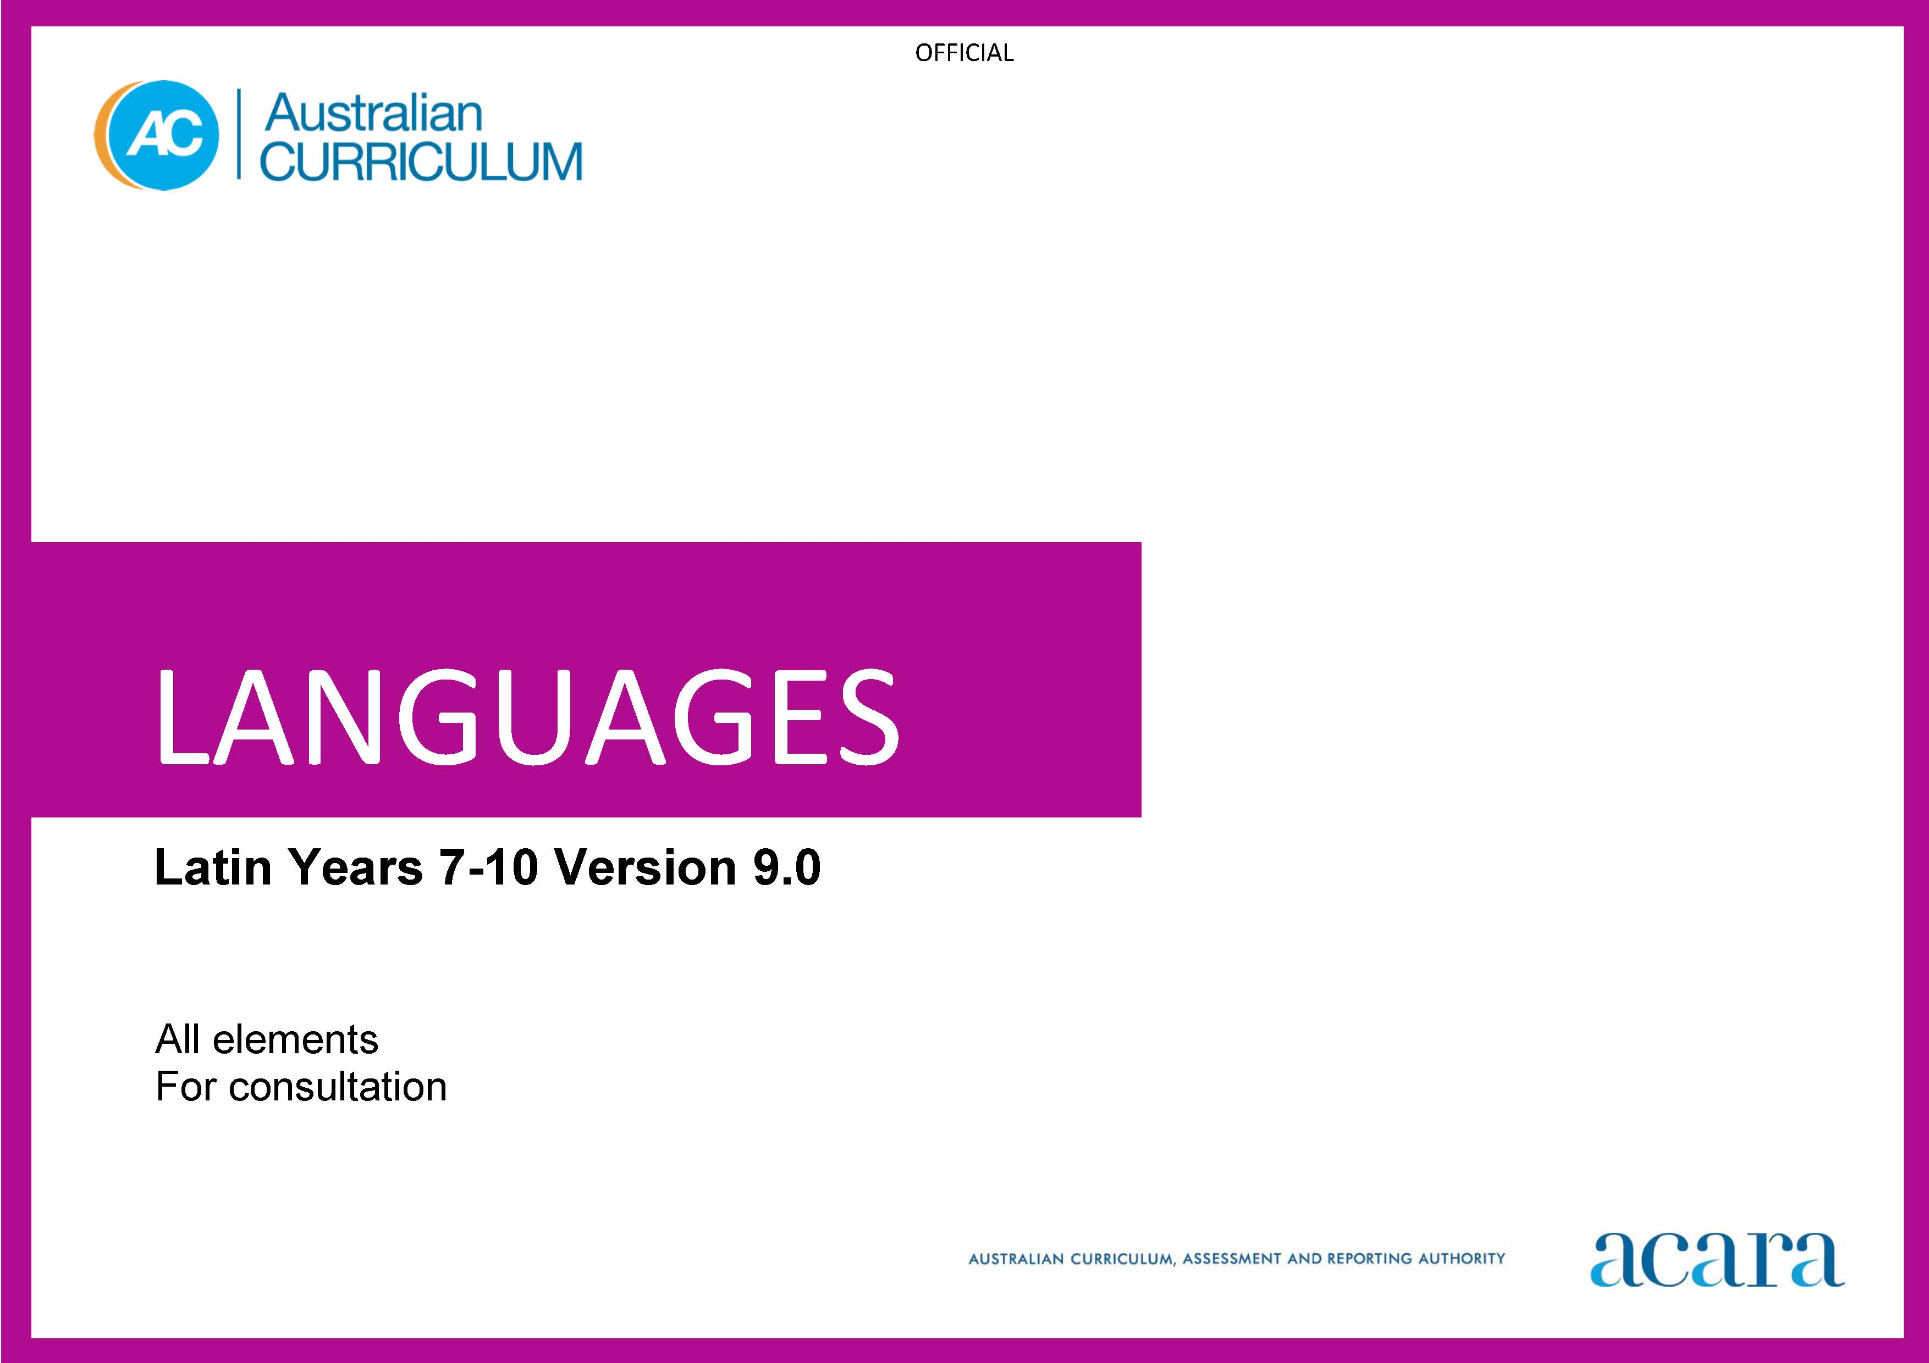

Copyright and Terms of Use Statement
© Australian Curriculum, Assessment and Reporting Authority 2023
The material published in this work is subject to copyright pursuant to the Copyright Act 1968 (Cth) and is owned by the Australian Curriculum, Assessment and Reporting Authority (ACARA) (except to the extent that copyright is held by another party, as indicated).
The viewing, downloading, displaying, printing, reproducing (such as by making photocopies) and distributing of these materials is permitted only to the extent permitted by, and is subject to the conditions imposed by, the terms and conditions of using the ACARA website (see, especially, clauses 2, 3 and 4 of those terms and conditions). The terms and conditions can be viewed at https://www.acara.edu.au/contact-us/copyright

TABLE OF CONTENTS
Years 7-10 AUSTRALIAN CURRICULUM: LANGUAGES – LATIN 3
ABOUT THE LEARNING AREA 3
Introduction 3
Rationale 3
Aims 4
Structure 4
Key considerations 7
Key connections 9
Resources 13
ABOUT LATIN 14
Introduction 14
Rationale 14
Structure 14
CURRICULUM ELEMENTS 16
Years 7–8 (Year 7 entry) 16
Years 9–10 (Year 7 entry) 23

Years 7-10 AUSTRALIAN CURRICULUM: LANGUAGES – LATIN

ABOUT THE LEARNING AREA

Introduction
The Australian Curriculum: Languages has been developed to give all students the opportunity to engage in learning a language in addition to English. The design of the Languages curriculum recognises features that all languages share as well as the distinctiveness of each language.
Languages includes language-specific curricula for world languages and a Framework for Aboriginal Languages and Torres Strait Islander Languages.
Learners of languages in Australia comprise 3 major groups:
- Second-language learners: Second-language learners are introduced to learning the target language at school as an additional, new language. The first language used before they start school (and/or the language used at home) is not the language being learnt.
- Background-language learners: Background-language learners may use the language at home, not necessarily exclusively, and have varying degrees of knowledge of, and proficiency in, the language being learnt. These learners have a base for literacy development in the language.
- First-language learners: First-language learners are learners who use, and/or identify with, the language as their mother tongue; learners use the language for primary socialisation and/or education and/or literacy development.

Rationale
Communication is a human imperative. Irrespective of which language, communication involves interaction to convey meaning as well as imagination, creativity and a broad understanding of ourselves and others. Language learning provides the opportunity for students to engage with the linguistic and cultural diversity of the world and its peoples, and reflect on their experience in various aspects of social life, including their own participation and ways of being in the world.
Learning a language(s) broadens students’ horizons in relation to the personal, social, cultural and employment opportunities that an increasingly interconnected and interdependent world can offer. The interdependence of countries and communities means people in all spheres of life are required to negotiate experiences and meanings across languages and cultures. Despite its status as a world language, a capability solely in English can limit global opportunities. A bilingual or plurilingual capability is the norm in many parts of the world.
Learning language(s) develops learners’:
- communication skills
- literacy skills in their first and additional languages
- intercultural capabilities
- understanding of, and respect for, diversity and difference, and an openness to different experiences and perspectives
- understanding and appreciation of how culture shapes world views and extends their understanding of themselves, their own heritage, values, culture and identity
- critical and creative thinking.
Learning a language provides opportunities for the community to engage socially, culturally and economically in domains which include business, trade, science, law, education, tourism, diplomacy, international relations, health and communications.
For First Nations Australian students, learning their own languages is crucial to overall learning and achievement to develop a sense of identity and recognition, and understanding of language, culture, Country and Place. For all students, learning Aboriginal languages and Torres Strait Islander languages provides a distinctive means of understanding the country in which they live, including the relationship between land, the environment and people. Ongoing and necessary reclamation and revitalisation of these languages contribute to reconciliation.

Aims
The 3 interrelated aims of Languages are to develop knowledge, understanding and skills to ensure students:
- develop linguistic competence
- understand language and culture, and their relationship, and thereby develop an intercultural capability in communication
- understand themselves as communicators.

Structure
Languages is presented in 2 sequences that offer different entry points into language learning; from Foundation to Year 10 or Year 7 to Year 10.
The Foundation to Year 10 sequence is presented in bands of 2-year levels after the Foundation year. The Years 7 to 10 sequence is presented in bands of 2-year levels; Years 7 and 8, and Years 9 and 10.
Content in Languages is organised under 2 interrelated strands, each with a number of sub-strands. The strands and sub-strands are presented in Figure 1.
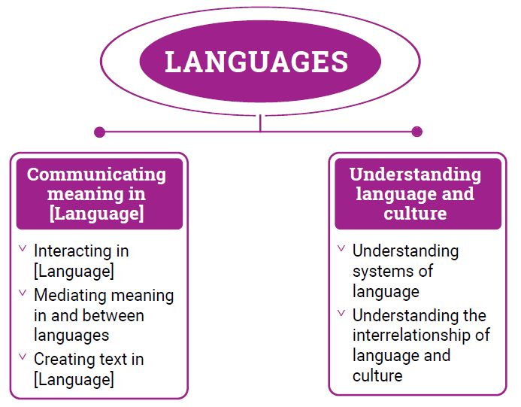
Figure 1: Languages content structure

Strand: Communicating meaning in [Language]
This involves students learning to use language for communicative purposes in interpreting, creating and exchanging meaning. There are 3 sub-strands.
Interacting in [Language]
Exchanging ideas, opinions, experiences, thoughts and feelings in non-verbal, spoken and written interactions; participating in planning, negotiating, deciding and taking action.
Mediating meaning in and between languages
Obtaining, processing, interpreting and conveying information through a range of spoken, written and multimodal texts; moving between languages and cultures non-verbally, orally and in writing, recognising different interpretations.
Creating text in [Language]
Creating a range of spoken, written and multimodal texts for specific contexts, purposes and audiences.
Strand: Understanding language and culture
This involves students learning to analyse and understand language and culture as resources for interpreting and shaping meaning in intercultural exchange. There are 2 sub-strands.
Understanding systems of language
Understanding the linguistic features of the language, including sound, writing, grammatical and textual conventions.
Understanding the interrelationship of language and culture
Analysing and reflecting on the role of language and culture in shaping meaning and identity.

Key considerations
Flexible entry points to F–10 and Years 7–10 sequences
Languages provides 2 learning sequences to cater for different entry points into language learning. The curriculum recognises that these 2 sequences do not necessarily represent the variety of entry points into the curriculum. Teachers can use the sequences flexibly to meet the needs of their students in their teaching and learning contexts.
Use of English
Students should use the target language to communicate whenever possible in classroom, local or digital environments. The use of English provides opportunities for students to reflect on, explore and discuss ideas, and use metalanguage to talk about and compare languages and cultures.
Macro skills
The macro skills of listening, speaking, reading, viewing and writing – also known as language modes – are interrelated. The learning of one often supports and extends the learning of others. To acknowledge these interrelationships, content in Languages incorporates these macro skills in an integrated and interdependent way.
Teaching and learning contexts will necessarily draw from more than one of these skills to support students’ effective learning. For example, students will learn new vocabulary, such as words, phrases and expressions, through listening, reading and viewing. They will apply their knowledge and understanding in their speaking and writing, as well as in their comprehension of spoken, visual, written and multimodal texts.
The macro skills are aligned most strongly to the Communicating meaning in [Language] strand, and are implicit in the content of the sub-strands and across the content descriptions, as shown in Table 1.
Table 1: The relationship between macro skills and the Communicating meaning in [Language] strand
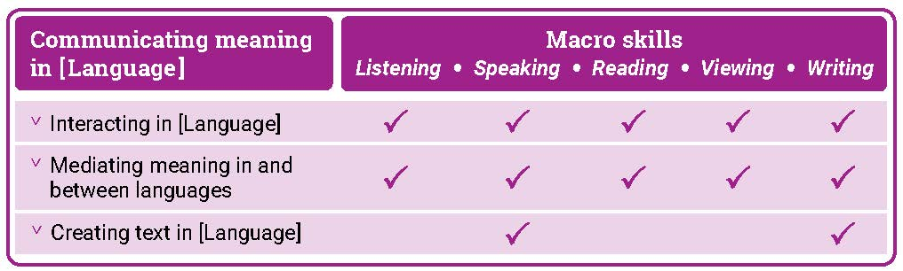

Texts
Texts can be spoken, written, visual, multimodal, and in print and digital/online forms. Multimodal texts combine language with other means of communication such as visual images and audio or spoken words in film or digital media. Texts include all forms of augmentative and alternative communication; for example, gesture, signing, real objects, photographs, pictographs and pictograms. Texts provide important opportunities for learning about aspects of students’ experiences of languages and cultures. Many of the tasks that students undertake in and out of school involve understanding and producing informative and imaginative texts in everyday and workplace contexts.
Teachers are best placed to guide the selection of materials for students to listen to, read, view, write and create. They provide purposeful activities that can be organised around these materials to meet the needs of the students in their classes.
Protocols for engaging First Nations Australians
When planning teaching activities involving engagement with First Nations Australians, teachers should follow protocols that describe principles, procedures and behaviours for recognising and respecting First Nations Australians and their intellectual property. Teachers should use approved resources such as those that may be provided by their state or territory school system, First Nations Australians education consultative groups or other protocols accredited by First Nations Australians.
While the Australian Curriculum uses the terms ‘First Nations Australians’ and ‘Australian First Nations Peoples’, there may be other terms that First Nations Australians of a particular area or location prefer. It is important to use the terms preferred in a particular area or location.
Meeting the needs of diverse learners
The Australian Curriculum values diversity by providing for multiple means of representation, action, expression and engagement, and allows schools the flexibility to respond to the diversity of learners within their community. All schools have a responsibility when implementing the Australian Curriculum to ensure that students’ learning is inclusive, and relevant to their experiences, abilities and talents.
For some students with diverse languages, cultures, abilities and talents it may be necessary to provide a range of curriculum adjustments so they can access age-equivalent content in Languages and participate in learning on the same basis as their peers.
The study of languages is important in the multilingual societies and the global economy in which we live. Students with diverse identities, languages, cultures, abilities and talents benefit from the study of languages when an appropriate learning environment is provided.
Languages is intended for all students, and it is recognised that some students may require adjustments to support how they see, hear, and/or process language. Students may require access to a wide range of approaches and resources including, and not limited to:
multi-sensory visual, auditory, tactile, and/or kinesthetic experiences and resources
simultaneous learning channels such as combinations of listening, speaking, reading, viewing and writing resources to teach a language concept
resources such as picture cues for words or hand and mouth movements to illustrate a sound, or colour-coding to illustrate gender or subject/verb agreements
modified equipment and tools
multilingual labels, signs and posters around the classroom
devices, mnemonics, rhythms and rhymes to reinforce vocabulary, expressions and features
peer-assisted learning
open-ended tasks that provide flexibility and can be completed at different levels of complexity
challenging individual and group extension activities.

Key connections
General capabilities
General capabilities equip young Australians with the knowledge, skills, behaviours and dispositions to live and work successfully. General capabilities support and deepen student engagement with learning area content and are best developed within the context of learning areas.
Opportunities to develop general capabilities in learning area content vary. In addition to Literacy and Numeracy, which are fundamental to all learning areas, the general capabilities of most relevance and application to Languages are Intercultural Understanding, Critical and Creative Thinking, Personal and Social capability, and Digital Literacy. These general capabilities are identified in content descriptions when they are developed or applied through the Languages content. They are also identified in content elaborations when they offer opportunities to add depth and richness to student learning.
Literacy
Languages develops students’ ability to listen to, read, view, create, and perform a range of spoken, written and multimodal texts in the target language. It provides opportunities for students to move between the target language and English to analyse, interpret and reflect on texts. Students enhance and extend their knowledge and understanding of English literacy, and use their knowledge of English literacy to support their learning in the target language. They develop increasing fluency in the second or additional language. They also develop the ability to reflect on and discuss their understanding of language as a system, using the metalanguage of English.
Learning an additional language(s) and English is mutually beneficial to literacy development. This is reflected in the links between language learning and the National Literacy Learning Progression (NLLP) in Languages. Content is linked to the expected level of literacy development that students, typically, would have achieved at each year/band of years. For example, students in Year 8 are likely to be operating at Level 6 in the Speaking sub-element of the NLLP. These students may not be operating at Level 6 Speaking in a second or additional language(s). However, the teacher can make connections and draw on students’ English literacy skills to support their learning of the second or additional language(s).
Intercultural Understanding
The Intercultural Understanding capability is core to Languages. In learning a second or additional language, students develop an appreciation of languages, cultures and beliefs including their own. Students learn about the strong interrelationships between languages and cultures and how these shape identity. They develop and apply intercultural understanding to value and respect diverse ways of communicating, thinking and behaving. They recognise how these are reflected in social and cultural practices, and language use. Students develop connections with communities and cultures, become aware of similarities and differences, and cultivate mutual respect. The Intercultural Understanding capability assists students to navigate and reflect on language use, perspectives and behaviours.
Critical and Creative Thinking
Languages develops students’ ability to think logically, critically and creatively. It provides opportunities for students to inquire, generate, analyse and reflect on a range of information, ideas and perspectives in spoken and written texts. Students learn how to analyse texts and interpret how the language of texts conveys meaning. They reflect on the thinking and processes used to mediate meaning between languages. They apply their knowledge of language as a system to new contexts and learn to revise and modify texts when considering context, purpose and audience.
Personal and Social capability
Languages enhances students’ personal and social capability. Through the Communicating meaning in [Language] strand, students develop a range of interpersonal skills essential to effective communication, such as decision-making, negotiation, and collaboration. Content in both the Communicating meaning in [Language] and Understanding language and culture strands encourages students to develop an appreciation of diverse cultures and perspectives, and recognise how these influence identity, including their own.
Digital Literacy
Languages develops students’ digital literacy capability as they use a range of digital tools to access and create information, ideas and perspectives in multimodal texts. Students develop understanding of how they can use digital tools to access diverse language-speaking communities and authentic texts. They evaluate and analyse information in digital formats and develop understanding of their intended context, purpose and audience.

Numeracy
Languages develops students’ numeracy capability as they communicate in real or simulated real-life situations. Students use number in the target language to share information (time, directions, etc.) and understand how these might be represented in diverse languages and cultures. They use aspects of measurement in the language of transaction when using money, and units of measurement in the number, volume and weight of items. Students use number patterns and algebraic thinking when they recognise and apply the patterns of grammatical and syntactical rules to respond to and create text.
Cross-curriculum priorities
Cross-curriculum priorities support the Australian Curriculum to be a relevant, contemporary and engaging curriculum that reflects national, regional and global contexts. Cross-curriculum priorities are incorporated through learning area content; they are not separate learning areas or subjects. They provide opportunities to enrich the content of the learning areas, where most appropriate and authentic, allowing students to engage with and better understand their world.
Opportunities to apply cross-curriculum priorities to learning area content vary. All 3 cross-curriculum priorities have some relevance and meaning to the Languages curriculum.
Aboriginal and Torres Strait Islander Histories and Cultures
Languages recognises the interrelationship of languages and cultures. Languages together with the Aboriginal and Torres Strait Islander Histories and Cultures cross-curriculum priority enable students to develop knowledge and understanding by engaging students with the languages and cultures of First Nations Australians. Students can make interlinguistic and intercultural connections across languages with First Nations Australian languages and their cultural expression. They develop understanding of concepts related to the diverse linguistic landscape of Australia.
The Framework for Aboriginal Languages and Torres Strait Islander Languages provides opportunities for all students to learn languages of First Nations Australians. Each language is recognised as belonging to a group of people who are its custodians. Schools must seek advice and consent from the custodians when developing language-specific curricula and planning language programs.
Asia and Australia’s Engagement with Asia
Languages provides learning opportunities in combination with the Asia and Australia’s Engagement with Asia cross-curriculum priority. Students develop knowledge and understanding by engaging with the languages and cultures of Asia, and people of Asian heritage.
Languages enables students to learn languages of the Asian region and to communicate, interact and explore concepts, experiences and perspectives from within and across Asian cultures. Students develop an appreciation for the place of Australia within the Asian region, including the interconnections of languages and cultures, peoples and communities, and histories and economies. They learn how national linguistic and cultural identities continuously evolve in local, regional and international contexts.
Sustainability
Languages provides students with opportunities to develop the world views necessary to contribute to a sustainable future by reflecting on how they interpret and engage with the world and its peoples. The learning contexts in which students develop their language learning provide opportunities for them to explore actions to improve sustainability in local, national and global communities.
When learning a second or additional language, students develop understanding of diverse attitudes, beliefs and values, and ways of thinking and being. They learn that sustainability is relevant to the dynamic nature of language and its continuous changes and variations over time and place. They develop understanding that sometimes, due to globalisation, societal and political influences, languages may become vulnerable and at risk of losing their uniqueness or usage. Students consider the value of sustaining language knowledge and use, and reflect on its important connection to cultural expression.
Learning areas
Languages provides opportunities to integrate and connect content to other learning areas; in particular, English, Humanities and Social Sciences and The Arts.
Languages and English
Languages and English support students’ literacy development. Both learning areas share the focus for students to interact with others and create spoken, written and multimodal texts with an awareness of context, purpose and audience. Languages and English help students to understand the relationship between spoken and written language and recognise how cultural context shapes meaning. They develop students’ understanding of, and ability to use, grammatical and language features.
Languages and Humanities and Social Sciences
Languages and Humanities and Social Sciences subjects share learning contexts that progressively shape the students’ world. In both learning areas, students’ learning involves perspectives of their personal worlds, such as personal and family histories and events, their local communities, and national and global contexts. In the process of understanding an expanding world view, both learning areas help students to learn to reflect on the relationship between cultures and identities.
Languages and The Arts
Languages and The Arts share a focus on the communication of stories, ideas, perspectives and cultures. Both learning areas help students to explore relationships among people, cultures and identities, and recognise how these are exemplified in and through linguistic and artistic practices and behaviours.

Resources
A scope and sequence representation of the curriculum, the glossary, and comparative information about Version 8.4 and Version 9 are available as a download from the Australian Curriculum Version 9 website.
Language support resource
Each language curriculum has an optional support resource, developed to support teachers as they plan teaching and learning programs. This resource provides suggestions for sequential development in language structures and features, and thematic contexts for language use. Teachers can use suggestions in the resource to adapt curriculum content to meet the diverse language needs and learning backgrounds of students at different entry points into second language learning. These documents are available as downloads.

ABOUT LATIN

Introduction
The Australian Curriculum: Latin is pitched to second language learners in Years 7-10, that is, the dominant structure and sequence of learning in the current Australian context. For most students it is their first experience of learning Latin.

Rationale
Latin was the official language of ancient Rome, and the language of transmission of Roman law, government, literature and cultural knowledge and values throughout much of Europe, North Africa and West Asia during the period 753 BCE – 476 CE. After the fall of the Roman empire, Latin remained a language for literary, liturgical, legal, political, philosophical and scientific texts, many of lasting historical and aesthetic value. Latin continued as the language of Western Christianity, and remains so today for the official business of the Roman Catholic Church and the Vatican City State. The enduring achievements and rich legacy of the ancient Roman world are evident in modern beliefs, customs and values, architecture, art, engineering, laws and forms of government, literature and medicine.

Latin has been taught in Australian universities and schools since the 1800s. By accessing and translating Latin texts and engaging with artefacts, students make connections with ancient worlds that have shaped contemporary life and societies Learning Latin enhances students’ understanding of English due to its influence on the alphabet and vocabulary of English, some Latin terms and mottoes which remain unchanged, and commonly used abbreviations. Knowledge of Latin and the ancient Roman world enriches students’ knowledge of how an ancient civilisation influences life and thought in the modern world; and promotes understanding of diverse attitudes, beliefs and values.

Structure
Latin has been developed as a Second Language Learner Pathway which caters for students learning Latin as a second or additional language in Years 7-10.

The Second Language Learner Pathway includes one sequence:
- Years 7 to 10.

Teachers use the curriculum to cater for learners of different backgrounds by making appropriate adjustments to differentiate learning experiences.

Content in Latin is organised under 2 interrelated strands, each with a number of sub-strands. The strands and sub-strands are presented in Figure 2.
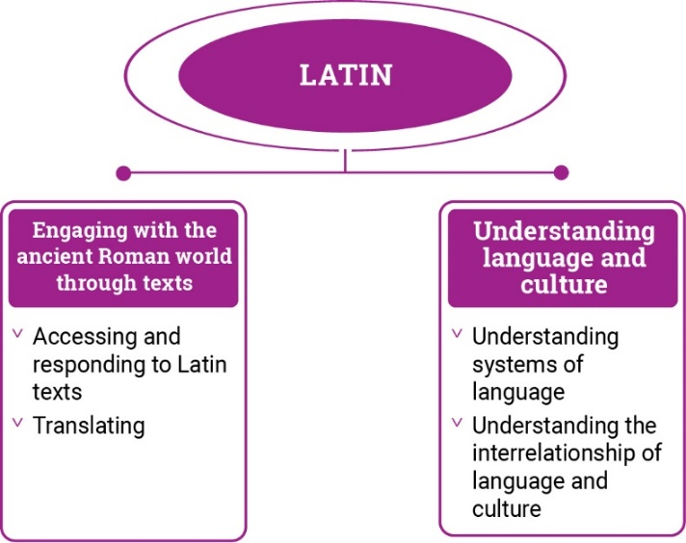
Figure 2: Latin content structure

Strand: Engaging with the ancient Roman world through texts
This involves students engaging with the language, culture and history of the ancient Roman world through the interpretation, analysis and translation of Latin texts. There are 2 sub-strands.

Accessing and responding to Latin texts
Engaging with and responding to people and ideas in the ancient world through texts that reveal language use and social and cultural practices

Translating
Translating Latin texts into English, comparing and explaining different interpretations of the same text

Strand: Understanding language and culture
This involves students learning to analyse language and culture as resources for understanding meaning. There are 2 sub-strands.

Understanding systems of language
Understanding the linguistic features of Latin, including sound, writing, grammatical and textual conventions.

Understanding the interrelationship of language and culture
Analysing and reflecting on the role of language and culture in shaping meaning and identity.

CURRICULUM ELEMENTS

Years 7–8 (Year 7 entry)
Band level description
In Years 7 and 8, students are beginning their learning of Latin, and this will be influenced by prior learning and experiences of language learning. Students access a range of texts in Latin and English to understand and explore the ancient Roman world. They interact and collaborate with teachers and peers when engaged in activities involving listening, reading aloud, reading, viewing, translating and writing, supported by modelling, scaffolding and feedback. They access authentic and purpose-developed artefacts, spoken, written and multimodal resources which may include cartoons, stories, video clips, textbooks, and modified or authentic extracts of literature.

Students use their English literacy knowledge of metalanguage to reflect on similarities and differences between Latin and English vocabulary, pronunciation, grammatical structures and features. They comment on the impact of ancient Roman culture on the modern world today. They recognise that language reflects social and cultural identity, beliefs and values.

Achievement standard
By the end of Year 8, students use their knowledge of Latin language to interpret texts, and respond to information about ancient Roman society. They develop strategies to translate Latin texts into English, identifying familiar vocabulary, language structures and features to interpret meaning.

Students apply Latin sound–script relationships and use restored pronunciation when reading aloud. They demonstrate understanding that Latin has conventions and rules for spoken and written communication. They understand that Latin has influenced English vocabulary and comment on language structures and features, using metalanguage. They demonstrate awareness that language, texts and artefacts from Ancient Rome are connected with culture and identity, and explore the relationship between language(s), culture(s) and identity.

Strand: Engaging with the ancient Roman world through texts |  | Years 7–8 (Year 7 entry)
Sub-strand: Accessing and responding to Latin texts
Content descriptions  Students learn to: | Content elaborations  This may involve students:
access and interpret Latin texts to explore the ancient Roman world  ACL9LL8E01 | - reading Latin texts and examining artefacts to learn about Roman daily life, for example, the family, daily routines, food, occupations, schooling, public entertainment and ceremonies, politics, and leisure pursuits  - examining artefacts, images, inscriptions and writings to learn about important aspects of a Roman town, for example, the forum, temples, theatres, shops and roads, and what these can reveal about daily life  - researching the purpose and function of the forum during elections and the campaigning and voting process for candidates, for example, Pompeii  - exploring the importance of storytelling in capturing language, heritage and history and recognising that stories connect societies across time and place (FN CCP)  - comparing details from different sources about Roman social structure such as citizenship and slavery and discussing what they reveal about varying attitudes in the Roman period  - reading historical accounts and interpreting the information about significant events in Roman history, for example, Pliny’s eyewitness account of the eruption of Vesuvius  - gathering information from texts about Roman religious beliefs and practices, for example, the Olympian deities, Lares et Penates, special festivals such as the Liberalia, Saturnalia and the Vestalia  - reading Roman myths and legends in English and discussing what these stories reveal about Roman attitudes and values  - reading English translations or modified Latin texts of the works of ancient authors, such as Virgil, Homer, Horace and Ovid, for example, stories or plays based on the Trojan War, mythology, and epic heroes  - identifying influences from Latin literature on popular culture and music, for example, Harry Potter, Romeo and Juliet, superheroes such as Superman and Hercules, Bastille’s Pompeii, musical instruments such as horns, pipes, the lyre  - discussing the meaning of simple Latin mottoes used by modern institutions, such as school mottoes or the Olympic motto Citius, Altius, Fortius
respond to texts and convey information in English or Latin as appropriate  ACL9LL8E02 | 1. creating posters or digital displays, with annotations in English or words and simple phrases in Latin, to share information about daily routine such as family life, education, food, entertainment, bathing and hygiene, exercise etc in the Roman world  2. reading stories about the daily lives of ancient Romans, and recreating their everyday experiences, for example, through role play, diary entries or an imaginative animated cartoon  3. creating maps, plans and diagrams using labels in Latin or English to demonstrate the purpose and function of Roman structures and institutions, for example, the Roman forum, houses, baths, roads, aqueducts  4. acting out stories, such as Romulus and Remus, Horatius guarding the bridge, or Hercules’ labours, to convey Roman attitudes and values  5. presenting short Latin texts orally, such as stories, plays, dialogues or songs, for example, singing songs such as gaudeamus igitur; duc, duc navem duc  6. responding to prompts to communicate in simple spoken and written Latin, for example, creating short sentences in Latin or answering questions based on a text  7. producing news reports, blogs or documentaries about significant events in Roman history, for example, the eruption of Mount Vesuvius, the fire of Rome, the reign of an emperor  8. discussing influence of Roman culture on modern novels, poetry, drama and film and creating a visual display highlighting significant elements  9. discussing how characters and plot in Latin texts are used to create humour, suspense and other effects on the audience, for example, the use of comic episodes, plot twists.
Sub-strand: Translating
develop and apply strategies to interpret and translate Latin texts to convey meaning in English  ACL9LL8E03 | 1. developing skills to infer meaning from textual cues, for example, titles, headings, images or, captions  2. determining the general sense of texts through initial holistic reading, by identifying familiar people, vocabulary, places or topics, contextualising new vocabulary  3. using knowledge of high-frequency words in familiar and unfamiliar contexts and knowledge of Latin-derived English words to deduce the meaning of unknown Latin words  4. reading sentences in Latin and using visual cues to infer meaning, such as Latin word order, capitalisation of proper nouns, modern punctuation and conjunctions  5. using known vocabulary in Latin, English derivatives, and context to deduce the meaning of unknown words, for example, clamor, exclamare; puer in cubiculo dormit  6. listening to simple sentences in Latin and using aural cues to identify meaning, such as tone, inflection, emphasis and signpost words, for example, ecce, olim, cur; ubi, euge, eheu  7. identifying and explaining the function of inflected forms, for example, puella canem vocat (subject+object+verb) and recognising irregular forms, such as est, sunt  8. translating Latin into fluent and idiomatic English, for example, by including the definite or indefinite article in the translation and determining appropriate word order in English  9. discussing effective strategies to translate and the merits of different translations of the same text, for example, clamabat -she was shouting, she used to shout, she began to shout  10. considering multiple meanings of vocabulary by using dictionaries and electronic translation tools, and making appropriate selections according to context, for example, petit; ago; de  11. discussing social, contextual and cultural references embedded in texts and how they should be translated, for example, dominus, servus  12. collaborating with peers to interpret and build meaning in texts and develop and edit joint translations, using a range of digital tools  13. using methods to build knowledge of vocabulary, such as the use of ICT, developing lists of unfamiliar words, mnemonics  14. developing own and class lists of frequently used vocabulary related to texts and topics, such as daily life in Ancient Rome, for example, tandem, tamen; thermae, caldarium; magister, ludus

Strand: Understanding language and culture |  | Years 7–8 (Year 7 entry)
Sub-strand: Understanding systems of language
Content descriptions  Students learn to: | Content elaborations  This may involve students:
understand and begin to apply the phonological and orthographic systems of Latin  ACL9LL8U01 | - recognising that the written alphabet used by the Romans is the basis for the modern English alphabet  - discussing Roman numerals and naming conventions, such as the use of capital letters for names and abbreviated forms, for example, the use of M for Marcus  - matching script to sound, using the restored pronunciation, for example, pronouncing long and short vowels, diphthongs, the consonants u/v, c and h, and distinguishing i as a vowel and as a consonant, for example, intrat, ianua  - listening to and reproducing familiar and unfamiliar words, phrases and simple texts in Latin  - using the spoken stress of Latin, and dramatic expression appropriate to the tone and purpose of a text, for example, furcifer, eheu, euge, ita vero, cachinnans  - reading aloud or reciting, individually or in a class group, for example, performing a short play in Latin
develop knowledge of the vocabulary, and structures and features of Latin grammatical systems to understand, translate and respond to texts  ACL9LL8U02 | - identifying parts of speech, such as, nouns, verbs, adjectives and adverbs and their functions in texts to determine meaning, for example, identifying which noun is the subject of the verb  - recognising noun inflections for case and number in first, second and third declensions, for example, amicus, amicum; villa, villae and exploring the use of cases to convey meaning  - recognising that nouns in Latin have gender, for example, dominus is masculine, villa is feminine, atrium is neuter  - exploring the concepts of verb number, person and tense and identifying the endings of regular verbs in different persons and tenses, for example, clamat, clamant; portavi, portavit;  - recognising other forms of verbs, such as present infinitives and imperatives, for example, portare; clama, clamate!  - identifying endings of irregular verbs in different tenses and forms, for example, sum, possum, volo, nolo  - identifying first, second and third declension adjectives, for example, laeta/laetus; tristis and exploring the concept of noun-adjective agreement  - recognising the comparative and superlative degree of regular adjectives, for example, iratus, iratior, iratissimus  - recognising prepositional phrases including different forms and meanings, for example, e villa, ex urbe, in villa, in villam  - identifying the forms of pronouns, such as personal, relative and demonstrative  - using Latin word order to deduce meaning in texts and interpreting compound sentences using conjunctions, for example, canis intrat sed non latrat  15. identifying cardinal 1-20 and ordinal numbers, for example, unus, primus, and Roman numerals, for example, I, V, X, L, C, M  16. using the metalanguage used to describe structures and features of Latin grammatical systems, for example, declension, conjugation
compare Latin vocabulary, language features and structures with English, using metalanguage  ACL9LL8U03 | - recognising connections between spelling of Latin and English words and applying understanding to improve spelling in English, for example, portat–portable, audit–audible  - identifying and using Latin derivatives to expand English vocabulary, for example, maternal, nominate, puerile, agriculture, commerce, science  - identifying word families in which the same Latin root is used with different prefixes or suffixes, for example, the use of the root verb duco in reduce, introduce, deduce, conduct, produce  - discussing expressions and abbreviations in Latin that are incorporated into English, for example, postmortem, in loco parentis, e.g., i.e., am, pm, etc.  - understanding conventions of word order in both Latin and English sentences such as adjectives generally follow after the noun in Latin and before the noun in English for example, puella tristis/sad girl  - exploring how use of language techniques in narratives such as exclamation, repetition, alliteration, onomatopoeia can encourage the audience to respond in particular ways in both Latin and English, for example, veni, vidi, vici; ululavit

Sub-strand: Understanding the interrelationship of language and culture
recognise that language, texts and artefacts provide insights into culture and identity  ACL9LL8U04 | - recognising that Latin has influenced many modern languages and applying knowledge of Latin to understand words and expressions in Romance languages, for example, deux, tempo, liberté, égalité, fraternité, amigo; la dolce vita  - locating the Roman Empire and places where Latin was spoken on a map and considering how cultural diversity has continued to be an integral feature of society since ancient times  - exploring mottoes and inscriptions, such as per ardua ad astra, e pluribus unum and discussing their relevance in expressing belonging and/or identity in both the ancient and modern world  - exploring First Nations Australians material culture such as instruments, jewellery, music, art, painting and dance and recognising how they provide insights into beliefs, cultural practices and social values (FN CCP)  - exploring language use that reflects social structures, for example, pater familias, libertus, servus, matrona and discussing what these may reveal about cultural attitudes in Ancient Rome  - exploring the colloquial language that Romans used for greetings, or answering questions about daily life, such as salvete, quid agis?  - considering how learning about the ancient world through texts and artefacts offers different ways of interpreting the modern world  - discussing the impact of Roman infrastructure on people throughout the empire, for example, aqueducts, roads, safe trade routes, standardised currency and weights and measures and reflecting on infrastructure in the modern world  - reflecting on how learning Latin provides insights into the relationship between language and culture, and how this may have influenced way of thinking about own language(s), culture(s) and identity

Years 9–10 (Year 7 entry)
Band level description
In Years 9 and 10, Latin language learning builds on each student’s prior learning and experiences. Students access and translate a range of texts in Latin and English to interpret and analyse the society and culture of Ancient Rome. They communicate their ideas and opinions about the ancient world. Students continue to receive guidance, modelling, feedback and support from peers and teachers. They use authentic and purpose-developed resources and artefacts, and a range of spoken, written and multimodal texts which may include extracts from authentic literature, textbooks, audio and video clips, magazines, online and print articles.
Students use metalanguage to analyse structures and features of Latin and explain the influence on English. They evaluate the impact of ancient Roman culture on the modern world today. They reflect on how language and social and cultural identity can shape behaviours, beliefs and values.
Achievement standard
By the end of Year 10, students use their knowledge of Latin to interpret and analyse information about ancient Roman society and culture. They apply strategies to translate and interpret Latin texts into English and demonstrate understanding of how language conveys cultural meaning.
Students apply Latin sound–script relationships, using restored pronunciation, when reading aloud. They select and apply Latin grammatical conventions and rules when translating and responding to texts. They explain how Latin has influenced English vocabulary and analyse language structures and features, using metalanguage. They demonstrate understanding that the language, texts and artefacts from Ancient Rome are connected with culture and identity and reflect on the interrelationship of language(s), culture(s) and identity.

Strand: Engaging with the ancient Roman world through texts |  | Years 9–10 (Year 7 entry)
Sub-strand: Accessing and responding to Latin texts
Content descriptions  Students learn to: | Content elaborations  This may involve students:
interpret Latin texts to analyse the society and culture of the ancient Roman world  ACL9LL10E01 | - investigating Roman political institutions and concepts such as republic and principate, the senate, the cursus honorum and political offices  - researching personal legal rights and citizenship in Rome  - examining how cultural attitudes are conveyed in Latin texts such as attitudes to civil rights, imperialism, slavery and women, and compare these with modern social issues  - investigating the importance of storytelling in capturing language, heritage and history and discussing how stories connect societies across time and place (FN CCP)  - exploring the ancient origins of modern structures and concepts, for example, social classes, property rights and divorce  - studying research from archaeological sites to learn about Roman urban planning, architecture and engineering  - investigating what the location and role of places of entertainment and worship reveal about the values and attitudes of the Romans  - researching references in Latin texts to foreign religions, for example, Mithraism, Isis worship and Christianity, and discussing the extent of their influence in Rome  - investigating ancient practices such as Roman military practices or practices in medicine and science, for example, Galen’s surgical procedures and Pliny the Elder’s classification of animals and plants  - reading extracts from original Latin texts such as Martial, Horace, Catullus, Ovid, and analysing how they convey the attitudes of Roman society  - examining Latin inscriptions, curses or graffiti to elicit information about Roman society, for example, defixiones from Bath, graffiti at the Colosseum or in Pompeii, and creating examples in English or Latin  - gathering and collating information about Roman art, including, jewellery, painting, sculpture and investigating famous modern artists’ incorporation of classical themes and methods
respond to texts and discuss ideas about ancient Roman society in English or Latin as appropriate  ACL9LL10E02 | - discussing the importance of entertainment in the Roman world by researching references in texts to theatres, amphitheatres, and the Circus Maximus  - creating a virtual tour of the Colosseum, with accompanying text in English or Latin  - exploring language that reveals the importance of public spaces and buildings in Ancient Rome, for example, forum, temples, theatres to create a model, plan or digital representation of the Roman urban environment  - researching language that reveals information about Roman government and administration, such as res publica, senatus, comitia, consul, dictator, princeps and discussing how they reveal Roman attitudes towards politics  - explaining the importance of religion to the Romans, with reference to concepts such as Lares et Penates, the worship of local gods throughout the empire, vestal virgins, cult of the Emperor, and comparing these with modern religions  - discussing the significance of historical or mythological characters or events which exemplify Roman values and attitudes, such as Romulus and Remus, Lucretia, Horatius, Cloelia  - exploring how language is used to reveal character, key messages, purpose and values in texts such as narratives, plays and poems, for example, by performing Latin plays, or creating theatrical interpretations of Latin stories such as extracts from Cena Trimalchionis; the plays of Plautus; Odi et amo  - analysing Latin texts and responding to questions in English to demonstrate understanding of content, context, purpose and technique, for example, the author’s use of literary devices, such as asyndeton, to create effect  - communicating in spoken or written Latin, for example, creating complex sentences in Latin or answering questions based on a text  - discussing the influence of visual arts in Roman society such as paintings, mosaics and sculpture, and producing artwork inspired by these or developing an online exhibition catalogue
Sub-strand: Translating
apply strategies to interpret and translate Latin texts to convey meaning and demonstrate understanding of context, purpose and audience  ACL9LL10E03 | - inferring the meaning of new words, using knowledge of the text type and the author’s purpose and technique, for example, res, gero, rem gerere  - predicting the context and content of Latin texts through initial holistic reading, by identifying key words and phrases, for example, Romani Carthaginienses valde timebant  - deducing the meaning of new words by drawing on prior knowledge, derivatives and connections with familiar words, for example, dormire, obdormire; ferre, inferre, offerre  - investigating First Nations Australians material culture such as instruments, jewellery, music, art, painting and dance and discussing how they provide an understanding of beliefs, cultural practices and social values (FN CCP)  - applying knowledge of word origins and word building to interpret unfamiliar vocabulary, such as vowel changes, for example, aedificium: aedifico; capere: cip (recipere) and compound words, for example, ‘prefect’ from prae + factum  - listening to complex sentences in Latin and using aural cues and literary devices to infer meaning, such as correlatives, for example, quantum..tantum and anaphora for example, nihil...nihil...nihil...  - applying knowledge of grammar, sentence structure and word inflections to deduce meaning  - translating, independently or in collaboration with peers, unseen texts with compound or complex sentences, drawing on familiarity with the style and language of texts already studied, for example, variation in word order  - applying strategies to create fluent and idiomatic translation such as rendering the precise meaning of tenses, for example, cotidie ibat; si veneris  - refining translations to convey shades of meaning of a range of subtle vocabulary, for example, by exploring dictionaries and electronic translation tools to infer the different connotations of a word in a particular context, such as virtus; causa; gero; ago  - selecting appropriate vocabulary and phrasing in English to convey the author’s meaning, such as reflecting tone and translating idiomatic and culturally specific terms in Latin, for example, flocci non facio (I could not care less)  - constructing and editing translations collaboratively with peers, using a range of ICT, justifying opinions for the selection of specific words and phrases  - evaluating the effectiveness of translations, using criteria such as selection of appropriate vocabulary, grammatical accuracy, fluency, conciseness and clarity

Strand: Understanding language and culture |  | Years 9–10 (Year 7 entry)
Sub-strand: Understanding systems of language
Content descriptions  Students learn to: | Content elaborations  This may involve students:
apply the phonological and orthographic systems of Latin in a range of contexts  ACL9LL10U01 | - discussing conventions of Latin texts, such as metre in poetry, for example, the division of a line of poetry into feet, and the use of scansion to identify vowels as short or long or recognising elisions between words, such as mult(um) ill(e) et terris iactatus  - understanding the writing conventions for original Latin text, inscriptions and epistles, for example, acknowledging the absence of punctuation by Roman writers and modern editors’ use of punctuation to guide readers  - understanding conventions for reading Latin aloud, such the significance of elision when reading verse aloud, for example, od(i) et amo  - applying knowledge of the phonological systems of Latin to read familiar and unfamiliar words aloud  - reading Latin passages and applying, stress, rhythm and tone to convey meaning, for example, by reciting or presenting extracts from Latin texts to the class or school community  - reading aloud extracts from different genres of Latin literature with appropriate expression, such as the epigrams of Martial, poetry of Virgil or the speeches of Cicero
select and use vocabulary, grammatical structures and linguistic features of Latin to interpret, translate, and respond to texts  ACL9LL10U02 | - using a range of methods to deduce the meaning of unknown Latin words such as by recognising the construction of compound words, for example, felix, infelix; loquor, colloquor  - applying understanding of parts of speech such as nouns, verbs, adjectives and adverbs and their functions in texts to determine meaning, for example, recognising noun and adjective agreement  - using metalanguage to describe structures and features of Latin grammatical systems, for example, mood, voice, tense  - applying knowledge of noun inflections for case and number in first to fifth declensions and analysing case usage of nouns, in all five declensions, for example, partitive genitive quid novi? the locative case  - understanding the relationship between noun gender and declension, for example, most first declension nouns are feminine, and acknowledging that nouns may have unexpected genders, for example, first declension agricola (m), second declension humus (f)  - applying understanding of verb number, person, tense, mood and voice, for example, indicative, subjunctive and imperative moods, active and passive voice  - understanding the use of differents forms of verbs such as principal parts, infinitives, participles, gerunds, gerundives, for example, portavisse, clamans, amandum, delenda  - applying knowledge of the endings of irregular and deponent verbs in different tenses and forms, for example, eo, ire, ii/ivi; loquor, loqui, locutus sum  - applying understanding of the inflection of first, second and third declension adjectives, for example, laeta/laetus, tristis and analysing noun-adjective agreement  - applying knowledge of the degree of regular and irregular adjectives and adverbs, for example, stulta, stultior, stultissima; malus, peior, pessimus  - applying understanding of prepositional phrases including cases followed by prepositions and changes in word order, for example, medio in mare  - applying knowledge of the forms and use of a range of pronouns such as reflexive, emphatic, indefinite, interrogative  - understanding the range of subordinate clauses used in complex sentences to convey sophisticated ideas, for example, relative, causal, temporal, and recognising common conjunctions used, for example, cum, ut  - using cardinal numbers 1-100 and ordinal numbers 1-20  - understanding conventions of the Roman calendar and the use of numbers to express distance, capacity, time and price, for example, duo milia passuum, quinquaginta denariis
explain how Latin vocabulary, structures and features extend understanding of English, using metalanguage  ACL9LL10U03 | - recognising connections between grammatical structures and features in Latin and English and applying knowledge to extend grammatical understanding of the English language, for example, use of participles, gerunds  - identifying Latin roots in English medical scientific and technical and terminology, for example, genus, species; computer, data, super conductor and exploring how Latin is used to coin terms for new technology and discoveries, such as internet, Trojan (horse), forum, virus  - recognising terms in English that are hybrids of Latin and Classical Greek, for example, metalanguage, quantum physics, teleconference  - examining Latin expressions, abbreviations and words that are used in fields such as law, business and education, de facto, non sequitur, agenda, forum, curriculum  - explaining how in both Latin and English, the coherence of complex texts relies on devices that signal text structure and guide readers, for example, primo … deinde … tandem; non solum … verum etiam  - analysing how Latin and English use linguistic features and word order to influence the audience, for example, the contrast of short and periodic sentences to persuade, the intentional use of word order to produce emphasis and tone, for example, qualis vir? conclamant omnes; miser Catulle
Sub-strand: Understanding the interrelationship of language and culture
reflect on and explain how language, texts and artefacts provide understanding of culture and identity  ACL9LL10U04 | - recognising that Latin is a member of the Indo-European family of languages, related to and influenced by other ancient languages, such as the use of Classical Greek vocabulary and concepts in Roman literature and philosophy, for example, stadium, rhetor, theatrum, poeta, stoica, philosophia  - recognising that Latin became the common language across the empire and investigating the enduring use of Latin in academia, law, medicine and religion, for example, summa cum laude, modus operandi, ab initio, pater noster  - analysing cultural attitudes and values embedded in language and symbols, for example, pietas, virtus, hospitium, SPQR, fasces and making comparisons to their own language and culture  - investigating the importance of storytelling in capturing language, heritage and history and discussing how stories connect societies across time and place  - understanding how language and cultural practices are interconnected, for example, the use of cognates of the father’s name for sons and daughters, Julia as daughter of Julius, or religious connotations associated with words and expressions such as the polite command in the English RIP ‘rest in peace’ and the more prayerful subjunctive in the Latin requiescat in pace  - investigating the importance of understanding Latin for personal status in the Roman world, and a vehicle for social, economic and political advancement, for example, the education in Latin of the local elite in the provinces  - considering how cultural diversity has continued to be an integral feature of society since ancient times  - investigating how language, texts and artefacts provide a means of understanding the social values, attitudes and cultural practices of the Romans and making links and comparisons to their own language(s) and culture(s)  - analysing how learning Latin provides insights into the language, culture and identity of people living in the Roman world and reflecting on students’ own relationship to language(s), culture(s) and identity in their community, state/territory or nation and as a global citizen

