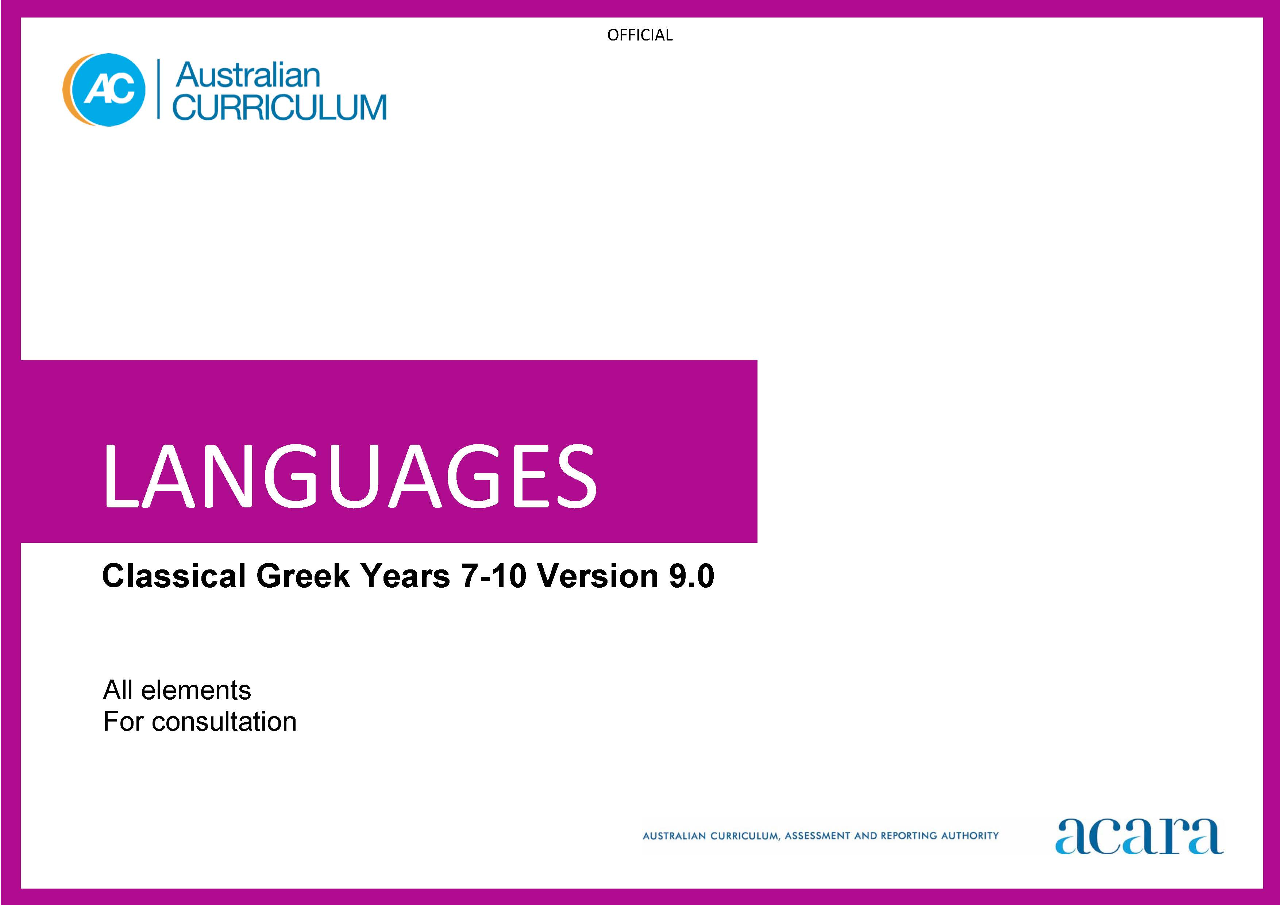

Copyright and Terms of Use Statement
© Australian Curriculum, Assessment and Reporting Authority 2023
The material published in this work is subject to copyright pursuant to the Copyright Act 1968 (Cth) and is owned by the Australian Curriculum, Assessment and Reporting Authority (ACARA) (except to the extent that copyright is held by another party, as indicated).
The viewing, downloading, displaying, printing, reproducing (such as by making photocopies) and distributing of these materials is permitted only to the extent permitted by, and is subject to the conditions imposed by, the terms and conditions of using the ACARA website (see, especially, clauses 2, 3 and 4 of those terms and conditions). The terms and conditions can be viewed at https://www.acara.edu.au/contact-us/copyright

TABLE OF CONTENTS
Years 7–10 AUSTRALIAN CURRICULUM: LANGUAGES – CLASSICAL GREEK 3
ABOUT THE LEARNING AREA 3
Introduction 3
Rationale 3
Aims 4
Structure 4
Key considerations 7
Key connections 9
Resources 13
ABOUT CLASSICAL GREEK 14
Introduction 14
Rationale 14
Structure 14
CURRICULUM ELEMENTS 17
Years 7–8 (Year 7 entry) 17
Years 9–10 (Year 7 entry) 24

Years 7 to 10 AUSTRALIAN CURRICULUM: LANGUAGES – CLASSICAL GREEK

ABOUT THE LEARNING AREA

Introduction
The Australian Curriculum: Languages has been developed to give all students the opportunity to engage in learning a language in addition to English. The design of the Languages curriculum recognises features that all languages share as well as the distinctiveness of each language.
Languages includes language-specific curricula for world languages and a Framework for Aboriginal Languages and Torres Strait Islander Languages.
Learners of languages in Australia comprise 3 major groups:
- Second-language learners: Second-language learners are introduced to learning the target language at school as an additional, new language. The first language used before they start school (and/or the language used at home) is not the language being learnt.
- Background-language learners: Background-language learners may use the language at home, not necessarily exclusively, and have varying degrees of knowledge of, and proficiency in, the language being learnt. These learners have a base for literacy development in the language.
- First-language learners: First-language learners are learners who use, and/or identify with, the language as their mother tongue; learners use the language for primary socialisation and/or education and/or literacy development.

Rationale
Communication is a human imperative. Irrespective of which language, communication involves interaction to convey meaning as well as imagination, creativity and a broad understanding of ourselves and others. Language learning provides the opportunity for students to engage with the linguistic and cultural diversity of the world and its peoples, and reflect on their experience in various aspects of social life, including their own participation and ways of being in the world.
Learning a language(s) broadens students’ horizons in relation to the personal, social, cultural and employment opportunities that an increasingly interconnected and interdependent world can offer. The interdependence of countries and communities means people in all spheres of life are required to negotiate experiences and meanings across languages and cultures. Despite its status as a world language, a capability solely in English can limit global opportunities. A bilingual or plurilingual capability is the norm in many parts of the world.
Learning language(s) develops learners’:
- communication skills
- literacy skills in their first and additional languages
- intercultural capabilities
- understanding of, and respect for, diversity and difference, and an openness to different experiences and perspectives
- understanding and appreciation of how culture shapes world views and extends their understanding of themselves, their own heritage, values, culture and identity
- critical and creative thinking.
Learning a language provides opportunities for the community to engage socially, culturally and economically in domains which include business, trade, science, law, education, tourism, diplomacy, international relations, health and communications.
For First Nations Australian students, learning their own languages is crucial to overall learning and achievement to develop a sense of identity and recognition, and understanding of language, culture, Country and Place. For all students, learning Aboriginal languages and Torres Strait Islander languages provides a distinctive means of understanding the country in which they live, including the relationship between land, the environment and people. Ongoing and necessary reclamation and revitalisation of these languages contribute to reconciliation.

Aims
The 3 interrelated aims of Languages are to develop knowledge, understanding and skills to ensure students:
- develop linguistic competence
- understand language and culture, and their relationship, and thereby develop an intercultural capability in communication
- understand themselves as communicators.

Structure
Languages is presented in 2 sequences that offer different entry points into language learning; from Foundation to Year 10 or Year 7 to Year 10.
The Foundation to Year 10 sequence is presented in bands of 2-year levels after the Foundation year. The Years 7 to 10 sequence is presented in bands of 2-year levels; Years 7 and 8, and Years 9 and 10.
Content in Languages is organised under 2 interrelated strands, each with a number of sub-strands. The strands and sub-strands are presented in Figure 1.
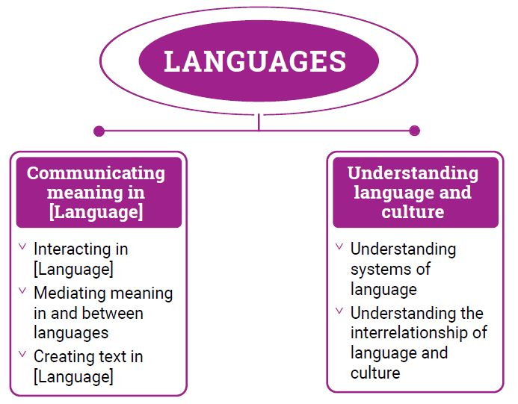
Figure 1: Languages content structure

Strand: Communicating meaning in [Language]
This involves students learning to use language for communicative purposes in interpreting, creating and exchanging meaning. There are 3 sub-strands.
Interacting in [Language]
Exchanging ideas, opinions, experiences, thoughts and feelings in non-verbal, spoken and written interactions; participating in planning, negotiating, deciding and taking action.
Mediating meaning in and between languages
Obtaining, processing, interpreting and conveying information through a range of spoken, written and multimodal texts; moving between languages and cultures non-verbally, orally and in writing, recognising different interpretations.
Creating text in [Language]
Creating a range of spoken, written and multimodal texts for specific contexts, purposes and audiences.
Strand: Understanding language and culture
This involves students learning to analyse and understand language and culture as resources for interpreting and shaping meaning in intercultural exchange. There are 2 sub-strands.
Understanding systems of language
Understanding the linguistic features of the language, including sound, writing, grammatical and textual conventions.
Understanding the interrelationship of language and culture
Analysing and reflecting on the role of language and culture in shaping meaning and identity.

Key considerations
Flexible entry points to F–10 and Years 7–10 sequences
Languages provides 2 learning sequences to cater for different entry points into language learning. The curriculum recognises that these 2 sequences do not necessarily represent the variety of entry points into the curriculum. Teachers can use the sequences flexibly to meet the needs of their students in their teaching and learning contexts.
Use of English
Students should use the target language to communicate whenever possible in classroom, local or digital environments. The use of English provides opportunities for students to reflect on, explore and discuss ideas, and use metalanguage to talk about and compare languages and cultures.
Macro skills
The macro skills of listening, speaking, reading, viewing and writing – also known as language modes – are interrelated. The learning of one often supports and extends the learning of others. To acknowledge these interrelationships, content in Languages incorporates these macro skills in an integrated and interdependent way.
Teaching and learning contexts will necessarily draw from more than one of these skills to support students’ effective learning. For example, students will learn new vocabulary, such as words, phrases and expressions, through listening, reading and viewing. They will apply their knowledge and understanding in their speaking and writing, as well as in their comprehension of spoken, visual, written and multimodal texts.
The macro skills are aligned most strongly to the Communicating meaning in [Language] strand, and are implicit in the content of the sub-strands and across the content descriptions, as shown in Table 1.
Table 1: The relationship between macro skills and the Communicating meaning in [Language] strand
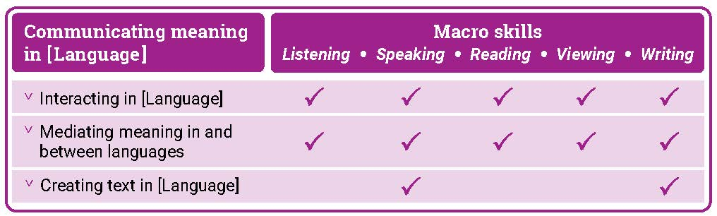

Texts
Texts can be spoken, written, visual, multimodal, and in print and digital/online forms. Multimodal texts combine language with other means of communication such as visual images and audio or spoken words in film or digital media. Texts include all forms of augmentative and alternative communication; for example, gesture, signing, real objects, photographs, pictographs and pictograms. Texts provide important opportunities for learning about aspects of students’ experiences of languages and cultures. Many of the tasks that students undertake in and out of school involve understanding and producing informative and imaginative texts in everyday and workplace contexts.
Teachers are best placed to guide the selection of materials for students to listen to, read, view, write and create. They provide purposeful activities that can be organised around these materials to meet the needs of the students in their classes.
Protocols for engaging First Nations Australians
When planning teaching activities involving engagement with First Nations Australians, teachers should follow protocols that describe principles, procedures and behaviours for recognising and respecting First Nations Australians and their intellectual property. Teachers should use approved resources such as those that may be provided by their state or territory school system, First Nations Australians education consultative groups or other protocols accredited by First Nations Australians.
While the Australian Curriculum uses the terms ‘First Nations Australians’ and ‘Australian First Nations Peoples’, there may be other terms that First Nations Australians of a particular area or location prefer. It is important to use the terms preferred in a particular area or location.
Meeting the needs of diverse learners
The Australian Curriculum values diversity by providing for multiple means of representation, action, expression and engagement, and allows schools the flexibility to respond to the diversity of learners within their community. All schools have a responsibility when implementing the Australian Curriculum to ensure that students’ learning is inclusive, and relevant to their experiences, abilities and talents.
For some students with diverse languages, cultures, abilities and talents it may be necessary to provide a range of curriculum adjustments so they can access age-equivalent content in Languages and participate in learning on the same basis as their peers.
The study of languages is important in the multilingual societies and the global economy in which we live. Students with diverse identities, languages, cultures, abilities and talents benefit from the study of languages when an appropriate learning environment is provided.
Languages is intended for all students, and it is recognised that some students may require adjustments to support how they see, hear, and/or process language. Students may require access to a wide range of approaches and resources including, and not limited to:
- multi-sensory visual, auditory, tactile, and/or kinesthetic experiences and resources
- simultaneous learning channels such as combinations of listening, speaking, reading, viewing and writing resources to teach a language concept
- resources such as picture cues for words or hand and mouth movements to illustrate a sound, or colour-coding to illustrate gender or subject/verb agreements
- modified equipment and tools
- multilingual labels, signs and posters around the classroom
- devices, mnemonics, rhythms and rhymes to reinforce vocabulary, expressions and features
- peer-assisted learning
- open-ended tasks that provide flexibility and can be completed at different levels of complexity
- challenging individual and group extension activities.

Key connections
General capabilities
General capabilities equip young Australians with the knowledge, skills, behaviours and dispositions to live and work successfully. General capabilities support and deepen student engagement with learning area content and are best developed within the context of learning areas.
Opportunities to develop general capabilities in learning area content vary. In addition to Literacy and Numeracy, which are fundamental to all learning areas, the general capabilities of most relevance and application to Languages are Intercultural Understanding, Critical and Creative Thinking, Personal and Social capability, and Digital Literacy. These general capabilities are identified in content descriptions when they are developed or applied through the Languages content. They are also identified in content elaborations when they offer opportunities to add depth and richness to student learning.
Literacy
Languages develops students’ ability to listen to, read, view, create, and perform a range of spoken, written and multimodal texts in the target language. It provides opportunities for students to move between the target language and English to analyse, interpret and reflect on texts. Students enhance and extend their knowledge and understanding of English literacy, and use their knowledge of English literacy to support their learning in the target language. They develop increasing fluency in the second or additional language. They also develop the ability to reflect on and discuss their understanding of language as a system, using the metalanguage of English.
Learning an additional language(s) and English is mutually beneficial to literacy development. This is reflected in the links between language learning and the National Literacy Learning Progression (NLLP) in Languages. Content is linked to the expected level of literacy development that students, typically, would have achieved at each year/band of years. For example, students in Year 8 are likely to be operating at Level 6 in the Speaking sub-element of the NLLP. These students may not be operating at Level 6 Speaking in a second or additional language(s). However, the teacher can make connections and draw on students’ English literacy skills to support their learning of the second or additional language(s).
Intercultural Understanding
The Intercultural Understanding capability is core to Languages. In learning a second or additional language, students develop an appreciation of languages, cultures and beliefs including their own. Students learn about the strong interrelationships between languages and cultures and how these shape identity. They develop and apply intercultural understanding to value and respect diverse ways of communicating, thinking and behaving. They recognise how these are reflected in social and cultural practices, and language use. Students develop connections with communities and cultures, become aware of similarities and differences, and cultivate mutual respect. The Intercultural Understanding capability assists students to navigate and reflect on language use, perspectives and behaviours.
Critical and Creative Thinking
Languages develops students’ ability to think logically, critically and creatively. It provides opportunities for students to inquire, generate, analyse and reflect on a range of information, ideas and perspectives in spoken and written texts. Students learn how to analyse texts and interpret how the language of texts conveys meaning. They reflect on the thinking and processes used to mediate meaning between languages. They apply their knowledge of language as a system to new contexts and learn to revise and modify texts when considering context, purpose and audience.
Personal and Social capability
Languages enhances students’ personal and social capability. Through the Communicating meaning in [Language] strand, students develop a range of interpersonal skills essential to effective communication, such as decision-making, negotiation, and collaboration. Content in both the Communicating meaning in [Language] and Understanding language and culture strands encourages students to develop an appreciation of diverse cultures and perspectives, and recognise how these influence identity, including their own.
Digital Literacy
Languages develops students’ digital literacy capability as they use a range of digital tools to access and create information, ideas and perspectives in multimodal texts. Students develop understanding of how they can use digital tools to access diverse language-speaking communities and authentic texts. They evaluate and analyse information in digital formats and develop understanding of their intended context, purpose and audience.

Numeracy
Languages develops students’ numeracy capability as they communicate in real or simulated real-life situations. Students use number in the target language to share information (time, directions, etc.) and understand how these might be represented in diverse languages and cultures. They use aspects of measurement in the language of transaction when using money, and units of measurement in the number, volume and weight of items. Students use number patterns and algebraic thinking when they recognise and apply the patterns of grammatical and syntactical rules to respond to and create text.
Cross-curriculum priorities
Cross-curriculum priorities support the Australian Curriculum to be a relevant, contemporary and engaging curriculum that reflects national, regional and global contexts. Cross-curriculum priorities are incorporated through learning area content; they are not separate learning areas or subjects. They provide opportunities to enrich the content of the learning areas, where most appropriate and authentic, allowing students to engage with and better understand their world.
Opportunities to apply cross-curriculum priorities to learning area content vary. All 3 cross-curriculum priorities have some relevance and meaning to the Languages curriculum.
Aboriginal and Torres Strait Islander Histories and Cultures
Languages recognises the interrelationship of languages and cultures. Languages together with the Aboriginal and Torres Strait Islander Histories and Cultures cross-curriculum priority enable students to develop knowledge and understanding by engaging students with the languages and cultures of First Nations Australians. Students can make interlinguistic and intercultural connections across languages with First Nations Australian languages and their cultural expression. They develop understanding of concepts related to the diverse linguistic landscape of Australia.
The Framework for Aboriginal Languages and Torres Strait Islander Languages provides opportunities for all students to learn languages of First Nations Australians. Each language is recognised as belonging to a group of people who are its custodians. Schools must seek advice and consent from the custodians when developing language-specific curricula and planning language programs.
Asia and Australia’s Engagement with Asia
Languages provides learning opportunities in combination with the Asia and Australia’s Engagement with Asia cross-curriculum priority. Students develop knowledge and understanding by engaging with the languages and cultures of Asia, and people of Asian heritage.
Languages enables students to learn languages of the Asian region and to communicate, interact and explore concepts, experiences and perspectives from within and across Asian cultures. Students develop an appreciation for the place of Australia within the Asian region, including the interconnections of languages and cultures, peoples and communities, and histories and economies. They learn how national linguistic and cultural identities continuously evolve in local, regional and international contexts.
Sustainability
Languages provides students with opportunities to develop the world views necessary to contribute to a sustainable future by reflecting on how they interpret and engage with the world and its peoples. The learning contexts in which students develop their language learning provide opportunities for them to explore actions to improve sustainability in local, national and global communities.
When learning a second or additional language, students develop understanding of diverse attitudes, beliefs and values, and ways of thinking and being. They learn that sustainability is relevant to the dynamic nature of language and its continuous changes and variations over time and place. They develop understanding that sometimes, due to globalisation, societal and political influences, languages may become vulnerable and at risk of losing their uniqueness or usage. Students consider the value of sustaining language knowledge and use, and reflect on its important connection to cultural expression.
Learning areas
Languages provides opportunities to integrate and connect content to other learning areas; in particular, English, Humanities and Social Sciences and The Arts.
Languages and English
Languages and English support students’ literacy development. Both learning areas share the focus for students to interact with others and create spoken, written and multimodal texts with an awareness of context, purpose and audience. Languages and English help students to understand the relationship between spoken and written language and recognise how cultural context shapes meaning. They develop students’ understanding of, and ability to use, grammatical and language features.
Languages and Humanities and Social Sciences
Languages and Humanities and Social Sciences subjects share learning contexts that progressively shape the students’ world. In both learning areas, students’ learning involves perspectives of their personal worlds, such as personal and family histories and events, their local communities, and national and global contexts. In the process of understanding an expanding world view, both learning areas help students to learn to reflect on the relationship between cultures and identities.
Languages and The Arts
Languages and The Arts share a focus on the communication of stories, ideas, perspectives and cultures. Both learning areas help students to explore relationships among people, cultures and identities, and recognise how these are exemplified in and through linguistic and artistic practices and behaviours.

Resources
A scope and sequence representation of the curriculum, the glossary, and comparative information about Version 8.4 and Version 9 are available as a download from the Australian Curriculum Version 9 website.
Language support resource
Each language curriculum has an optional support resource, developed to support teachers as they plan teaching and learning programs. This resource provides suggestions for sequential development in language structures and features, and thematic contexts for language use. Teachers can use suggestions in the resource to adapt curriculum content to meet the diverse language needs and learning backgrounds of students at different entry points into second language learning. These documents are available as downloads.

ABOUT CLASSICAL GREEK

Introduction
The Australian Curriculum: Classical Greek is pitched to second language learners in Years 7-10, that is, the dominant structure and sequence of learning in the current Australian context. For most students it is their first experience of learning Classical Greek.

Rationale
Classical Greek is defined as the literary Attic–Ionic dialect used by prominent Greek historians, orators, philosophers and playwrights in the 5th and 4th centuries BCE. The conquests of Alexander the Great in the 4th century BCE extended the influence of Greek language and culture in western Asia and Egypt, and resulted in the upsurge in Greek literature and learning known as the Hellenistic Age. The eastern Roman Empire, based at Constantinople, continued as a Greek-speaking, Christian community until it was conquered by the Turks in 1453 CE. After the conquest of Constantinople, many Greek scholars moved to western Europe, stimulating the revival of Classical Greek learning, art and culture during the Renaissance period. The Greek language continued to evolve and absorb influences from other languages until the present day. Modern Greek uses the same alphabet, and the written language bears strong resemblance to Classical Greek. The enduring achievements and rich legacy of the ancient Greek world are evident in modern beliefs, customs and values, architecture, art, engineering, laws and forms of government, literature, mathematics, medicine, philosophy and sciences.

Classical Greek has been taught in Australian universities and schools since the 1800s. By accessing and translating Classical Greek texts and engaging with artefacts, students make connections with ancient worlds that have shaped contemporary life and societies. Learning Classical Greek enhances students’ understanding of English due to its influence on the vocabulary of English. Knowledge of Classical Greek and the ancient Greek world enriches students’ knowledge of how an ancient civilisation influences life and thought in the modern world; and promotes understanding of diverse attitudes, beliefs and values.

Structure
Classical Greek has been developed as a Second Language Learner Pathway which caters for students learning Classical Greek as a second or additional language in Years 7-10.

The Second Language Learner Pathway includes one sequence:
- Years 7 to 10.

Teachers use the curriculum to cater for learners of different backgrounds by making appropriate adjustments to differentiate learning experiences.

Content in Classical Greek is organised under 2 interrelated strands, each with a number of sub-strands. The strands and sub-strands are presented in Figure 2.

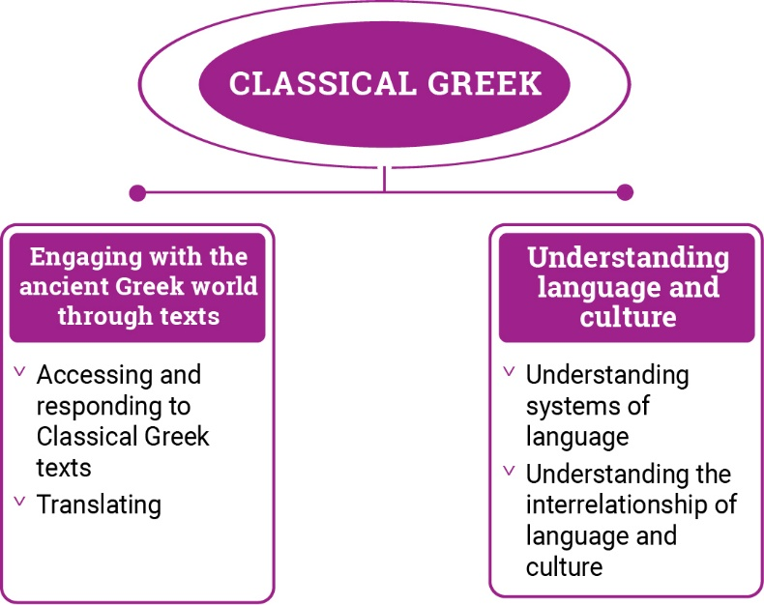

Figure 2: Classical Greek content structure

Strand: Engaging with the ancient Greek world through texts
This involves students engaging with the language, culture and history of the ancient Greek world through the interpretation, analysis and translation of Classical Greek texts. There are 2 sub-strands.

Accessing and responding to Classical Greek texts
Engaging with and responding to people and ideas in the ancient world through texts that reveal language use and social and cultural practices

Translating
Translating Classical Greek texts into English, comparing and explaining different interpretations of the same text

Strand: Understanding language and culture
This involves students learning to analyse language and culture as resources for understanding meaning. There are 2 sub-strands.

Understanding systems of language
Understanding the linguistic features of Classical Greek, including sound, writing, grammatical and textual conventions.

Understanding the interrelationship of language and culture
Analysing and reflecting on the role of language and culture in shaping meaning and identity.

CURRICULUM ELEMENTS

Years 7–8 (Year 7 entry)
Band level description
In Years 7 and 8, students are beginning their learning of Classical Greek, and this will be influenced by prior learning and experiences of language learning. Students access a range of texts in Classical Greek and English to understand and explore the ancient Greek world. They interact and collaborate with teachers and peers when engaged in activities involving listening, reading aloud, reading, viewing, translating and writing, supported by modelling, scaffolding and feedback. Students access authentic and purpose-developed artefacts, spoken, written and multimodal resources which may include cartoons, stories, video clips, textbooks, and modified or authentic extracts of literature.

Students use their English literacy knowledge of metalanguage to reflect on similarities and differences between Classical Greek and English vocabulary, pronunciation, grammatical structures and features. They comment on the impact of ancient Greek culture on the modern world today. They recognise that language reflects social and cultural identity, beliefs and values.

Achievement standard
By the end of Year 8, students use their knowledge of Classical Greek language to interpret texts, and respond to information about ancient Greek society. They develop strategies to translate Classical Greek texts into English, identifying familiar vocabulary, language structures and features to interpret meaning.

Students apply Classical Greek sound–script relationships and use restored pronunciation when reading aloud. They demonstrate understanding that Classical Greek has conventions and rules for spoken and written communication. They understand that Classical Greek has influenced English vocabulary and comment on language structures and features, using metalanguage. They demonstrate awareness that language, texts and artefacts from Ancient Greece are connected with culture and identity, and explore the relationship between language(s), culture(s) and identity.

Strand: Engaging with the ancient Greek world through texts |  | Years 7–8 (Year 7 entry)
Sub-strand: Accessing and responding to Classical Greek texts
Content descriptions  Students learn to: | Content elaborations  This may involve students:
access and interpret Classical Greek texts to explore the ancient Greek world  ACL9LCG8E01 | - locating places where Greek was spoken in antiquity on a map and connecting the spread of the Greek culture with the evolution and spread of the language  - listening to simple sentences in Classical Greek to infer meaning, using aural cues such as ἆρα ἤδη πονεῖτε ἐν τοῖς ἀγροῖς; ἐλθὲ δεῦρο  - inferring meaning from textual cues, for example, titles, headings, images, maps, captions or by identifying familiar people, vocabulary, places or topics, for example, ὁ Λεωνίδας μάχεται ἐν ταῖς Θερμοπύλαις  - exploring the importance of storytelling in capturing language, heritage and history and recognising that stories connect societies across time and place (FN CCP)  - identifying cultural representations such as symbols, for example, the owl (Athena), trident (Poseidon), olive wreath (Olympic victory), the letter lambda (Spartans)  5. researching the purpose and function of spaces in an ancient Greek home, for example, the ἀνδρών and γυναικών rooms  6. examining artefacts from the classical Greek period such as those from ancient Athens to see what they reveal about the everyday lives of ancient Greek people  7. collating and sharing information online about ancient Greek inventions, engineering and infrastructure, for example, the Antikythera Mechanism, the Hippodamian urban grid plan, Archimedes’ screw  8. recognising the ancient origins of national values such as democracy, equity and justice, freedom of speech and independent thought  9. exploring the attitudes of ancient Greeks revealed in their myths and legends, for example, Hercules’ and Theseus’ attitudes to seeking glory  10. identifying references to ancient Greek mythology and literature in visual and performing arts and literature from antiquity to the present  11. exploring ancient connections with modern society in sport, theatre, schooling, music, architecture  12. identifying literary influences from the Classical Greek period on popular culture, such as brand names, cartoons, adventure films, for example, Clash of the Titans, Troy, Hercules
respond to texts and convey information in English or Classical Greek as appropriate  ACL9LCG8E02 | - listening to and reading texts, such as stories about life in the city/country, legends or myths, and responding to questions in English relating to content and context or providing a summary  - gathering, collating information about daily routine in the ancient Greek world such as about family life, education, food, hygiene, exercise, and presenting in posters or digital displays with annotations in English or words and simple phrases in Classical Greek  - exploring and discussing references in texts to social structure in Sparta and Athens, including perioikoi, the helots and Athenian metics.  - researching artefacts such as Greek vases and explaining what they tell us about daily life and cultural practices in Ancient Greece  - comparing details from different sources about where Greek people lived, such as in urban centres or rural settlements, for example, through dioramas or drawings with labels in English or Classical Greek, and discussing what they reveal about different lifestyles in the Classical period  - reading accounts of historical events, such as Aeschylus’ eyewitness account of the Battle of Salamis, and presenting information in new ways, for example, as a news report  - discussing how scenes and characters are depicted in texts, such as through imagery or conversations,  - reading a text such as a story or a myth and illustrating it with images and simple captions in Classical Greek  - identifying and discussing the techniques writers use to achieve specific effects, such as humour or surprise,  - presenting orally short texts in Classical Greek, such as stories, dialogues, poems or speeches using strategies to convey tone and emotion  - creating a class bank of references in texts to worship of the Olympian gods and local heroes, the panhellenic festivals of the Olympic and Pythian Games, or the dramatic performances of the Dionysia in Athens to assess the importance of religion in ancient Greek society
Sub-strand: Translating
develop and apply strategies to interpret and translate Classical Greek texts to convey meaning in English  ACL9LCG8E03 | 1. using print and electronic resources to locate the appropriate meanings of words  2. using knowledge of Classical Greek-derived English words to deduce the meaning of Classical Greek words  3. considering multiple meanings of vocabulary, for example, by using dictionaries and electronic translation tools, and making appropriate selections according to context, for example, ἄριστος  4. using known vocabulary, in Classical Greek or English, and context to deduce the meaning of unknown words  5. applying knowledge of grammar to determine meaning of inflected forms and to recognise in context the specific function of words which may have multiple applications, such as subject or object, for example, τὸ δένδρον θάλλει. ὁ γεωργὸς κόπτει τὸ δένδρον  6. translating Classical Greek into idiomatic English, identifying words and expressions that do not translate easily, for example, ἀγαθός, ἄριστος, καλός, ξένος, δεινός, πρὸς τῶν θεῶν, ἔστι μοι δοῦλος  7. recognising that Classical Greek word order is different from English and determining appropriate word order in English to retain meaning and emphasis, for example, κελεύει σε ὁ Ζεύς  8. identifying and discussing effective strategies to create appropriate translations, applying problem-solving skills to resolve difficulties  9. discussing how words that refer to aspects of ancient Greek culture should be translated, for example, ὁ δῆμος (deme, people, citizen body), ὁ ἀνήρ (man, husband, hero), ξένος (stranger, guest, foreigner)  10. exploring the effect of using the variety of English translations for verb tenses, for example, ἰδών (‘having seen’, ‘after seeing’, ‘on seeing’, ‘seeing’)  11. collaborating with peers to edit joint translations and to compare and discuss the merits of different translations of the same text

Strand: Understanding language and culture |  | Years 7–8 (Year 7 entry)
Sub-strand: Understanding systems of language
Content descriptions  Students learn to: | Content elaborations  This may involve students:
understand and begin to apply the phonological and orthographic systems of Classical Greek  ACL9LCG8U01 | - learning the Greek alphabet in lower and upper case, including final sigma, matching script to sound, for example, δ - d, γ - g, θ - th  - learning the standard system of transliteration of Greek into English letters, for example, δ - d, χ - ch, αι - ae  - recognising the use of the upper case in Classical Greek to distinguish proper nouns  - writing simple sentences in Classical Greek to consolidate knowledge of script  - recognising and representing diphthongs, double consonants and aspirated consonants, for example, αι, γγ, ψ, ξ, θ, χ, φ  - recognising and using diacritical marks to show aspiration and iota subscript, for example, ἡ ὁδός, τῇ ὁδῷ  - recognising that punctuation in Classical Greek can be different from English, for example, the use of the semicolon as the question mark in Classical Greek  - listening to and reproducing familiar and unfamiliar words and phrases and reciting simple texts in Classical Greek to convey meaning, using restored pronunciation and appropriate phrasing and expression
develop knowledge of vocabulary, and structures and features of Classical Greek grammatical systems to understand, translate and respond to texts  ACL9LCG8U02 | - using the definite article to identify the number, gender and case of nouns, for example, αἱ ὁδοί, τούς δικαστάς  - recognising that the definite article, nouns, pronouns and adjectives inflect to show number and case, for example, ὁ ἡμέτερος πατήρ, τὰ μικρὰ ἄροτρα  - identifying the forms and functions of the nominative, vocative, accusative, genitive and dative cases of the definite article, nouns and pronouns, for example, τῶν πολιτῶν πολλοί (partitive genitive), τῇ ὑστεραίᾳ (dative of time when)  - recognising that Greek words have variable endings that indicate their grammatical function in a sentence,  - recognising -ω verbs and contract verbs –εω, –αω in the present, future, active and middle, for example, λύω/λύομαι, φιλῶ/φιλοῦμαι, τιμῶ/τιμῶμαι  - using the present imperative, active and middle, for example, σπεῦδε  - using the infinitive and participles, active and middle, in the present, future, for example, παύειν/παύων, παύσειν/παύσων,  - using the irregular verb ‘to be’ in the present, future and imperfect tenses, for example, εἰμἰ/ἔσομαι/ἦν  - recognising the use of common prefixes to form compound words ἐκβαίνω, εἰσβαίνω  - identifying the three declensions of nouns and adjectives, including variants and common irregular forms, for example, ἠ ναῦς, πολύς/πολλή/πολύ  - recognising agreement between adjectives and nouns in number, gender and case, for example, ἠ μακρὰ ὁδός, τοῦ ἀληθοῦς λόγου  - recognising the comparative and superlative degrees of regular adjectives, for example, ἀνδρεῖος, ἀνδρειότερος, ἀνδρειότατος  - identifying cardinal numbers εἷς/μία/ἕν to χίλοι/αι/α and μὐριοι/αι/α and ordinal numbers πρῶτος/η/ον to χιλιοστός, μυριοστός  - identifying the forms and application of personal, interrogative, indefinite, demonstrative and relative pronouns, for example, ἐγώ/σύ, ἡμεῖς/ὑμεῖς, τίς/τί, τις/τι, οὗτος/αὕτη/τοῦτο, ὅς/ἥ/ὅ  - recognising prepositional phrases using the accusative, genitive and dative cases, for example, πρὸς τὴν πόλιν, πρὸς τῶν θεῶν, πρὸς τῇ νηί  - recognising positive, comparative and superlative adverbs from adjectives, for example, ἀληθῶς/ἀληθέστερον/ἀληθέστατα
compare Classical Greek vocabulary and language features and structures with English, using metalanguage  ACL9LCG8U03 | - recognising how word order may be different in Classical Greek and English, such as the use of the attributive and predicative position of the adjective to vary meaning, for example, ἡ καλὴ κόρη and καλὴ ἡ κόρη  - understanding that one Classical Greek word may correspond to several different English words, and selecting the most appropriate meaning of a word in its context  - using terms relating to parts of speech to compare basic sentence structures in Classical Greek and English  - developing strategies for vocabulary building by applying knowledge of roots and derivatives, for example, ἄγγελος (angel/archangel/evangelist), περί (periscope/perimeter/periphery), μόνος/η/ον (monotony, monologue, monopoly)  - building vocabulary by recognising Classical Greek words commonly used in English, for example, analysis, aroma, drama, eureka, hoi polloi, hyperbole, idea, , , synthesis, ,  - identifying and using Classical Greek derivatives to expand own English vocabulary, for example, , antithesis, cynic, sceptic  - identifying and collecting word families in which the same Classical Greek root is used with different prefixes or suffixes, for example, biography, calligraphy; biology, technology; analysis, paralysis; Palaeolithic, palaeontology

Sub-strand: Understanding the interrelationship of language and culture
recognise that language, texts and artefacts provide insights into culture and identity  ACL9LCG8U04 | - recognising that Greek has been spoken in various forms uninterruptedly from the 3rd millennium BCE to the present day and has been documented in writing since about 1450 BCE, reflecting the culture of Greek-speaking peoples not only from the mainland but also Greek colonies across the Mediterranean and Black Sea  - investigating how the Classical Greek language was the medium with which innovative Greek ideas were spread in the areas of science, medicine, mathematics, historiography, geography and philosophy, for example, μαθηματικά, ἱστορία  - identifying connections between language and significant cultural attitudes, for example, the concept of μυθος, πανηγυρις  - exploring First Nations Australians material culture such as instruments, jewellery, music, art, painting and dance and recognising how they provide insights into beliefs, cultural practices and social values (FN CCP)  - exploring the colloquial language that ancient Greeks used for greetings, or answering questions about daily life, such as χαῖρε/χαίρετε, πῶς ἔχεις/ἔχετε; τὶ ἔστιν  - considering how learning about the ancient world through texts offers insights into different ways of representing experience  - reflecting and reporting on how learning Classical Greek gives insights into the relationship between language and culture in general, and how own way of thinking about language, culture and identity may change through the experience

Years 9–10 (Year 7 entry)
Band level description
In Years 9 and 10, Classical Greek learning builds on each student’s prior learning and experiences. Students access and translate a range of texts in Classical Greek and English to interpret and analyse the society and culture of Ancient Greece. They communicate their ideas and opinions about the ancient world. Students continue to receive guidance, modelling, feedback and support from peers and teachers. Students use authentic and purpose-developed resources and artefacts, and a range of spoken, written and multimodal texts which may include extracts from authentic literature, textbooks, audio and video clips, magazines, online and print articles.
Students use metalanguage to analyse structures and features of Classical Greek and explain the influence on English. They evaluate the impact of ancient Greek culture on the modern world today. They reflect on how language and social and cultural identity can shape behaviours, beliefs and values.
Achievement standard
By the end of Year 10, students use their knowledge of Classical Greek to interpret and analyse information about ancient Greece society and culture. They apply strategies to translate and interpret Classical Greek texts into English and demonstrate understanding of how language conveys cultural meaning.
Students apply Classical Greek sound–script relationships, using restored pronunciation, when reading aloud. They select and apply Classical Greek grammatical conventions and rules when translating and responding to texts. They explain how Classical Greek has influenced English vocabulary and analyse language structures and features, using metalanguage. They demonstrate understanding that language, texts and artefacts from Ancient Greece are connected with culture and identity and reflect on the interrelationship of language(s), culture(s) and identity.

Strand: Engaging with the ancient Greek world through texts |  | Years 9–10 (Year 7 entry)
Sub-strand: Accessing and responding to Classical Greek texts
Content descriptions  Students learn to: | Content elaborations  This may involve students:
interpret Classical Greek texts to analyse the society and culture of the ancient Greek world  ACL9LCG10E01 | - interpreting and inferring meaning using knowledge of text type, linguistic features and culture, for example, comparing Herodotus and Thucydides  - exploring famous centres of Greek learning and culture such as Alexandria, Antioch and Ephesus  - analysing texts to understand how different points of view are expressed on political or social issues, for example, the recall of military generals to Athens to stand trial after the Athenian victory at Arginusae in 406 BCE as reported in Thucydides, or the debate led by Themistocles at Corinth on where the Greeks should fight against the Persians  - investigating the importance of storytelling in capturing language, heritage and history and discussing how stories connect societies across time and place (FN CCP)  - examining how cultural attitudes are conveyed in Classical Greek texts, such as attitudes to enslaved people or women, political freedom, legal rights and obligations of citizens, social classes  - researching architectural remains of Ancient Greece through the study of an archaeological site and discussing what they reveal about the values and attitudes of the ancient Greeks  - exploring Classical Greek inscriptions to elicit information about ancient Greek society, for example, vases, funerary stelae, ostraka  - investigating ancient practices in engineering, medicine and science still relevant in the modern world, such as the theories of Hippocrates, Democritus, Pythagoras, Archimedes, Eratosthenes, Aristarchus  - researching references in Classical Greek texts to historical or mythological characters, such as Themistocles or Achilles, to examine how they represent the beliefs, values and attitudes of the time  - researching the rise of drama in Classical Greece and identifying its connection to the development of intellectual thought and democracy, for example how Aristophanes’ plays comment on the political situation of his time  - researching the influence of leading Greek intellectuals, such as Socrates, Plato, Aristotle, on modern Western philosophy
respond to texts and discuss ideas about ancient Greek society in English or Classical Greek as appropriate  ACL9LCG10E02 | - reading texts in Classical Greek and responding to questions in English to demonstrate understanding of content, context, purpose and technique  - comparing social issues such as class, the role of women and civil rights, in the modern and Classical Greek world  - researching inscriptions or graffiti and analysing what they reveal about the society of the time  - reading about events which have taken place in Athens and creating a virtual tour of the Agora or the Acropolis of Athens, with written or oral text in English or simple sentences in Classical Greek  - reading texts on the Peloponnesian war and re-enacting the ecclesia, debating a significant related issue such as whether the Athenian farmers should leave their lands, retreat to the city and conduct a long war against the Spartans  - gathering and collating information about ancient Greek art, including sculpture, jewellery and painting, and producing an online exhibition catalogue  - reading a text and analysing characters, themes and use of literary features  - discussing how language is used to reveal character, values and key messages in texts such as narratives, dialogues, plays, poems, letters or speeches, for example, Pericles’ funeral oration  - discussing characters, such as the depiction of Croesus in Herodotus’ Histories, Dicaeopolis in Aristophanes’ Acharnians, and composing an imaginative text or performing a roleplay from that character’s point of view  - evaluating the effectiveness of texts, by considering the use of techniques, for example, simile, metaphor, personification or pathos, for particular purposes, such as to entertain or persuade  - reading extracts from modified or original texts, and performing with appropriate expression, phrasing, stress and tone to convey meaning
Sub-strand: Translating
apply strategies to interpret and translate Classical Greek texts to convey meaning and demonstrate understanding of context, purpose and audience  ACL9LCG10E03 | 1. using print and online Classical Greek and English dictionaries and thesauruses to consider a variety of meanings and synonyms and to investigate how vocabulary choices in Classical Greek and English can express shades of meaning, for example,, ὑπεροράω ‘look down on’, ‘overlook’, ‘despise’  2. deducing the meaning of new words, by drawing on prior knowledge, derivatives, patterns of word formation and connections with familiar words, for example, σαρκοφάγος, κακοδαίμων, προσβάλλω/καταβάλλω/ἐκβάλλω, πόλις/πολίτης/πολιτικός/πολιτεία  3. rendering the precise meaning of grammatical forms such as tenses or prepositions with different cases into English, for example, ἐλάμβανον/ἔλαβον, μετα + accusative, μετα + genitive  4. conveying the meaning of idiomatic expressions, culture specific vocabulary and shades of meaning, differentiating between the different connotations of a word in a particular context, for example, δίκη, ἀρετή, ἔρρʼ ἐς κόρακας τύραννος, τυραννίς, τυραννικόν  5. recognising creative variations in Classical Greek word order to focus on action, or to create suspense by delaying a key word, phrase or clause and adjusting the word order of the English translation to reflect this  6. evaluating the effectiveness of translations of the same or different texts, using criteria such as selection of appropriate vocabulary, grammatical accuracy, fluency, coherence, clarity, idiomatic expression  7. analysing complex sentence structures, such as subordinate clauses and indirect speech, to provide appropriate and coherent English equivalents  8. constructing and editing translations collaboratively with peers, justifying opinions for the selection of specific words and phrases  9. translating, independently or in collaboration with peers, unseen texts with compound or complex sentences, drawing on familiarity with the style and language of texts already studied  10. recreating mood, tone and emphasis of the original text in English translations by selecting appropriate vocabulary, comparing and contrasting potential choices, for example, τύχη chance, luck, fortune, συμφορά event, circumstance, mishap, misfortune

Strand: Understanding language and culture |  | Years 9–10 (Year 7 entry)
Sub-strand: Understanding systems of language
Content descriptions  Students learn to: | Content elaborations  This may involve students:
apply the phonological and orthographic systems of Classical Greek in a range of contexts  ACL9LCG10U01 | - applying knowledge of sound and spelling changes, for example, those that occur when stops β/π/φ, τ/δ/θ/ζ, κ/γ/χ are followed by sigma, as in σπεύδω/ἔσπευσα, πέμπω/ἔπεμψα, διώκω/ἐδίωξα  - noting that iota subscript is given in the upper case when reading Classical Greek inscriptions  - recognising the component parts of compound words involving transfer of aspirates, for example, κατά + ἵστημι = καθίστημι  - applying knowledge of non-Attic versions of common words, for example, θάλασσα (θάλαττα), πονέω (πονῶ), ἐς (εἰς), μάτηρ (μήτηρ)  - applying knowledge of diacritical marks for accentuation, to distinguish between words with the same spelling, for example, interrogative and indefinite adverbs and pronouns such as τις and τίς, or verbs such as πονεῖ and πόνει  - understanding the function of crasis and elision when reading aloud, for example, κἀγαθοί = καὶ ἀγαθοί, τἄλλα = τὰ ἄλλα  - reciting or presenting extracts from Classical Greek texts, using expression to convey meaning, tone and emphasis, for example, excerpts from Homer’s Iliad, Pindar’s victory odes, Sophocles’ Antigone or Euripides’ Medea
select and use vocabulary, grammatical structures and linguistic features of Classical Greek to interpret, translate, and respond to texts  ACL9LCG10U02 | - applying expanded knowledge of vocabulary, grammar and problem-solving skills to translate compound sentences and complex sentences with nested clauses  - applying knowledge of -ω, contract and -μι verbs in all tenses, active and middle, indicative, imperative and infinitive forms  - applying knowledge of common irregular verbs, for example, oἶδα, ἒοικα  - developing a broader understanding of moods, including the subjunctive and optative, as appropriate  - applying knowledge of the use of participles with the genitive absolute and the accusative absolute, for example, ἡμέρας γενομένης, ἔδοξεν ταῖς κόραις πρὸς τὸν κρήνην βαίνειν and δέον τὴν πόλιν ἀμύνεσθαι, οἱ ἄνδρες τὰ ὅπλα ἔφερον  - applying knowledge of the passive voice in all applicable tenses including first and second aorist and future  - developing a broader understanding of clauses, including fearing, conditional and indefinite clauses  - understanding the structure and use of indirect statements with ὅτι, the infinitive or the participle  - distinguishing between the simple infinitive and recognising the use of the articular infinitive, for example, ἀγαθὸς εἰς τὸ λέγειν τε καὶ πράττειν  - identifying verbs that take supplementary participles, for example, ἔτυχον παροῦσαι αἱ γυναῖκες/οἱ Ἀθηναῖοι ἐφαίνοντο οὐ βουλόμενοι ἀγορεύειν  - applying knowledge of the comparative and superlative degrees of common irregular adjectives, for example, ἀγαθός/ἀμείνων/ἄριστος, ἀγαθός/βελτίων/βέλτιστος, ἀγαθός/κρείττων/κράτιστος  - applying knowledge of a wider range of indefinite pronouns and adjectives  - identifying the verbal adjective in –τέος, for example, οὐ λεκτέοι εἰσὶν οἱ λόγοι
explain how Classical Greek structures and features extend understanding of English, using metalanguage  ACL9LCG10U03 | - investigating and explaining the effect of word order in Classical Greek and English in producing emphasis and tone, for example, indignation, anger, suspense  - reflecting on the particular use of tenses in Classical Greek and making comparisons with English, such as use of aspect, vivid use of the present in indirect speech  - identifying Classical Greek roots in English scientific, technical, legal and academic terminology, for example, pathogen, symmetry, geology, metropolis, gigabyte, nanotechnology  - applying knowledge of Classical Greek to understand the formation of English words, for example, criterion/criteria, macroeconomics  - recognising terms in English that are hybrids of Latin and Classical Greek, for example, metalanguage, quantum physics, teleconference  - recognising the influence of literary genres such as epic, tragedy, comedy, epigram, ode, history, myth in order to understand different text types in English  - analysing language features in Classical Greek and English used to influence the intended audience, such as imagery, rhetorical devices

Sub-strand: Understanding the interrelationship of language and culture
reflect on and explain how language, texts and artefacts provide understanding of culture and identity  ACL9LCG10U04 | - discussing the spread of Greek influence across the Mediterranean and Black Sea, including the use of Greek as the common language for government, trade, commerce, education and law  - recognising that Classical Greek was the form of the language used by significant ancient Greek authors, such as Thucydides, Sophocles, Plato, Lysias, in texts in which they expressed attitudes, beliefs and values of the time  - understanding how language and cultural practices are interconnected, for example, by explaining religious or political connotations associated with words such as ἡρῷον, μυστήρια, βουλη, δημαγωγος  - investigating First Nations Australians material culture such as instruments, jewellery, music, art, painting and dance and discussing how they provide an understanding of beliefs, cultural practices and social values (FN CCP)  - discussing ancient Greek values that are embedded in terms such as such as ξενία and considering their significance in the modern world  - discussing how values, attitudes and practices of people living in Ancient Greece reflect their identity and are similar to or different from their own  - exploring how the study of ancient texts, language and artefacts can help to examine and interpret own world, challenging own and others’ assumptions about family and civic responsibilities, traditions, values and attitudes, and shaping own sense of identity  - exploring the identity and loyalty of the ancient Greeks as members of separate city-states and relating this to their own identity as a member of a local community, or a state/territory/nation  - considering how cultural diversity has continued to be an integral feature of society since ancient times  - discussing the enduring use of Classical Greek in religious contexts in the contemporary world, for example, κύριε ἐλέησον, Χριστὀς, ἐκκλησία, κλῆρος, ἄγγελος, ὕμνος, εὐαγγέλιον  - investigating the use of dialects to denote differences in ethnicity and social status in Ancient Greece, for example, Aristophanes’ use of Doric to ridicule a Spartan character

