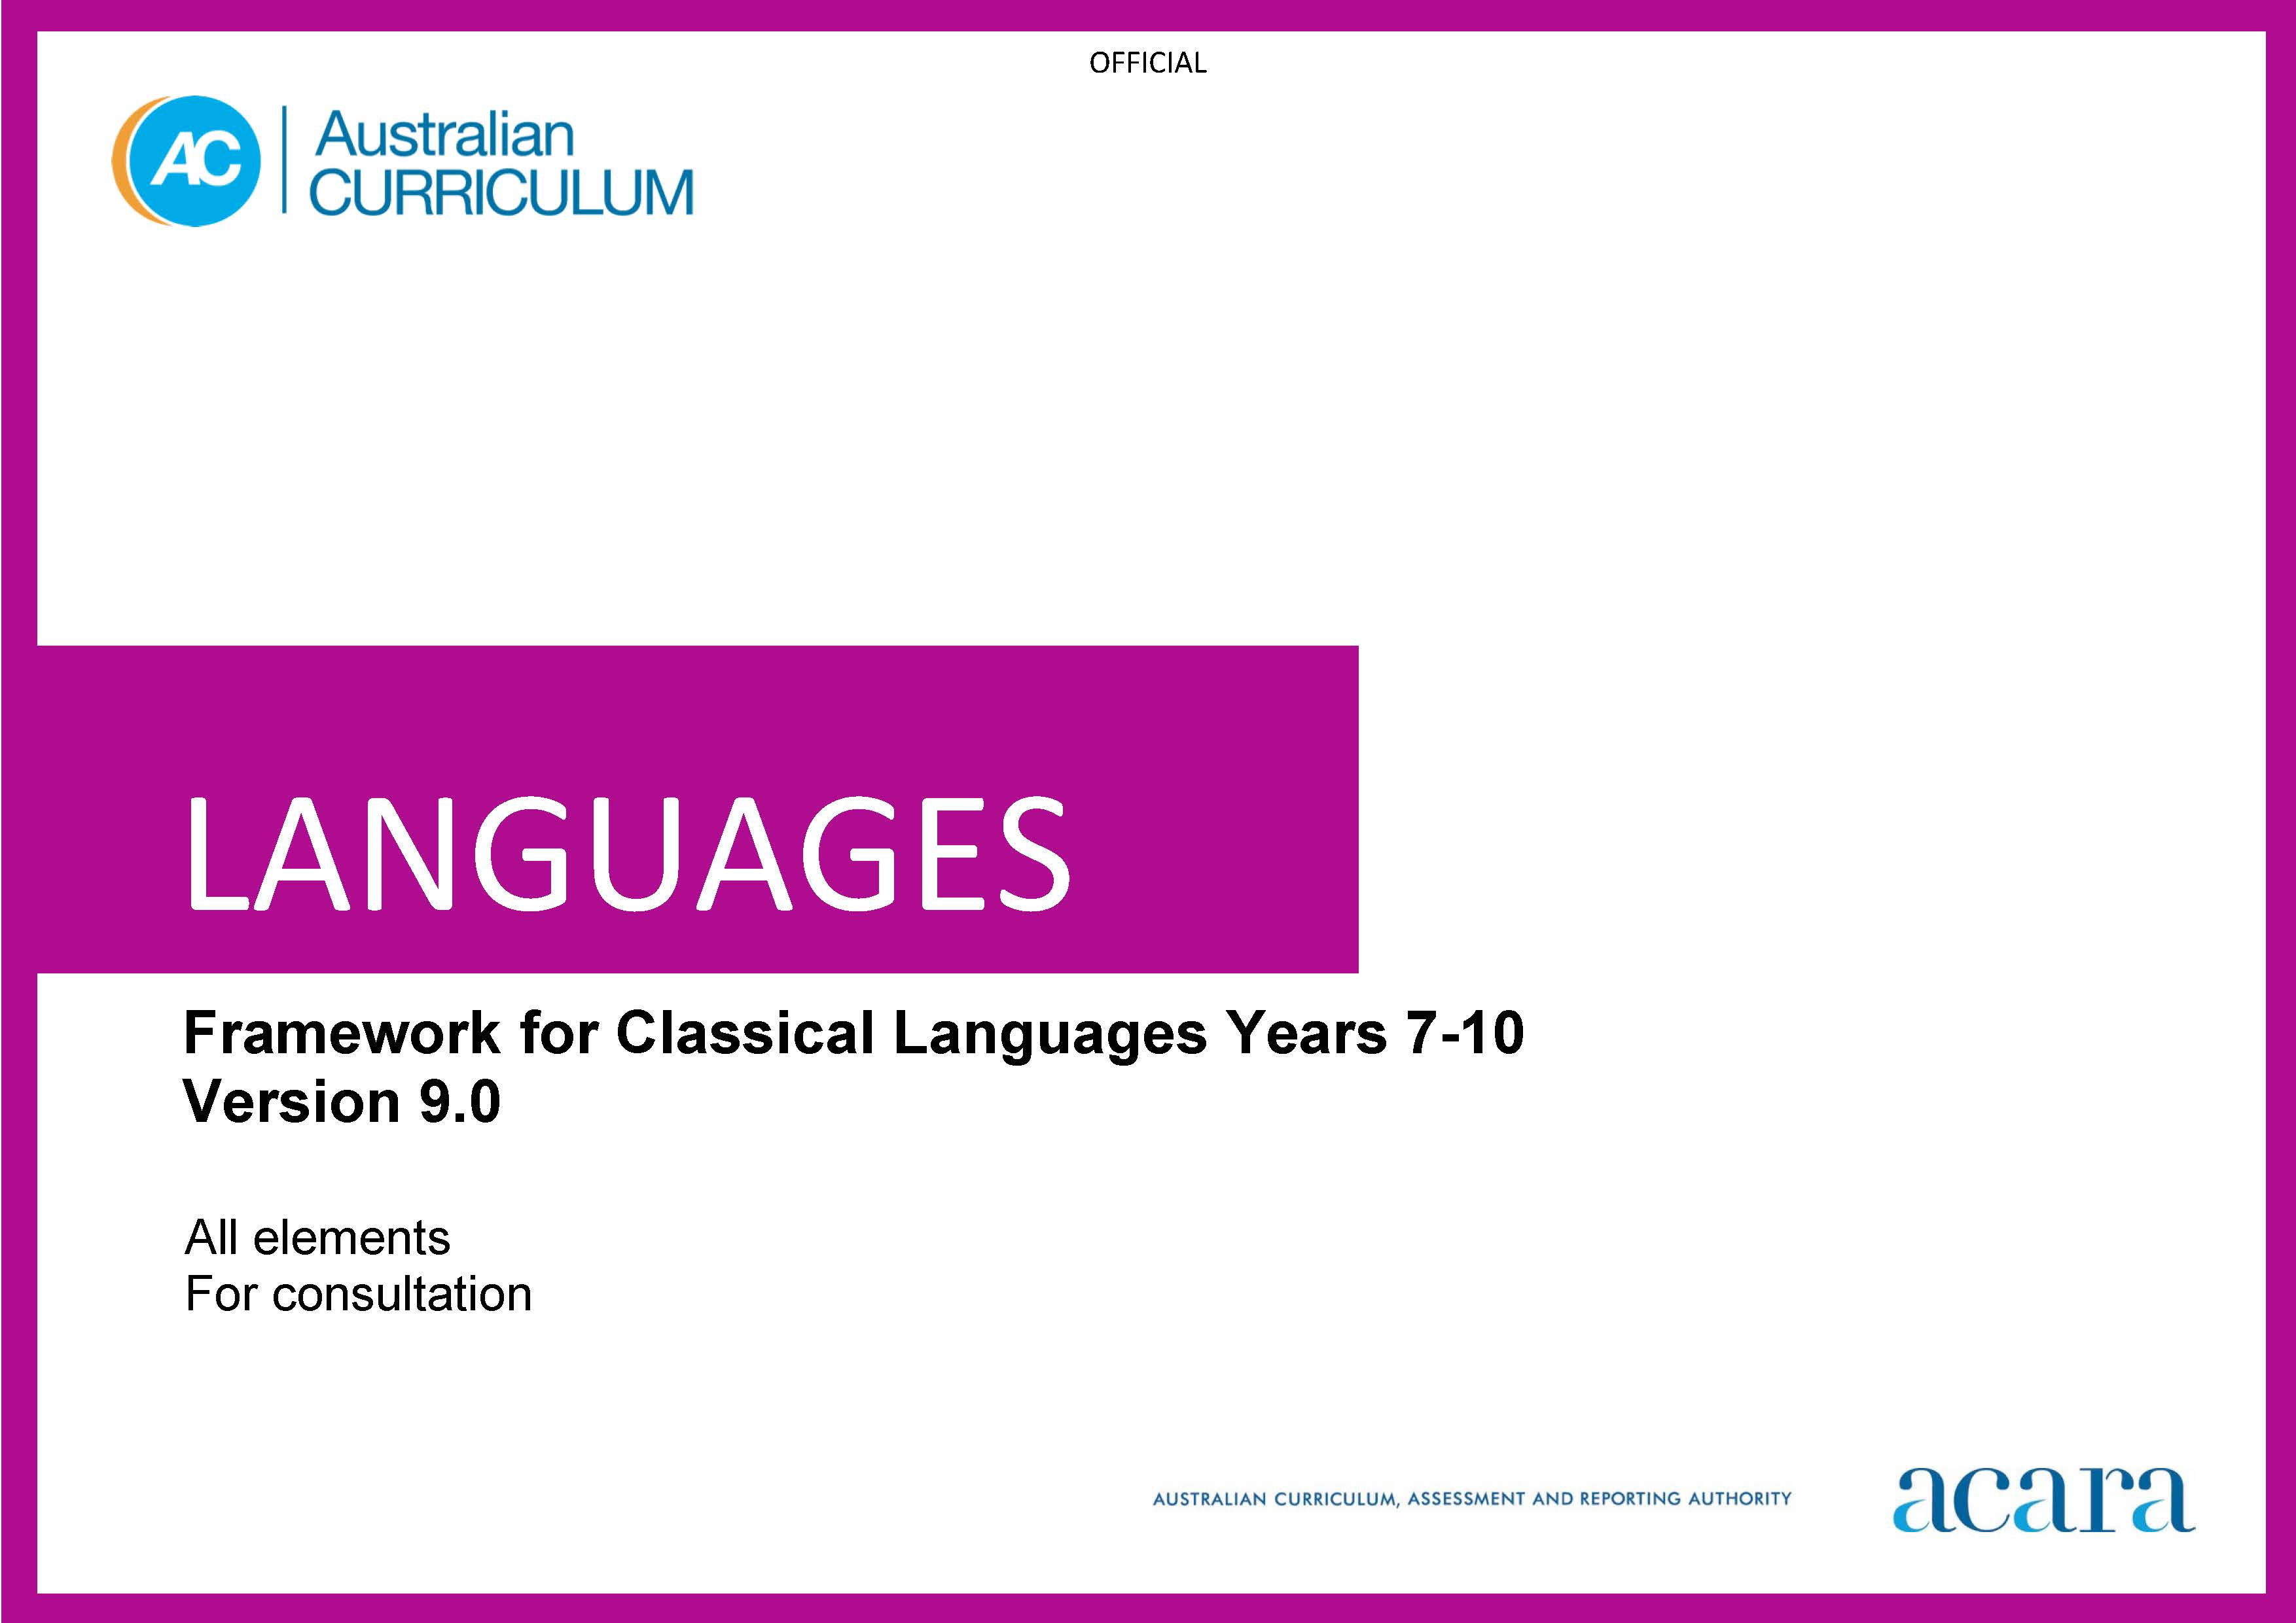

Copyright and Terms of Use Statement
© Australian Curriculum, Assessment and Reporting Authority 2023
The material published in this work is subject to copyright pursuant to the Copyright Act 1968 (Cth) and is owned by the Australian Curriculum, Assessment and Reporting Authority (ACARA) (except to the extent that copyright is held by another party, as indicated).
The viewing, downloading, displaying, printing, reproducing (such as by making photocopies) and distributing of these materials is permitted only to the extent permitted by, and is subject to the conditions imposed by, the terms and conditions of using the ACARA website (see, especially, clauses 2, 3 and 4 of those terms and conditions). The terms and conditions can be viewed at https://www.acara.edu.au/contact-us/copyright

TABLE OF CONTENTS
AUSTRALIAN CURRICULUM: LANGUAGES – FRAMEWORK FOR CLASSICAL LANGUAGES 3
ABOUT THE LEARNING AREA 3
Introduction 3
Rationale 3
Aims 4
Structure 4
Key considerations 7
Key connections 9
Resources 13
ABOUT THE FRAMEWORK FOR CLASSICAL LANGUAGES 14
Introduction 14
Rationale 14
Structure 14
CURRICULUM ELEMENTS 17
Years 7–8 (Year 7 entry) 17
Years 9–10 (Year 7 entry) 22

AUSTRALIAN CURRICULUM: LANGUAGES – FRAMEWORK FOR CLASSICAL LANGUAGES

ABOUT THE LEARNING AREA

Introduction
The Australian Curriculum: Languages has been developed to give all students the opportunity to engage in learning a language in addition to English. The design of the Languages curriculum recognises features that all languages share as well as the distinctiveness of each language.
Languages includes language-specific curricula for world languages and a Framework for Aboriginal Languages and Torres Strait Islander Languages.
Learners of languages in Australia comprise 3 major groups:
- Second-language learners: Second-language learners are introduced to learning the target language at school as an additional, new language. The first language used before they start school (and/or the language used at home) is not the language being learnt.
- Background-language learners: Background-language learners may use the language at home, not necessarily exclusively, and have varying degrees of knowledge of, and proficiency in, the language being learnt. These learners have a base for literacy development in the language.
- First-language learners: First-language learners are learners who use, and/or identify with, the language as their mother tongue; learners use the language for primary socialisation and/or education and/or literacy development.

Rationale
Communication is a human imperative. Irrespective of which language, communication involves interaction to convey meaning as well as imagination, creativity and a broad understanding of ourselves and others. Language learning provides the opportunity for students to engage with the linguistic and cultural diversity of the world and its peoples, and reflect on their experience in various aspects of social life, including their own participation and ways of being in the world.
Learning a language(s) broadens students’ horizons in relation to the personal, social, cultural and employment opportunities that an increasingly interconnected and interdependent world can offer. The interdependence of countries and communities means people in all spheres of life are required to negotiate experiences and meanings across languages and cultures. Despite its status as a world language, a capability solely in English can limit global opportunities. A bilingual or plurilingual capability is the norm in many parts of the world.
Learning language(s) develops learners’:
- communication skills
- literacy skills in their first and additional languages
- intercultural capabilities
- understanding of, and respect for, diversity and difference, and an openness to different experiences and perspectives
- understanding and appreciation of how culture shapes world views and extends their understanding of themselves, their own heritage, values, culture and identity
- critical and creative thinking.
Learning a language provides opportunities for the community to engage socially, culturally and economically in domains which include business, trade, science, law, education, tourism, diplomacy, international relations, health and communications.
For First Nations Australian students, learning their own languages is crucial to overall learning and achievement to develop a sense of identity and recognition, and understanding of language, culture, Country and Place. For all students, learning Aboriginal languages and Torres Strait Islander languages provides a distinctive means of understanding the country in which they live, including the relationship between land, the environment and people. Ongoing and necessary reclamation and revitalisation of these languages contribute to reconciliation.

Aims
The 3 interrelated aims of Languages are to develop knowledge, understanding and skills to ensure students:
- develop linguistic competence
- understand language and culture, and their relationship, and thereby develop an intercultural capability in communication
- understand themselves as communicators.

Structure
Languages is presented in 2 sequences that offer different entry points into language learning; from Foundation to Year 10 or Year 7 to Year 10.
The Foundation to Year 10 sequence is presented in bands of 2-year levels after the Foundation year. The Years 7 to 10 sequence is presented in bands of 2-year levels; Years 7 and 8, and Years 9 and 10.
Content in Languages is organised under 2 interrelated strands, each with a number of sub-strands. The strands and sub-strands are presented in Figure 1.
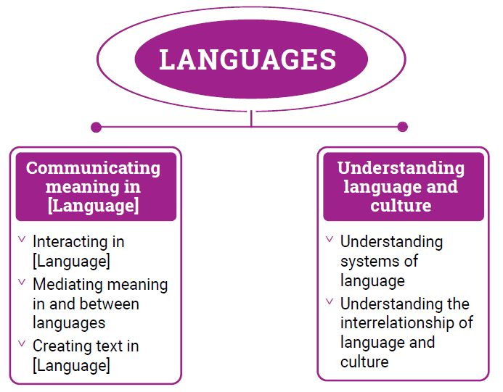
Figure 1: Languages content structure

Strand: Communicating meaning in [Language]
This involves students learning to use language for communicative purposes in interpreting, creating and exchanging meaning. There are 3 sub-strands.
Interacting in [Language]
Exchanging ideas, opinions, experiences, thoughts and feelings in non-verbal, spoken and written interactions; participating in planning, negotiating, deciding and taking action.
Mediating meaning in and between languages
Obtaining, processing, interpreting and conveying information through a range of spoken, written and multimodal texts; moving between languages and cultures non-verbally, orally and in writing, recognising different interpretations.
Creating text in [Language]
Creating a range of spoken, written and multimodal texts for specific contexts, purposes and audiences.
Strand: Understanding language and culture
This involves students learning to analyse and understand language and culture as resources for interpreting and shaping meaning in intercultural exchange. There are 2 sub-strands.
Understanding systems of language
Understanding the linguistic features of the language, including sound, writing, grammatical and textual conventions.
Understanding the interrelationship of language and culture
Analysing and reflecting on the role of language and culture in shaping meaning and identity.

Key considerations
Flexible entry points to F–10 and Years 7–10 sequences
Languages provides 2 learning sequences to cater for different entry points into language learning. The curriculum recognises that these 2 sequences do not necessarily represent the variety of entry points into the curriculum. Teachers can use the sequences flexibly to meet the needs of their students in their teaching and learning contexts.
Use of English
Students should use the target language to communicate whenever possible in classroom, local or digital environments. The use of English provides opportunities for students to reflect on, explore and discuss ideas, and use metalanguage to talk about and compare languages and cultures.
Macro skills
The macro skills of listening, speaking, reading, viewing and writing – also known as language modes – are interrelated. The learning of one often supports and extends the learning of others. To acknowledge these interrelationships, content in Languages incorporates these macro skills in an integrated and interdependent way.
Teaching and learning contexts will necessarily draw from more than one of these skills to support students’ effective learning. For example, students will learn new vocabulary, such as words, phrases and expressions, through listening, reading and viewing. They will apply their knowledge and understanding in their speaking and writing, as well as in their comprehension of spoken, visual, written and multimodal texts.
The macro skills are aligned most strongly to the Communicating meaning in [Language] strand, and are implicit in the content of the sub-strands and across the content descriptions, as shown in Table 1.
Table 1: The relationship between macro skills and the Communicating meaning in [Language] strand
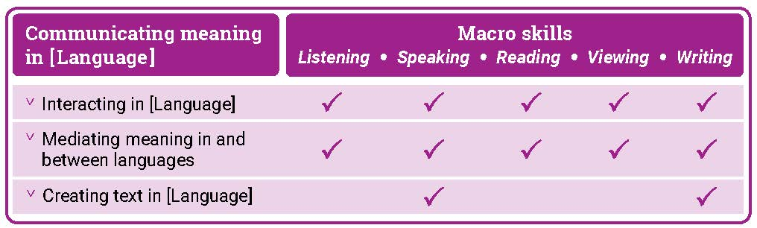

Texts
Texts can be spoken, written, visual, multimodal, and in print and digital/online forms. Multimodal texts combine language with other means of communication such as visual images and audio or spoken words in film or digital media. Texts include all forms of augmentative and alternative communication; for example, gesture, signing, real objects, photographs, pictographs and pictograms. Texts provide important opportunities for learning about aspects of students’ experiences of languages and cultures. Many of the tasks that students undertake in and out of school involve understanding and producing informative and imaginative texts in everyday and workplace contexts.
Teachers are best placed to guide the selection of materials for students to listen to, read, view, write and create. They provide purposeful activities that can be organised around these materials to meet the needs of the students in their classes.
Protocols for engaging First Nations Australians
When planning teaching activities involving engagement with First Nations Australians, teachers should follow protocols that describe principles, procedures and behaviours for recognising and respecting First Nations Australians and their intellectual property. Teachers should use approved resources such as those that may be provided by their state or territory school system, First Nations Australians education consultative groups or other protocols accredited by First Nations Australians.
While the Australian Curriculum uses the terms ‘First Nations Australians’ and ‘Australian First Nations Peoples’, there may be other terms that First Nations Australians of a particular area or location prefer. It is important to use the terms preferred in a particular area or location.
Meeting the needs of diverse learners
The Australian Curriculum values diversity by providing for multiple means of representation, action, expression and engagement, and allows schools the flexibility to respond to the diversity of learners within their community. All schools have a responsibility when implementing the Australian Curriculum to ensure that students’ learning is inclusive, and relevant to their experiences, abilities and talents.
For some students with diverse languages, cultures, abilities and talents it may be necessary to provide a range of curriculum adjustments so they can access age-equivalent content in Languages and participate in learning on the same basis as their peers.
The study of languages is important in the multilingual societies and the global economy in which we live. Students with diverse identities, languages, cultures, abilities and talents benefit from the study of languages when an appropriate learning environment is provided.
Languages is intended for all students, and it is recognised that some students may require adjustments to support how they see, hear, and/or process language. Students may require access to a wide range of approaches and resources including, and not limited to:
- multi-sensory visual, auditory, tactile, and/or kinesthetic experiences and resources
- simultaneous learning channels such as combinations of listening, speaking, reading, viewing and writing resources to teach a language concept
- resources such as picture cues for words or hand and mouth movements to illustrate a sound, or colour-coding to illustrate gender or subject/verb agreements
- modified equipment and tools
- multilingual labels, signs and posters around the classroom
- devices, mnemonics, rhythms and rhymes to reinforce vocabulary, expressions and features
- peer-assisted learning
- open-ended tasks that provide flexibility and can be completed at different levels of complexity
- challenging individual and group extension activities.

Key connections
General capabilities
General capabilities equip young Australians with the knowledge, skills, behaviours and dispositions to live and work successfully. General capabilities support and deepen student engagement with learning area content and are best developed within the context of learning areas.
Opportunities to develop general capabilities in learning area content vary. In addition to Literacy and Numeracy, which are fundamental to all learning areas, the general capabilities of most relevance and application to Languages are Intercultural Understanding, Critical and Creative Thinking, Personal and Social capability, and Digital Literacy. These general capabilities are identified in content descriptions when they are developed or applied through the Languages content. They are also identified in content elaborations when they offer opportunities to add depth and richness to student learning.
Literacy
Languages develops students’ ability to listen to, read, view, create, and perform a range of spoken, written and multimodal texts in the target language. It provides opportunities for students to move between the target language and English to analyse, interpret and reflect on texts. Students enhance and extend their knowledge and understanding of English literacy, and use their knowledge of English literacy to support their learning in the target language. They develop increasing fluency in the second or additional language. They also develop the ability to reflect on and discuss their understanding of language as a system, using the metalanguage of English.
Learning an additional language(s) and English is mutually beneficial to literacy development. This is reflected in the links between language learning and the National Literacy Learning Progression (NLLP) in Languages. Content is linked to the expected level of literacy development that students, typically, would have achieved at each year/band of years. For example, students in Year 8 are likely to be operating at Level 6 in the Speaking sub-element of the NLLP. These students may not be operating at Level 6 Speaking in a second or additional language(s). However, the teacher can make connections and draw on students’ English literacy skills to support their learning of the second or additional language(s).
Intercultural Understanding
The Intercultural Understanding capability is core to Languages. In learning a second or additional language, students develop an appreciation of languages, cultures and beliefs including their own. Students learn about the strong interrelationships between languages and cultures and how these shape identity. They develop and apply intercultural understanding to value and respect diverse ways of communicating, thinking and behaving. They recognise how these are reflected in social and cultural practices, and language use. Students develop connections with communities and cultures, become aware of similarities and differences, and cultivate mutual respect. The Intercultural Understanding capability assists students to navigate and reflect on language use, perspectives and behaviours.
Critical and Creative Thinking
Languages develops students’ ability to think logically, critically and creatively. It provides opportunities for students to inquire, generate, analyse and reflect on a range of information, ideas and perspectives in spoken and written texts. Students learn how to analyse texts and interpret how the language of texts conveys meaning. They reflect on the thinking and processes used to mediate meaning between languages. They apply their knowledge of language as a system to new contexts and learn to revise and modify texts when considering context, purpose and audience.
Personal and Social capability
Languages enhances students’ personal and social capability. Through the Communicating meaning in [Language] strand, students develop a range of interpersonal skills essential to effective communication, such as decision-making, negotiation, and collaboration. Content in both the Communicating meaning in [Language] and Understanding language and culture strands encourages students to develop an appreciation of diverse cultures and perspectives, and recognise how these influence identity, including their own.
Digital Literacy
Languages develops students’ digital literacy capability as they use a range of digital tools to access and create information, ideas and perspectives in multimodal texts. Students develop understanding of how they can use digital tools to access diverse language-speaking communities and authentic texts. They evaluate and analyse information in digital formats and develop understanding of their intended context, purpose and audience.

Numeracy
Languages develops students’ numeracy capability as they communicate in real or simulated real-life situations. Students use number in the target language to share information (time, directions, etc.) and understand how these might be represented in diverse languages and cultures. They use aspects of measurement in the language of transaction when using money, and units of measurement in the number, volume and weight of items. Students use number patterns and algebraic thinking when they recognise and apply the patterns of grammatical and syntactical rules to respond to and create text.
Cross-curriculum priorities
Cross-curriculum priorities support the Australian Curriculum to be a relevant, contemporary and engaging curriculum that reflects national, regional and global contexts. Cross-curriculum priorities are incorporated through learning area content; they are not separate learning areas or subjects. They provide opportunities to enrich the content of the learning areas, where most appropriate and authentic, allowing students to engage with and better understand their world.
Opportunities to apply cross-curriculum priorities to learning area content vary. All 3 cross-curriculum priorities have some relevance and meaning to the Languages curriculum.
Aboriginal and Torres Strait Islander Histories and Cultures
Languages recognises the interrelationship of languages and cultures. Languages together with the Aboriginal and Torres Strait Islander Histories and Cultures cross-curriculum priority enable students to develop knowledge and understanding by engaging students with the languages and cultures of First Nations Australians. Students can make interlinguistic and intercultural connections across languages with First Nations Australian languages and their cultural expression. They develop understanding of concepts related to the diverse linguistic landscape of Australia.
The Framework for Aboriginal Languages and Torres Strait Islander Languages provides opportunities for all students to learn languages of First Nations Australians. Each language is recognised as belonging to a group of people who are its custodians. Schools must seek advice and consent from the custodians when developing language-specific curricula and planning language programs.
Asia and Australia’s Engagement with Asia
Languages provides learning opportunities in combination with the Asia and Australia’s Engagement with Asia cross-curriculum priority. Students develop knowledge and understanding by engaging with the languages and cultures of Asia, and people of Asian heritage.
Languages enables students to learn languages of the Asian region and to communicate, interact and explore concepts, experiences and perspectives from within and across Asian cultures. Students develop an appreciation for the place of Australia within the Asian region, including the interconnections of languages and cultures, peoples and communities, and histories and economies. They learn how national linguistic and cultural identities continuously evolve in local, regional and international contexts.
Sustainability
Languages provides students with opportunities to develop the world views necessary to contribute to a sustainable future by reflecting on how they interpret and engage with the world and its peoples. The learning contexts in which students develop their language learning provide opportunities for them to explore actions to improve sustainability in local, national and global communities.
When learning a second or additional language, students develop understanding of diverse attitudes, beliefs and values, and ways of thinking and being. They learn that sustainability is relevant to the dynamic nature of language and its continuous changes and variations over time and place. They develop understanding that sometimes, due to globalisation, societal and political influences, languages may become vulnerable and at risk of losing their uniqueness or usage. Students consider the value of sustaining language knowledge and use, and reflect on its important connection to cultural expression.
Learning areas
Languages provides opportunities to integrate and connect content to other learning areas; in particular, English, Humanities and Social Sciences and The Arts.
Languages and English
Languages and English support students’ literacy development. Both learning areas share the focus for students to interact with others and create spoken, written and multimodal texts with an awareness of context, purpose and audience. Languages and English help students to understand the relationship between spoken and written language and recognise how cultural context shapes meaning. They develop students’ understanding of, and ability to use, grammatical and language features.
Languages and Humanities and Social Sciences
Languages and Humanities and Social Sciences subjects share learning contexts that progressively shape the students’ world. In both learning areas, students’ learning involves perspectives of their personal worlds, such as personal and family histories and events, their local communities, and national and global contexts. In the process of understanding an expanding world view, both learning areas help students to learn to reflect on the relationship between cultures and identities.
Languages and The Arts
Languages and The Arts share a focus on the communication of stories, ideas, perspectives and cultures. Both learning areas help students to explore relationships among people, cultures and identities, and recognise how these are exemplified in and through linguistic and artistic practices and behaviours.

Resources
A scope and sequence representation of the curriculum, the glossary, and comparative information about Version 8.4 and Version 9 are available as a download from the Australian Curriculum Version 9 website.
Language support resource
Each language curriculum has an optional support resource, developed to support teachers as they plan teaching and learning programs. This resource provides suggestions for sequential development in language structures and features, and thematic contexts for language use. Teachers can use suggestions in the resource to adapt curriculum content to meet the diverse language needs and learning backgrounds of students at different entry points into second language learning. These documents are available as downloads.

ABOUT THE FRAMEWORK FOR CLASSICAL LANGUAGES
This framework may be used to develop Classical Language-specific curricula for Classical Languages other than Classical Greek and Latin, such as Classical Chinese, Classical Hebrew and Sanskrit.

Introduction
The Australian Curriculum: [Classical languages] is pitched to second language learners in Years 7-10, that is, the dominant structure and sequence of learning in the current Australian context. For most students it is their first experience of learning [Classical language].

Rationale
[Classical Language] was the official language of ancient [country/city]. Curriculum writers should indicate period of time, spread and influence of [Classical language]; and indicate the significance of [Classical language] and ancient [country/city] in and of its time, and influences in modern times.

[Classical language] has been taught in Australian universities and schools since .... Curriculum writers should indicate history of teaching and learning in Australia. By accessing and translating texts and engaging with artefacts, students make connections with ancient worlds that have shaped contemporary life and societies. Learning [Classical language] enhances students’ understanding and knowledge of… Curriculum writers should indicate significance of [Classical language] to English and/or other languages; and promotes understanding of diverse languages, cultures, attitudes, beliefs, values and traditions.

Structure
[Classical language] has been developed as a Second Language Learner Pathway which caters for students learning [Classical language] as a second or additional language in Years 7-10.

The Second Language Learner Pathway includes one sequence:
- Years 7 to 10.

Teachers use the curriculum to cater for learners of different backgrounds by making appropriate adjustments to differentiate learning experiences.

Content in [Classical language] is organised under 2 interrelated strands, each with a number of sub-strands. The strands and sub-strands are presented in Figure 2.

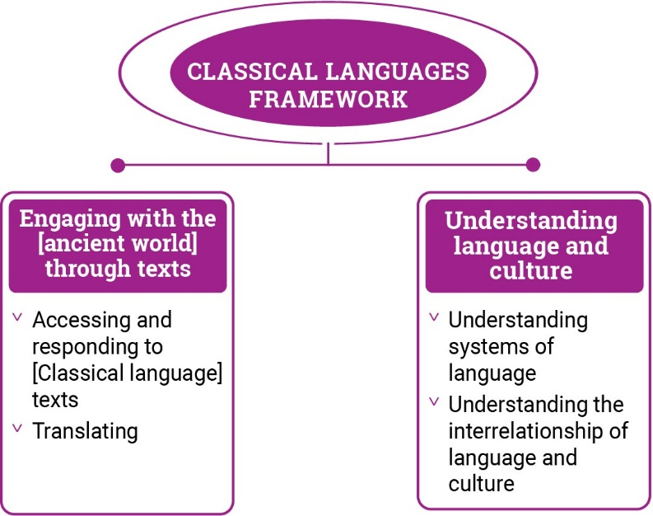
Figure 2: Classical Languages framework content structure

Strand: Engaging with the [ancient world] through texts
This involves students engaging with the language, culture and history of the ancient [country/city] world through the interpretation, analysis and translation of [Classical language] texts. There are 2 sub-strands.

Accessing and responding to [Classical language] texts
Engaging with and responding to people and ideas in the ancient world through texts that reveal language use and social and cultural practices

Translating
Translating [Classical language] texts into English, comparing and explaining different interpretations of the same text

Strand: Understanding language and culture
This involves students learning to analyse language and culture as resources for understanding meaning. There are 2 sub-strands.

Understanding systems of language
Understanding the linguistic features of [Classical language], including sound, writing, grammatical and textual conventions.

Understanding the interrelationship of language and culture
Analysing and reflecting on the role of language and culture in shaping meaning and identity.

CURRICULUM ELEMENTS

Years 7–8 (Year 7 entry)
Band level description
In Years 7 and 8, students are beginning their learning of [Classical language], and this will be influenced by prior learning and experiences of language learning. They access a range of texts in [Classical language] and English to understand and explore the ancient [country/city] world. They interact and collaborate with teachers and peers when engaged in activities involving listening, reading aloud, reading, viewing, translating and writing, supported by modelling, scaffolding and feedback. They access authentic and purpose-developed artefacts, spoken, written and multimodal resources which may include cartoons, stories, video clips, textbooks, and modified or authentic extracts of literature.

Students use their English literacy knowledge of metalanguage to reflect on similarities and differences between [Classical language] and English vocabulary, pronunciation, grammatical structures and features. They comment on the impact of ancient [country/city] culture on the modern world today. They recognise that language reflects social and cultural identity, beliefs and values.
Achievement standard
By the end of Year 8, students use their knowledge of [Classical language] language to interpret texts, and respond to information about ancient [country/city] society. They develop strategies to translate [Classical language] texts into English, identifying familiar vocabulary, language structures and features to interpret meaning.
Students apply [Classical language] sound–script relationships and use restored pronunciation when reading aloud. They demonstrate understanding that [Classical language] has conventions and rules for spoken and written communication. They understand that [Classical language] has influenced English vocabulary and comment on language structures and features, using metalanguage. They demonstrate awareness that language, texts and artefacts from Ancient [Country/City] are connected with culture and identity, and explore the relationship between language(s), culture(s) and identity.

Strand: Engaging with the ancient [country/city] world through texts |  | Years 7–8 (Year 7 entry)
Sub-strand: Accessing and responding to [Classical language] texts
Content descriptions  Students learn to: | Content elaborations  This may involve students:
access and interpret [Classical language] texts to explore the ancient [country/city] world  ACL9LCLF8E01 | - reading [Classical language] texts and examining artefacts to learn about ancient [country/city] daily life, for example, the family, daily routines, food, occupations, schooling, public entertainment and ceremonies, politics, and leisure pursuits  - researching the purpose and function of spaces in an ancient [country/city] home, for example,  - examining artefacts from the Ancient [country/city] to see what they reveal about the everyday lives of ancient [country/city] people  - exploring the importance of storytelling in capturing language, heritage and history and recognising that stories connect societies across time and place (FN CCP)  - reading historical accounts and interpreting the information about significant events in ancient [country/city] history  - gathering information from texts about [country/city] religious beliefs and practices
respond to texts and convey information in English or [Classical language] as appropriate  ACL9LCLF8E02 | - gathering, collating information about daily routine in the ancient [country/city] world such as about family life, education, food, hygiene, exercise, and presenting in posters or digital displays with annotations in English or words and simple phrases in [Classical language]  - researching artefacts and explaining what they tell us about daily life and cultural practices in Ancient [Country/City]  - reading accounts of historical events and presenting information in new ways, for example, as a news report  - researching language that reveals information about ancient [country/city] government and administration,  - discussing how characters and plot in [Classical language] texts are used to create humour, suspense and other effects on the audience, for example, the use of comic episodes, plot twists  - discussing influence of ancient [ country/city] culture on modern novels, poetry, drama and film and creating a visual display highlighting significant elements
Sub-strand: Translating
develop and apply strategies to interpret and translate [Classical language] texts to convey meaning in English  ACL9LCLF8E03 | - considering multiple meanings of vocabulary by using dictionaries and electronic translation tools, and making appropriate selections according to context  - listening to simple sentences in [Classical language] and using aural cues to infer meaning, such as tone, inflection, emphasis and signpost words  - using known vocabulary, in [Classical language] or English, and context to deduce the meaning of unknown words  - exploring the effect of using the variety of English translations for verb tenses  - determining the general sense of texts through initial holistic reading, by identifying familiar people, vocabulary, places or topics, contextualising new vocabulary  - collaborating with peers to edit joint translations and to compare and discuss the merits of different translations of the same text

Strand: Understanding language and culture |  | Years 7–8 (Year 7 entry)
Sub-strand: Understanding systems of language
Content descriptions  Students learn to: | Content elaborations  This may involve students:
understand and begin to apply the phonological and orthographic systems of [Classical language]  ACL9LCLF8U01 | - learning the [Classical language] alphabet and/or script and match letters or script to sound  - listening to and reproducing familiar and unfamiliar words, phrases and simple texts in [Classical language]  - using the spoken stress of [Classical language], and dramatic expression appropriate to the tone and purpose of a text  - writing simple sentences in {Classical language] to consolidate knowledge of script  - listening to and reproducing familiar and unfamiliar words and phrases and reciting simple texts in [Classical language] to convey meaning, using restored pronunciation and appropriate phrasing and expression  - reading aloud or reciting, individually or in a class group, for example, performing a short play in [Classical language]
develop knowledge of the vocabulary, and structures and features of [Classical language] grammatical systems to understand, translate and respond to texts  ACL9LCF8U02 | - identifying parts of speech, such as, nouns, verbs, adjectives and adverbs and their functions in texts to determine meaning  - identifying endings of irregular verbs in different tenses and forms  - recognising the comparative and superlative degrees of regular adjectives and adverbs  - exploring the concepts of verb number, person and tense and identifying the endings of regular verbs in different persons and tenses,  - recognising prepositional phrases including different forms and meanings  - using [Classical language] word order to deduce meaning in texts and interpreting compound sentences using conjunctions
compare [Classical language] vocabulary, language features and structures with English, using metalanguage  ACL9LCLF8U03 | - understanding conventions of word order and how they may be different in [Classical language] and English  - using terms relating to parts of speech to compare basic sentence structures in [Classical language] and English  - identifying and using [Classical language] derivatives to expand English vocabulary  - identifying and collecting word families in which the same [Classical language] root is used with different prefixes or suffixes  - understanding that one [Classical language] word may correspond to several different English words, and selecting the most appropriate meaning of a word in its context  - exploring how use of language techniques in narratives such as exclamation, repetition, alliteration, onomatopoeia can encourage the audience to respond in particular ways in both [Classical language] and English,

Sub-strand: Understanding the interrelationship of language and culture
recognise that language, texts and artefacts provide insights into culture and identity  ACL9LCLF8U04 | - locating the ancient [Country/city] empire and places where [Classical language] was spoken on a map and considering how cultural diversity has continued to be an integral feature of society since ancient times  - exploring language use that reflects social structures and discussing what these may reveal about cultural attitudes in Ancient [Country/City]  - exploring mottoes and inscriptions and discussing their relevance in expressing belonging and/or identity in both the ancient and modern world  - exploring First Nations Australians material culture such as instruments, jewellery, music, art, painting and dance and recognising how they provide insights into beliefs, cultural practices and social values (FN CCP)  - considering how learning about the ancient world through texts and artefacts offers different ways of interpreting the modern world  - reflecting on how learning [Classical language] provides insights into the relationship between language and culture, and how this may have influenced way of thinking about own language(s), culture(s) and identity

Years 9–10 (Year 7 entry)
Band level description
In Years 9 and 10, [Classical language] language learning builds on each student’s prior learning and experiences. They access and translate a range of texts in [Classical language] and English to interpret and analyse the society and culture of Ancient [country/city]. They communicate their ideas and opinions about the ancient world. They continue to receive guidance, modelling, feedback and support from peers and teachers. They use authentic and purpose-developed resources and artefacts, and a range of spoken, written and multimodal texts which may include extracts from authentic literature, textbooks, audio and video clips, magazines, online and print articles.
Students use metalanguage to analyse structures and features of [Classical language] and explain the influence on English. They evaluate the impact of ancient [Classical] culture on the modern world today. They reflect on how language and social and cultural identity can shape behaviours, beliefs and values.
Achievement standard
By the end of Year 10, students use their knowledge of [Classical language] to interpret and analyse information about ancient [country/city] society and culture. They apply strategies to translate and interpret [Classical language] texts into English and demonstrate understanding of how language conveys cultural meaning.
Students apply [Classical language] sound–script relationships, using restored pronunciation, when reading aloud. They select and apply [Classical language] grammatical conventions and rules when translating and responding to texts. They explain how [Classical language] has influenced English vocabulary and analyse language structures and features, using metalanguage. They demonstrate understanding that the language, texts and artefacts from Ancient [Country/City] are connected with culture and identity and reflect on the interrelationship of language(s), culture(s) and identity.

Strand: Engaging with the ancient [country/city] world through texts |  | Years 9–10 (Year 7 entry)
Sub-strand: Accessing and responding to [Classical language] texts
Content descriptions  Students learn to: | Content elaborations  This may involve students:
interpret [Classical language] texts to analyse the society and culture of the ancient [country/city] world  ACL9LCLF10E01 | - examining how cultural attitudes are conveyed in [Classical language] texts such as attitudes to civil rights, women etc and compare these with modern social issues  - reading extracts from original [Classical language] texts and analysing how they convey the attitudes of ancient [country/city] society  - researching architectural remains of Ancient [Country/City] through the study of an archaeological site and discussing what they reveal about the values and attitudes of the ancient [people]  - investigating the importance of storytelling in capturing language, heritage and history and discussing how stories connect societies across time and place (FN CCP)  - researching the influence of leading intellectuals. politicians or orators from Ancient [Country/City]  - exploring the ancient origins of modern structures and concepts, for example, social classes, property rights and divorce
respond to texts and discuss ideas about ancient [country/city] society in English or [Classical language] as appropriate  ACL9LCLF10E02 | 1. reading texts in [Classical language] and responding to questions in English to demonstrate understanding of content, context, purpose and technique  2. gathering and collating information about ancient [country/city] art, including sculpture, jewellery and painting, and producing an online exhibition catalogue  3. researching inscriptions or graffiti and analysing what they reveal about the society of Ancient [Country/City]  4. evaluating the effectiveness of texts, by considering the use of techniques, for example, simile, metaphor, personification or pathos, for particular purposes, such as to entertain or persuade  5. exploring how language is used to reveal character, key messages, purpose and values in texts such as narratives, plays and poems, for example, by performing [Classical language] plays, or creating theatrical interpretations of [Classical language] stories  6. reading a text in [Classical language] and analysing plot, characters, themes and use of literary features
Sub-strand: Translating
apply strategies to interpret and translate [Classical language] texts to convey meaning and demonstrate understanding of context, purpose and audience  ACL9LCLF10E03 | - exploring print and online [Classical language] and English dictionaries and thesauruses to consider a variety of meanings and synonyms and to investigate how vocabulary choices in [Classical language] and English can express shades of meaning  - deducing the meaning of new words by drawing on prior knowledge, derivatives and connections with familiar words  - predicting the context and content of [Classical language] texts through initial holistic reading, by identifying key words and phrases  - constructing, editing and refining translations collaboratively with peers, using a range of digital tools and software, justifying opinions for the selection of specific words and phrases  - conveying the meaning of idiomatic expressions, culture specific vocabulary and shades of meaning, differentiating between the different connotations of a word in a particular context  - evaluating the effectiveness of translations of the same or different texts, using criteria such as selection of appropriate vocabulary, grammatical accuracy, fluency, coherence, clarity, idiomatic expression

Strand: Understanding language and culture |  | Years 9–10 (Year 7 entry)
Sub-strand: Understanding systems of language
Content descriptions  Students learn to: | Content elaborations  This may involve students:
apply the phonological and orthographic systems of [Classical language] in a range of contexts  ACL9LCLF10U01 | - applying knowledge of the phonological systems of [Classical language] to read aloud  - reciting or presenting extracts from [Classical language] texts, using expression to convey meaning, tone and emphasis  - reading aloud extracts from different genres of [Classical language] literature with appropriate expression  - understanding the writing conventions for original [Classical language] text, inscriptions etc  - discussing conventions of [Classical language] texts, such as metre in poetry etc  - understanding the writing conventions for original [Classical language] text, inscriptions etc
select and use vocabulary, grammatical structures and linguistic features of [Classical language] to interpret, translate, and respond to texts  ACL9LCLF10U02 | - applying understanding of parts of speech such as nouns, verbs, adjectives and adverbs and their functions in texts to determine meaning  - applying expanded knowledge of vocabulary, grammar and problem-solving skills to translate compound sentences and complex sentences with nested clauses  - using common irregular verbs  - using different forms of verbs such as principal parts, infinitives, participles, gerunds etc  - understanding the range of subordinate clauses used in complex sentences to convey sophisticated ideas  - applying knowledge of the comparative and superlative degrees of common irregular adjectives and adverbs
explain how [Classical language] vocabulary, structures and features extend understanding of English, using metalanguage  ACL9LCLF10U03 | - recognising connections between grammatical structures and features in [Classical language] and English and applying knowledge to extend grammatical understanding of the English language,  - reflecting on the particular use of tenses in [Classical language] and making comparisons with English  - identifyng [Classical language] roots in English medical. scientific, technical, legal and academic terminology  - explaining how in both [Classical language] and English, the coherence of complex texts relies on devices that signal text structure and guide readers  - analysing language features in [Classical language] and English used to influence the intended audience, such as imagery, rhetorical devices  - investigating and explaining the effect of word order in [Classical language] and English in producing emphasis and tone, for example, indignation, anger, suspense
Sub-strand: Understanding the interrelationship of language and culture
reflect on and explain how language, texts and artefacts provide understanding of culture and identity  ACL9LCLF10U04 | - recognising that [Classical language] was the form of the language used by significant ancient [country/city] authors in texts in which they expressed attitudes, beliefs and values of the time  - considering how cultural diversity has continued to be an integral feature of society since ancient times  - discussing the enduring use of [Classical language] in some religious contexts in the contemporary world  - investigating First Nations Australians material culture such as instruments, jewellery, music, art, painting and dance and discussing how they provide an understanding of beliefs, cultural practices and social values (FN CCP)  - analysing cultural attitudes and values embedded in language and symbols and making comparisons to their own language and culture  - investigating how language, texts and artefacts provide a means of understanding the social values, attitudes and cultural practices of the ancient [people] and making links and comparisons to their own language(s) and culture(s)

