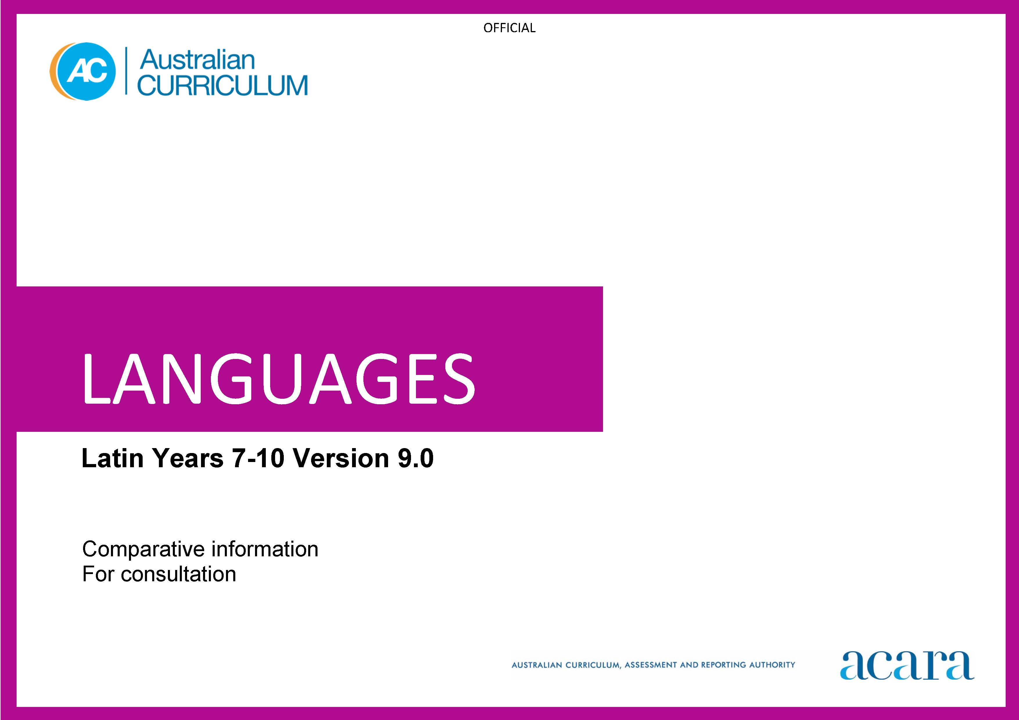

Copyright and Terms of Use Statement
© Australian Curriculum, Assessment and Reporting Authority 2023
The material published in this work is subject to copyright pursuant to the Copyright Act 1968 (Cth) and is owned by the Australian Curriculum, Assessment and Reporting Authority (ACARA) (except to the extent that copyright is held by another party, as indicated).
The viewing, downloading, displaying, printing, reproducing (such as by making photocopies) and distributing of these materials is permitted only to the extent permitted by, and is subject to the conditions imposed by, the terms and conditions of using the ACARA website (see, especially, clauses 2, 3 and 4 of those terms and conditions). The terms and conditions can be viewed at https://www.acara.edu.au/contact-us/copyright
LATIN
Years 7–8 (Year 7 entry)
Achievement standard
Version 9.0 | Version 8.4
By the end of Year 8, students use their knowledge of Latin language to interpret texts, and respond to information about ancient Roman society. They develop strategies to translate Latin texts into English, identifying familiar vocabulary, language structures and features to interpret meaning.  Students apply Latin sound–script relationships and use restored pronunciation when reading aloud. They demonstrate understanding that Latin has conventions and rules for spoken and written communication. They understand that Latin has influenced English vocabulary and comment on language structures and features, using metalanguage. They demonstrate awareness that language, texts and artefacts from Ancient Rome are connected with culture and identity, and explore the relationship between language(s), culture(s) and identity. | By the end of Year 8, students use their knowledge of vocabulary, grammar and textual cues to identify and interpret information in Latin texts, such as narratives, about the daily life and attitudes of the Romans. They interpret grammatical structures such as inflected forms; identify linguistic features such as striking word choice, for example, laetissimus, or use of imagery, for example, dies est calidus; frigidus est rivus; infer meaning from textual cues such as headings, images or maps; and describe social and cultural practices embedded in Latin text, such as puer patrem timet. They convey information and ideas about Roman society and culture, in oral, written or digital forms, using Latin as appropriate, for example, a news report in English about a historical event such as the assassination of Julius Caesar, or a digital poster about family life in Rome with annotations in Latin, such as a mother instructing her daughter about how to organise the slaves and manage the household. They share their responses to Latin texts, such as stories, myths and plays, by expressing their feelings and ideas about characters, events, actions, settings and themes. They read aloud or recite Latin texts, such as stories, dialogues or songs, or perform Latin texts, such as short plays, to entertain an audience, conveying meaning effectively by using appropriate phrasing and voice inflection. Students translate Latin texts accurately into Standard English, applying their knowledge of vocabulary, including roots and derivatives, linguistic cues, culture, and accidence and syntax, including number, gender and case of nouns, for example, in first, second and third declensions, agreement of nouns and adjectives, for example, mater nostra, conjugation and tense, such as regular and irregular verbs in the present tense, for example, audit; potest, and indicative active voice and imperative active mood, for example, paratis, parate!, and conventions of sentence structure. They explain the relative effectiveness of different translations of the same text, and identify the features of a successful translation.  Students identify Latin sound–script relationships and use restored pronunciation when reading aloud, such as for single consonants, long and short vowels, diphthongs, double consonants and consonant clusters, for example, in aestate, puella, observare. They identify the structure and features of different texts in Latin, such as narratives or short plays, and explain how these elements contribute to an audience's response to the text. They describe how the Latin language spread with the expansion of the Roman empire, and developed over time into its modern descendants, the Romance languages. They explain how Latin has influenced and continues to influence English vocabulary, by identifying derivatives such as ‘itinerary’ from Latin iter, and Latin words and expressions that are used in modern English, such as et cetera. Students give examples of how particular language use reflects the lifestyles, ideas, feelings and attitudes of Romans in the Classical period, and identify connections between ancient and modern customs, religion, literature and architecture. They share their reactions to and assumptions about the language and culture of Roman society, identifying similarities or differences to their own language and culture. They describe how learning Latin impacts on their approaches to learning and on their understanding of their own heritage, values and culture.

Content descriptions
Version 9.0 Strand: Engaging with the ancient Roman world through texts
Version 9.0 | Action taken | Version 8.4
Version 9.0 Sub-strand: Accessing and responding to Latin texts
access and interpret Latin texts to explore the ancient Roman world  ACL9LL8E01 | Combined  Refined | Read, comprehend and discuss Latin texts, using vocabulary, grammar and textual cues, to explore the Roman world  ACLCLE031  Listen to and read Latin texts, such as stories, myths and plays; share reactions and make connections with characters, events, actions, settings and key emotions  ACLCLE033
 | Removed | identify the structure and features of a range of texts in Latin, such as narratives and short plays  ACLCLU040
respond to texts and convey information in English or Latin as appropriate  ACL9LL8E02 | Refined | Convey information and ideas about the daily life and attitudes of the Romans, in oral, written and digital forms, using Latin as appropriate  ACLCLE032
Version 9.0 Sub-strand: Translating
develop and apply strategies to interpret and translate Latin texts to convey meaning in English  ACL9LL8E03 | Combined  Refined | Translate Latin texts into Standard English, by applying knowledge of vocabulary, accidence and syntax, and linguistic and cultural cues  ACLCLE035  Compare different translations and interpretations of Latin texts, and identify features of successful translations  ACLCLE036

Version 9.0 Strand: Understanding language and culture
Version 9.0 | Action taken | Version 8.4
Version 9.0 Sub-strand: Understanding systems of language
understand and begin to apply the phonological and orthographic systems of Latin  ACL9LL8U01 | Combined  Refined  Split | Understand the phonological systems of Latin, including the restored pronunciation  ACLCLU037  Read aloud, recite or perform Latin texts, using phrasing and voice inflection to convey meaning and to entertain others  ACLCLE034
develop knowledge of the vocabulary, and structures and features of Latin grammatical systems to understand, translate and respond to texts  ACL9LL8U02 | Combined  Refined  Split | Understand the orthographic systems of Latin, including the written alphabet  ACLCLU037  Understand concepts of accidence and syntax used in simple and compound Latin sentences, including parts of speech, case, gender, number, person, declension and conjugation, agreement and tense, and conventions of sentence structure  ACLCLU038  Acquire and build vocabulary by using roots, derivatives and word lists, and use dictionaries to select appropriate meanings of Latin words  ACLCLU039
compare Latin vocabulary, language features and structures with English, using metalanguage  ACL9LL8U03 | New
Version 9.0 Sub-strand: Understanding the interrelationship of language and culture
recognise that language, texts and artefacts provide insights into culture and identity  ACL9LL8U04 |  | Examine the enduring influence of Roman culture on the modern world, by discussing the ancient origins of modern customs, religion, literature and architecture  ACLCLU042  Recognise that the language of the Romans provides insights into their daily lives, ideas, feelings and attitudes  ACLCLU043
 | Removed | Understand that Latin spread with the expansion of the Roman empire, developed over time into the Romance languages, and influenced English vocabulary  ACLCLU041
 | Removed | Reflect on own and others’ reactions to and assumptions about the language and culture of Roman society, considering similarities and differences to own language and culture  ACLCLU044
 | Removed | Reflect on self as a language learner, considering how learning Latin influences ways of learning and enhances understanding of own heritage, values and culture  ACLCLU045

Years 9–10 (Year 7 entry)
Achievement standard
Version 9.0 | Version 8.4
By the end of Year 10, students use their knowledge of Latin to interpret and analyse information about ancient Roman society and culture. They apply strategies to translate and interpret Latin texts into English and demonstrate understanding of how language conveys cultural meaning.  Students apply Latin sound–script relationships, using restored pronunciation, when reading aloud. They select and apply Latin grammatical conventions and rules when translating and responding to texts. They explain how Latin has influenced English vocabulary and analyse language structures and features, using metalanguage. They demonstrate understanding that the language, texts and artefacts from Ancient Rome are connected with culture and identity and reflect on the interrelationship of language(s), culture(s) and identity. | By the end of Year 10, students analyse a range of Latin texts to obtain information and ideas about Roman society and culture. They use vocabulary, grammar and textual cues to analyse and interpret language use and cultural references in Latin texts, such as poetry, letters or narratives, for example, by deducing the meaning of complex sentence structures, such as those with subordinate clauses or indirect speech; and explaining the impact of word order on emphasis and tone, for example, dum homines cibum devorant, subito intravit miles! and implicit values, concepts and assumptions embedded in language use, for example, arbiter bibendi. They convey their interpretations of information and ideas about Roman society and culture, in oral, written or digital forms, such as an investigation into Roman reactions to different religions, or a digital presentation on an archaeological site, for example, the forum Romanum. They share their responses to Latin texts, such as narratives, dialogues, plays, poems or letters, by describing themes, values and literary features, such as plot development and characterisation, and expressing and justifying their opinions with support from the text. They read aloud, recite or perform Latin texts, such as oratory, history, drama or poetry, to entertain different audiences, conveying meaning and emotion effectively by using appropriate phrasing, voice inflection or metrical effects, such as elision. Students translate a range of texts that incorporate complex sentence structures and extensive vocabulary, from Latin into Standard English that represents the style and purpose of the texts, applying their knowledge of roots and derivatives to infer the meaning of unfamiliar vocabulary, and using dictionaries to select the appropriate meaning of words. They analyse how the language is used in grammatically complex sentences, that include subordinate clauses, non-finite verb forms, pronoun forms, mood and voice, for example, by identifying case usage of nouns and pronouns, and all verb conjugations and tenses, including indicative, for example, quamquam dominus abest, necesse est nobis strenue laborare, and imperative moods, for example, noli dominum excitare!, and passive voice, for example, ab agricolis nihil agitur. They evaluate the effectiveness of different translations of the same Latin text, and identify strategies for successful translations.  Students apply the principles of pronunciation for the reading of Latin texts, for example, by stressing the correct syllables. They identify the structure and organisation of different text types in Latin, such as prose and verse, and explain how they relate to context, purpose and audience. They explain the role of Latin in facilitating the spread of Roman civilisation and culture during the expansion of the Roman empire, and the contribution of Latin to the enrichment of English through the transfer of specialist vocabulary, for example, sine qua non, abstract concepts, for example, an accused person’s right to a defence, and the coining of vocabulary for new technology and new discoveries, for example, digicam from digitus + camera. Students describe Roman values, attitudes and beliefs that are embedded in particular language use, such as pietas, virtus, hospitium, fides. They explain how the Roman world has influenced modern society, culture and political structures, such as literature, art, medical and scientific practices, government and infrastructure. They share reactions to and assumptions about the language, culture and values of Roman society, explaining how these relate to their own language and culture. They compare ways of communicating and living in the ancient world with those of the modern world, and explain how learning Latin influences their own style of communicating, ways of thinking and viewing the world.

Content descriptions
Version 9.0 Strand: Engaging with the ancient Roman world through texts
Version 9.0 | Action taken | Version 8.4
Version 9.0 Sub-strand: Accessing and responding to Latin texts
interpret Latin texts to analyse the society and culture of the ancient Roman world  ACL9LL10E01 | Refined | Read, analyse and interpret Latin texts, using vocabulary, grammar and textual cues, to engage with the Roman world  ACLCLE046
 | Removed | Analyse the structure and features of different text types in Latin, exploring how they relate to context, purpose and audience  ACLCLU055
respond to texts and discuss ideas about ancient Roman society in English or Latin as appropriate  ACL9LL10E02 | Combined  Refined | Convey interpretations of information and ideas about Roman society and culture, in oral, written and digital forms, using Latin as appropriate  ACLCLE047  Respond to Latin texts by analysing themes, values and literary features, such as plot development and characterisation, and sharing and justifying opinions  ACLCLE048  Discuss how the Roman world has influenced modern society, culture and political structures, such as literature, art, medical and scientific practices, government and infrastructure
Version 9.0 Sub-strand: Translating
apply strategies to interpret and translate Latin texts to convey meaning and demonstrate understanding of context, purpose and audience  ACL9LL10E03 | Combined  Refined | Translate a range of texts that incorporate complex sentence structures and extensive vocabulary from Latin into Standard English, representing the style and purpose of the texts  ACLCLE050  Evaluate different translations and interpretations of Latin texts, using metalanguage to discuss their effectiveness, and develop strategies for successful translations  ACLCLE051
Version 9.0 Strand: Understanding language and culture
Version 9.0 | Action taken | Version 8.4
Version 9.0 Sub-strand: Understanding systems of language
apply the phonological and orthographic systems of Latin in a range of contexts  ACL9LL10U01 | Combined  Refined | Understand and apply the principles of pronunciation for the reading of Latin texts  ACLCLU052  Read aloud, recite or perform Latin texts to entertain others, using strategies such as phrasing, voice inflection and metrical effects to convey meaning and emotion  ACLCLE049
select and use vocabulary, grammatical structures and linguistic features of Latin to interpret, translate, and respond to texts  ACL9LL10U02 | Combined  Refined | Understand concepts of accidence and syntax used in complex Latin sentences, including subordinate clauses, non-finite verb forms, pronoun forms, mood, voice, and conventions of complex sentence structure  ACLCLU053  Expand vocabulary by using a range of strategies, including knowledge of roots, cognates and derivatives, and use dictionaries to determine the meaning of unfamiliar vocabulary in specific contexts  ACLCLU054
explain how Latin vocabulary, structures and features extend understanding of English, using metalanguage  ACL9LL10U03 | New
Version 9.0 Sub-strand: Understanding the interrelationship of language and culture
reflect on and explain how language, texts and artefacts provide understanding of culture and identity  ACL9LL10U04 | Refined | Identify how cultural values, attitudes and beliefs of the Romans are embedded in their language  ACLCLU058
 | Removed | Understand that Latin became the official language of the Roman empire and facilitated the spread of Roman civilisation and culture, and that Latin continues to enrich English through specialist vocabulary and abstract concepts embodied in the language  ACLCLU056
 | Removed | Question and explain own and others’ reactions to and assumptions about the language, culture and values of Roman society, discussing how these relate to own language and culture  ACLCLU059
 | Removed | Reflect on self as a language learner, explaining how the study of Latin influences own style of communicating, ways of thinking and viewing the world  ACLCLU060

