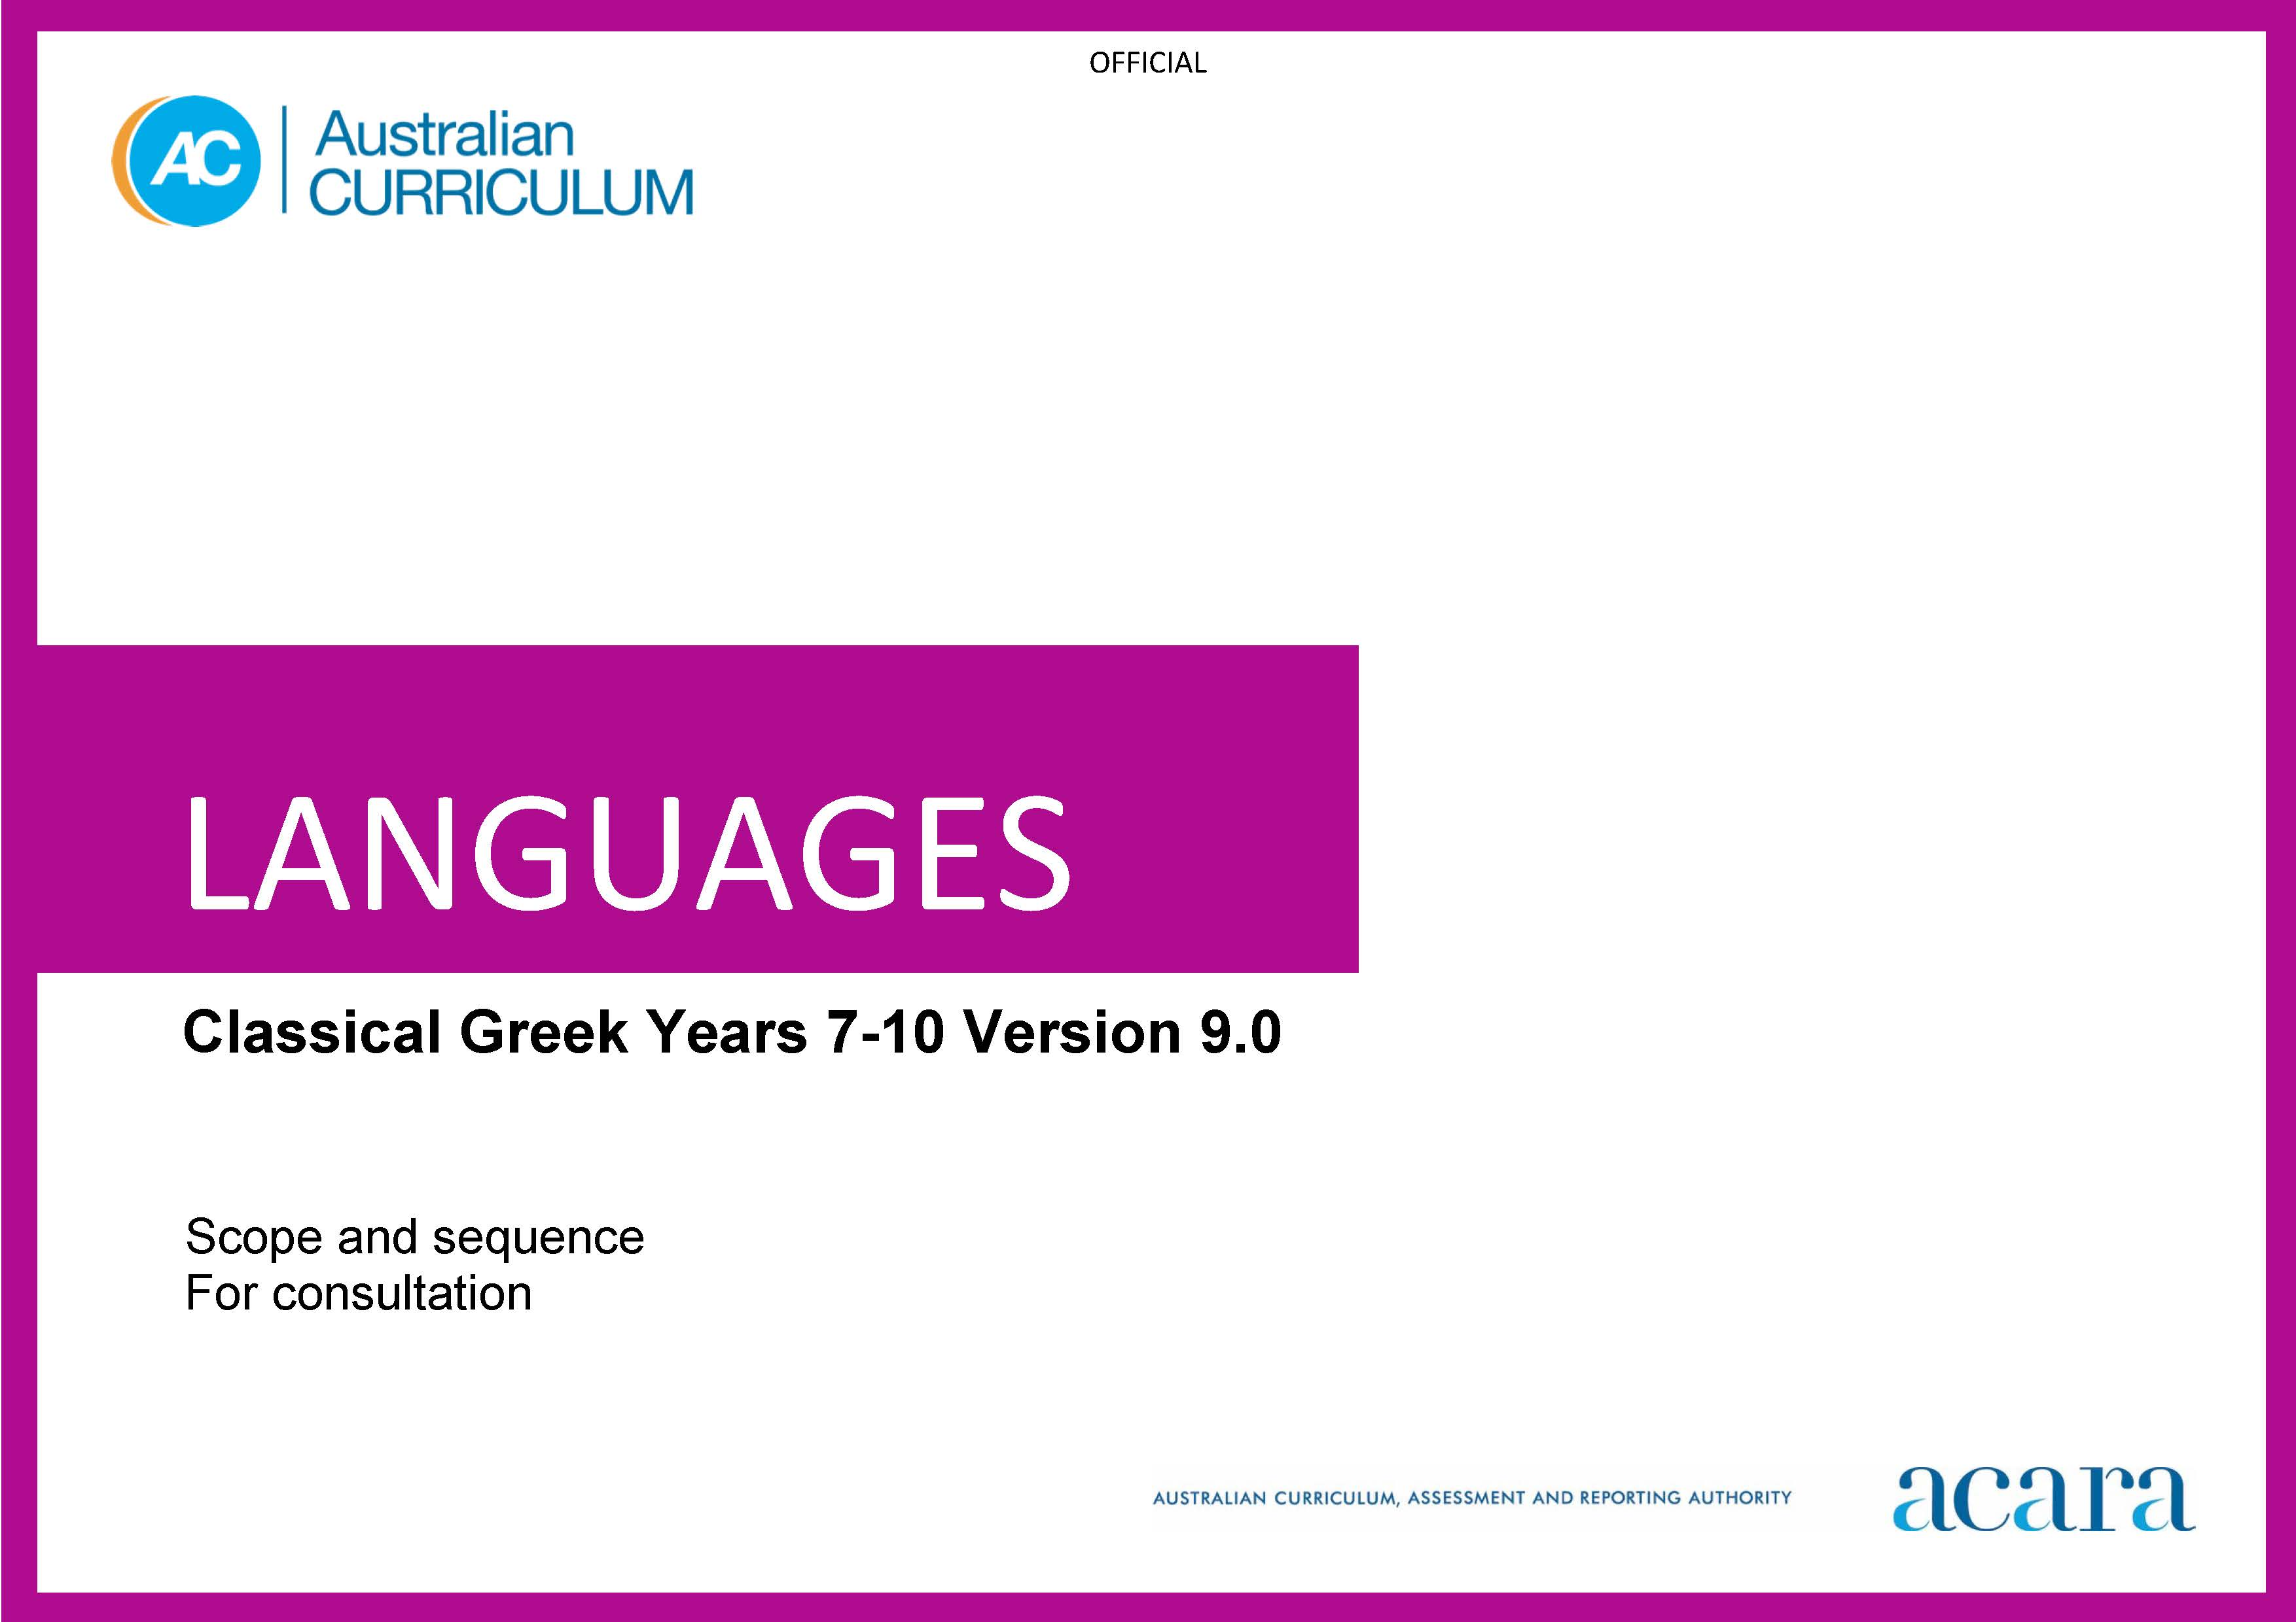

Copyright and Terms of Use Statement
© Australian Curriculum, Assessment and Reporting Authority 2023
The material published in this work is subject to copyright pursuant to the Copyright Act 1968 (Cth) and is owned by the Australian Curriculum, Assessment and Reporting Authority (ACARA) (except to the extent that copyright is held by another party, as indicated).
The viewing, downloading, displaying, printing, reproducing (such as by making photocopies) and distributing of these materials is permitted only to the extent permitted by, and is subject to the conditions imposed by, the terms and conditions of using the ACARA website (see, especially, clauses 2, 3 and 4 of those terms and conditions). The terms and conditions can be viewed at https://www.acara.edu.au/contact-us/copyright
CLASSICAL GREEK SCOPE AND SEQUENCE

Years 7–8 (Year 7 entry) | Years 9–10 (Year 7 entry)
Achievement standard
By the end of Year 8, students use their knowledge of Classical Greek language to interpret texts, and respond to information about ancient Greek society. They develop strategies to translate Classical Greek texts into English, identifying familiar vocabulary, language structures and features to interpret meaning.  Students apply Classical Greek sound–script relationships and use restored pronunciation when reading aloud. They demonstrate understanding that Classical Greek has conventions and rules for spoken and written communication. They understand that Classical Greek has influenced English vocabulary and comment on language structures and features, using metalanguage. They demonstrate awareness that language, texts and artefacts from Ancient Greece are connected with culture and identity, and explore the relationship between language(s), culture(s) and identity. | By the end of Year 10, students use their knowledge of Classical Greek to interpret and analyse information about ancient Greece society and culture. They apply strategies to translate and interpret Classical Greek texts into English and demonstrate understanding of how language conveys cultural meaning.  Students apply Classical Greek sound–script relationships, using restored pronunciation, when reading aloud. They select and apply Classical Greek grammatical conventions and rules when translating and responding to texts. They explain how Classical Greek has influenced English vocabulary and analyse language structures and features, using metalanguage. They demonstrate understanding that language, texts and artefacts from Ancient Greece are connected with culture and identity and reflect on the interrelationship of language(s), culture(s) and identity.

Content descriptions
Strand: Engaging with the ancient Greek world through texts
Sub-strand: Accessing and responding to Classical Greek texts
access and interpret Classical Greek texts to explore the ancient Greek world  ACL9LCG8E01 | interpret Classical Greek texts to analyse the society and culture of the ancient Greek world  ACL9LCG10E01
respond to texts and convey information in English or Classical Greek as appropriate  ACL9LCG8E02 | respond to texts and discuss ideas about ancient Greek society in English or Classical Greek as appropriate  ACL9LCG10E02
Sub-strand: Translating
develop and apply strategies to interpret and translate Classical Greek texts to convey meaning in English  ACL9LCG8E03 | apply strategies to interpret and translate Classical Greek texts to convey meaning and demonstrate understanding of context, purpose and audience  ACL9LCG10E03

Strand: Understanding language and culture
Sub-strand: Understanding systems of language
understand and begin to apply the phonological and orthographic systems of Classical Greek  ACL9LCG8U01 | apply the phonological and orthographic systems of Classical Greek in a range of contexts  ACL9LCG10U01
develop knowledge of vocabulary, and structures and features of Classical Greek grammatical systems to understand, translate and respond to texts  ACL9LCG8U02 | select and use vocabulary, grammatical structures and linguistic features of Classical Greek to interpret, translate, and respond to texts  ACL9LCG10U02
compare Classical Greek vocabulary and language features and structures with English, using metalanguage  ACL9LCG8U03 | explain how Classical Greek structures and features extend understanding of English, using metalanguage  ACL9LCG10U03
Sub-strand: Understanding the interrelationship of language and culture
recognise that language, texts and artefacts provide insights into culture and identity  ACL9LCG8U04 | reflect on and explain how language, texts and artefacts provide understanding of culture and identity  ACL9LCG10U04

