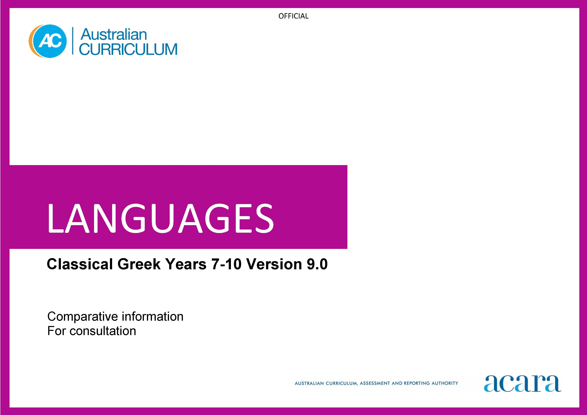

Copyright and Terms of Use Statement
© Australian Curriculum, Assessment and Reporting Authority 2023
The material published in this work is subject to copyright pursuant to the Copyright Act 1968 (Cth) and is owned by the Australian Curriculum, Assessment and Reporting Authority (ACARA) (except to the extent that copyright is held by another party, as indicated).
The viewing, downloading, displaying, printing, reproducing (such as by making photocopies) and distributing of these materials is permitted only to the extent permitted by, and is subject to the conditions imposed by, the terms and conditions of using the ACARA website (see, especially, clauses 2, 3 and 4 of those terms and conditions). The terms and conditions can be viewed at https://www.acara.edu.au/contact-us/copyright
Classical Greek
Years 7–8 (Year 7 entry)
Achievement standard
Version 9.0 | Version 8.4
By the end of Year 8, students use their knowledge of Classical Greek language to interpret texts, and respond to information about ancient Greek society. They develop strategies to translate Classical Greek texts into English, identifying familiar vocabulary, language structures and features to interpret meaning.  Students apply Classical Greek sound–script relationships and use restored pronunciation when reading aloud. They demonstrate understanding that Classical Greek has conventions and rules for spoken and written communication. They understand that Classical Greek has influenced English vocabulary and comment on language structures and features, using metalanguage. They demonstrate awareness that language, texts and artefacts from Ancient Greece are connected with culture and identity, and explore the relationship between language(s), culture(s) and identity. | By the end of Year 8, students use their knowledge of vocabulary, grammar and textual cues to identify and interpret information in Classical Greek texts, such as narratives, about the daily life and attitudes of the ancient Greeks. They interpret grammatical structures such as inflected forms; identify linguistic features such as striking word choice, for example, θηρίον δεινόν, Ἀθήνη γλαυκῶπις; infer meaning from textual cues such as headings, images or captions; and describe social and cultural practices embedded in Classical Greek words, such as γυμνάσιον, πανήγυρις, σπονδή, πομπή. They convey information and ideas about ancient Greek society and culture, in oral, written or digital forms, using Classical Greek as appropriate, for example, a news report in English about a historical event such as the Battle of Marathon, or a digital poster about family life in ancient Greece with annotations in Classical Greek, such as πατήρ, μήτηρ, υἱός, θυγάτηρ. They share their responses to Classical Greek texts, such-as stories, myths and plays, by expressing their feelings and ideas about characters, events, actions, settings and themes. They read aloud or recite Classical Greek texts, such as stories, dialogues, poems or speeches, or perform texts in Classical Greek, such as short plays, to entertain an audience, conveying meaning effectively by using appropriate phrasing and voice inflection. Students translate Classical Greek texts accurately into Standard English, applying their knowledge of vocabulary, including roots and derivatives, linguistic cues, culture, and accidence and syntax, including number, gender and case of nouns, pronouns and adjectives, for example, οὐδὲν κακὸν ἀμιγὲς καλοῦ, conjugation and tense, such as present and future tenses of verbs, for example, γράφω/γράψω, βάλλω/βαλῶ, δέχομαι/δέξομαι, and conventions of sentence structure. They explain the relative effectiveness of different translations of the same text, and identify the features of a successful translation.  Students identify Classical Greek sound–script relationships and use restored pronunciation when reading aloud, such as for diphthongs, double consonants and aspirated consonants, for example, εἴσοδος, ξένος, χάρις. They identify the structure and features of different texts in Classical Greek, such as narratives or short plays, and explain how these elements contribute to an audience's response to the text. They describe how the Greek language spread with the expansion of the ancient Greek world, and influenced other languages during the Classical period. They explain how Classical Greek has influenced and continues to influence English vocabulary, by identifying derivatives, for example, theory, dilemma, category, paragraph, and words that are used in modern English, for example, nemesis, catharsis, criterion, anathema. Students give examples of how particular language use reflects the lifestyles, ideas, feelings and attitudes of Greeks in the Classical period, and identify connections between ancient and modern values, pursuits, citizenship, literature, the arts and architecture. They share their reactions to and assumptions about the language and culture of ancient Greek society, identifying similarities or differences to their own language and culture. They describe how learning Classical Greek impacts on their own approaches to learning and on their understanding of their own heritage, values and culture.

Content descriptions
Version 9.0 Strand: Engaging with the ancient Greek world through texts
Version 9.0 | Action taken | Version 8.4
Version 9.0 Sub-strand: Accessing and responding to Classical Greek texts
access and interpret Classical Greek texts to explore the ancient Greek world  ACL9LCG8E01 | Refined | Read, comprehend and discuss Classical Greek texts, using vocabulary, grammar and textual cues, to explore the ancient Greek world  ACLCLE001  Listen to and read Classical Greek texts, such as stories, myths and plays; share reactions and make connections with characters, events, actions, settings and key emotions  ACLCLE003
 | Removed | Identify the structure and features of a range of texts in Classical Greek, such as narratives and short plays  ACLCLU010
respond to texts and convey information in English or Classical Greek as appropriate  ACL9LCG8E02 | Refined | Convey information and ideas about the daily life and attitudes of the ancient Greeks, in oral, written and digital forms, using Classical Greek as appropriate  ACLCLE002
Version 9.0 Sub-strand: Translating
develop and apply strategies to interpret and translate Classical Greek texts to convey meaning in English  ACL9LCG8E03 | Combined  Refined | Translate Classical Greek texts into Standard English, by applying knowledge of vocabulary, accidence and syntax, and linguistic and cultural cues  ACLCLE005  Compare different translations and interpretations of Classical Greek texts, and identify features of successful translations  ACLCLE006

Version 9.0 Strand: Understanding language and culture
Version 9.0 | Action taken | Version 8.4
Version 9.0 Sub-strand: Understanding systems of language
understand and begin to apply the phonological and orthographic systems of Classical Greek  ACL9LCG8U01 | Combined  Refined | Understand the phonological and orthographic systems of Classical Greek, including the restored pronunciation and the written alphabet  ACLCLU007  Read aloud, recite or perform Classical Greek texts, using phrasing and voice inflection to convey meaning and to entertain others  ACLCLE004
develop knowledge of the vocabulary, and structures and features of Classical Greek grammatical systems to understand, translate and respond to texts  ACL9LCG8U02 | Combined  Refined | Understand concepts of accidence and syntax used in simple and compound sentences in Classical Greek, including parts of speech, case, gender, number, person, declension and conjugation, agreement and tense, mood, voice, participles and infinitives  ACLCLU008  Acquire and build vocabulary by using roots, derivatives and word lists, and use dictionaries to select appropriate meanings of Classical Greek words  ACLCLU009
compare Classical Greek vocabulary, language features and structures with English, using metalanguage  ACL9LCG8U03 | New
Version 9.0 Sub-strand: Understanding the interrelationship of language and culture
recognise that language, texts and artefacts provide insights into culture and identity  ACL9LCG8U04 | Combined  Refined | Examine the enduring influence of ancient Greek culture on the modern world, by discussing the ancient origins of modern values, pursuits, citizenship, literature, the arts and architecture  ACLCLU012  Recognise that the language of the ancient Greeks provides insights into their daily lives, ideas, feelings and attitudes  ACLCLU013
 | Removed | Understand that Greek spread with the expansion of the ancient Greek world, and developed over time, influencing English and other languages  ACLCLU011
 | Removed | Reflect on own and others’ reactions to and assumptions about the language and culture of ancient Greek society, considering similarities and differences to own language and culture  ACLCLU014
 | Removed | Reflect on self as a language learner, considering how learning Classical Greek influences ways of learning and enhances understanding of own heritage, values and culture  ACLCLU015

Years 9–10 (Year 7 entry)
Achievement standard
Version 9.0 | Version 8.4
By the end of Year 10, students use their knowledge of Classical Greek to interpret and analyse information about ancient Greece society and culture. They apply strategies to translate and interpret Classical Greek texts into English and demonstrate understanding of how language conveys cultural meaning.  Students apply Classical Greek sound–script relationships, using restored pronunciation, when reading aloud. They select and apply Classical Greek grammatical conventions and rules when translating and responding to texts. They explain how Classical Greek has influenced English vocabulary and analyse language structures and features, using metalanguage. They demonstrate understanding that language, texts and artefacts from Ancient Greece are connected with culture and identity and reflect on the interrelationship of language(s), culture(s) and identity. | . By the end of Year 10, students analyse a range of Classical Greek texts to obtain information and ideas about ancient Greek society and culture. They use vocabulary, grammar and textual cues to analyse and interpret language use and cultural references in Classical Greek texts, such as poetry, plays or narratives, for example, by deducing the meaning of complex sentence structures, such as those with subordinate clauses or indirect speech, for example, ὁ ἄγγελος λέγει ὅτι οἱ πολέμιοι προσέρχονται, and explaining the impact of word order on emphasis and tone, for example, ὁ δὲ ἀνεξέταστος βίος οὐ βιωτὸς ἀνθρώπῳ, ἓν οἶδα ὃτι οὐδὲν οἶδα, πρῶτον μὲν γάρ, and implicit values, concepts and assumptions embedded in language use, for example, ἀριστεία, μίασμα. They convey their interpretations of information and ideas about ancient Greek society and culture, in oral, written or digital forms, such as role-plays or debates in English about how cultural attitudes are conveyed in Classical Greek texts, or a digital presentation of an archaeological site, using simple sentences in Classical Greek, for example, τὸ μαντεῖον τῶν Δελφῶν. They share their responses to Classical Greek texts, such as narratives, dialogues, plays, poems or letters, by describing themes, values and literary features, such as plot development and characterisation, and expressing and justifying their opinions with support from the text. They read aloud, recite or perform Classical Greek texts, such as oratory, history, drama or poetry, to entertain different audiences, conveying meaning and emotion effectively by using appropriate phrasing and voice inflection. Students translate a range of texts that incorporate complex sentence structures and extensive vocabulary, from Classical Greek into Standard English that represents the style and purpose of the texts, applying their knowledge of roots, cognates and derivatives to infer the meaning of unfamiliar vocabulary, and using dictionaries to select the appropriate meaning of words. They analyse how the language is used in grammatically complex sentences, including subordinate clauses, non-finite verb forms, pronoun forms, mood and voice, such as case usage of nouns, pronouns and adjectives, for example, τούτων τῶν ἀνθρώπων, τὰ μείζονα κακά, perfect and pluperfect conjugations, for example, λέλοιπα/ἐλελοίπη, subjunctive and optative moods, for example, μὴ κρύψῃς τὴν μάστιγα ὦ δοῦλε, ὁ δεσπότης ἠρώτησε τὶς λύσειε τοὺς βοῦς, and passive voice, for example, ὁ ἳππος ἐλύθη, τῷ οἰστῷ βληθείς. They evaluate the effectiveness of different translations of the same Classical Greek text, and identify strategies for successful translations.  Students apply the principles of pronunciation for the reading of Classical Greek texts. They identify the structure and organisation of different text types in Classical Greek, such as prose and verse, and explain how they relate to context, purpose and audience. They explain the role of Classical Greek in facilitating the spread of Greek civilisation and culture across the Mediterranean world, and the contribution of Classical Greek to the enrichment of English through the transfer of specialist vocabulary, for example, antithesis, ellipsis, euphemism, hyperbole, abstract concepts, for example, enthusiasm, patriotism, democracy, idiosyncrasy, and the coining of vocabulary for new technology and new discoveries, for example, thermodynamics, epigenomics. Students describe ancient Greek values, attitudes and beliefs that are embedded in particular language use, such as μέτρον and κλέος. They explain how the ancient Greek world has influenced social, political and legal structures, philosophy, literature, the arts, and medical and scientific practices in the modern world. They share reactions to and assumptions about the language, culture and values of ancient Greek society, explaining how these relate to their own language and culture. They compare ways of communicating and living in the ancient world with those of the modern world, and explain how learning Classical Greek influences their own ways of thinking and viewing the world.

Content descriptions
Version 9.0 Strand: Engaging with the ancient Greek world through texts
Version 9.0 | Action taken | Version 8.4
Version 9.0 Sub-strand: Accessing and responding to Classical Greek texts
interpret Classical Greek texts to analyse the society and culture of the ancient Greek world  ACL9LCG10E01 | Refined | Read, analyse and interpret Classical Greek texts, using vocabulary, grammar and textual cues, to engage with the ancient Greek world  ACLCLE016
 | Removed | Analyse the structure and features of different text types in Classical Greek, exploring how they relate to context, purpose and audience  ACLCLU025
respond to texts and discuss ideas about ancient Greek society in English or Classical Greek as appropriate  ACL9LCG10E02 | Combined  Refined | Convey interpretations of information and ideas about ancient Greek society and culture, in oral, written and digital forms, using Classical Greek as appropriate  ACLCLE017  Respond to Classical Greek texts by analysing themes, values and literary features, such as plot development and characterisation, and sharing and justifying opinions  ACLCLE018  Discuss how the ancient Greek world has influenced the modern world, in its social, political and legal structures; philosophy; literature; arts; and medical and scientific practices  ACLCLU027
Version 9.0 Sub-strand: Translating
apply strategies to interpret and translate Classical Greek texts to convey meaning and demonstrate understanding of context, purpose and audience  ACL9LCG10E03 | Combined  Refined | Translate a range of texts that incorporate complex sentence structures and extensive vocabulary from Classical Greek into Standard English, representing the style and purpose of the texts  ACLCLE020  Evaluate different translations and interpretations of Classical Greek texts, using metalanguage to discuss their effectiveness, and develop strategies for successful translations  ACLCLE021
Version 9.0 Strand: Understanding language and culture
Version 9.0 | Action taken | Version 8.4
Version 9.0 Sub-strand: Understanding systems of language
apply the phonological and orthographic systems of Classical Greek in a range of contexts  ACL9LCG10U01 | Combined  Refined | Understand and apply the principles of pronunciation for the reading of Classical Greek texts  ACLCLU022  Read aloud, recite or perform Classical Greek texts to entertain others, using strategies such as phrasing and voice inflection to convey meaning and emotion  ACLCLE019
select and use vocabulary, grammatical structures and linguistic features of Classical Greek to interpret, translate, and respond to texts  ACL9LCG10U02 | Combined  Refined | Understand concepts of accidence and syntax used in complex sentences in Classical Greek, including subordinate clauses, pronoun forms, mood, voice, and conventions of complex sentence structure  ACLCLU023  Expand vocabulary by using a range of strategies, including knowledge of roots, cognates and derivatives, and use dictionaries to determine the meaning of unfamiliar vocabulary in specific contexts  ACLCLU024
explain how Classical Greek vocabulary, structures and features extend understanding of English, using metalanguage  ACL9LCG10U03 | New
 | Removed | Understand that Greek became the dominant language of the ancient Mediterranean world and facilitated the spread of Greek civilisation and culture, and that Classical Greek continues to enrich English through specialist vocabulary and abstract concepts embodied in the language  ACLCLU026
Version 9.0 Sub-strand: Understanding the interrelationship of language and culture
reflect on and explain how language, texts and artefacts provide understanding of culture and identity  ACL9LCG10U04 | Refined | Identify how cultural values, attitudes and beliefs of the ancient Greeks are embedded in their language  ACLCLU028
 | Removed | Question and explain own and others’ reactions to and assumptions about the language, culture and values of ancient Greek society, discussing how these relate to own language and culture  ACLCLU029
 | Removed | Reflect on self as a language learner, explaining how the study of Classical Greek influences own communicative behaviours, ways of thinking and viewing the world  ACLCLU030

