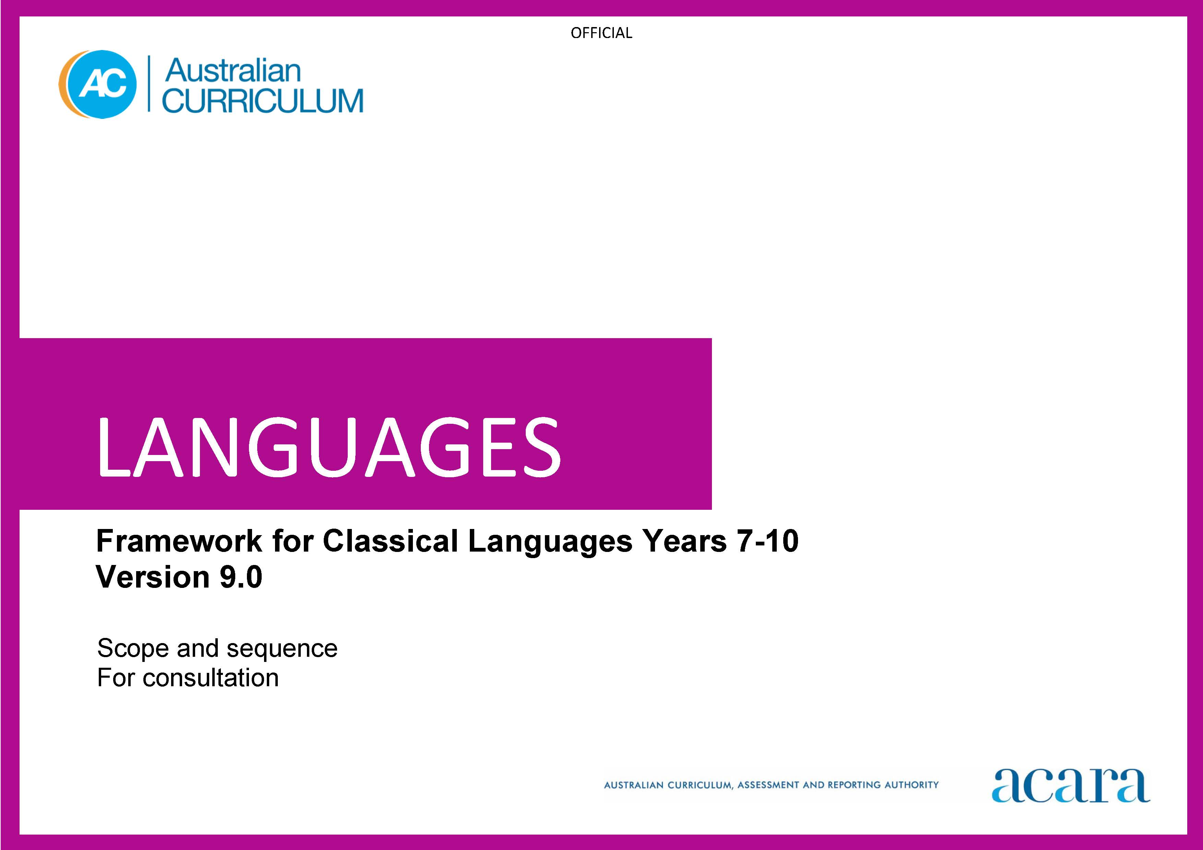

Copyright and Terms of Use Statement
© Australian Curriculum, Assessment and Reporting Authority 2023
The material published in this work is subject to copyright pursuant to the Copyright Act 1968 (Cth) and is owned by the Australian Curriculum, Assessment and Reporting Authority (ACARA) (except to the extent that copyright is held by another party, as indicated).
The viewing, downloading, displaying, printing, reproducing (such as by making photocopies) and distributing of these materials is permitted only to the extent permitted by, and is subject to the conditions imposed by, the terms and conditions of using the ACARA website (see, especially, clauses 2, 3 and 4 of those terms and conditions). The terms and conditions can be viewed at https://www.acara.edu.au/contact-us/copyright
CLASSICAL [LANGUAGE] SCOPE AND SEQUENCE

Years 7–8 (Year 7 entry) | Years 9–10 (Year 7 entry)
Achievement standard
By the end of Year 8, students use their knowledge of [Classical language] language to interpret texts, and respond to information about ancient [country/city] society. They develop strategies to translate [Classical language] texts into English, identifying familiar vocabulary, language structures and features to interpret meaning.  Students apply [Classical language] sound–script relationships and use restored pronunciation when reading aloud. They demonstrate understanding that [Classical language] has conventions and rules for spoken and written communication. They understand that [Classical language] has influenced English vocabulary and comment on language structures and features, using metalanguage. They demonstrate awareness that language, texts and artefacts from Ancient [Country/City] are connected with culture and identity, and explore the relationship between language(s), culture(s) and identity. | By the end of Year 10, students use their knowledge of [Classical language] to interpret and analyse information about ancient [country/city] society and culture. They apply strategies to translate and interpret [Classical language] texts into English and demonstrate understanding of how language conveys cultural meaning.  Students apply [Classical language] sound–script relationships, using restored pronunciation, when reading aloud. They select and apply [Classical language] grammatical conventions and rules when translating and responding to texts. They explain how [Classical language] has influenced English vocabulary and analyse language structures and features, using metalanguage. They demonstrate understanding that the language, texts and artefacts from Ancient [Country/City] are connected with culture and identity and reflect on the interrelationship of language(s), culture(s) and identity.

Content descriptions
Strand: Engaging with the ancient [country/city] world through texts
Sub-strand: Accessing and responding to [Classical language] texts
access and interpret [Classical language] texts to explore the ancient [country/city] world  ACL9LCLF8E01 | interpret [Classical language] texts to analyse the society and culture of the ancient [country/city] world  ACL9LCLF10E01
respond to texts and convey information in English or [Classical language] as appropriate  ACL9LCLF8E02 | respond to texts and discuss ideas about ancient [country/city] society in English or [Classical language] as appropriate  ACL9LCLF10E02
Sub-strand: Translating
develop and apply strategies to interpret and translate [Classical language] texts to convey meaning in English  ACL9LCLF8E03 | apply strategies to interpret and translate [Classical language] texts to convey meaning and demonstrate understanding of context, purpose and audience  ACL9LCLF10E03

Strand: Understanding language and culture
Sub-strand: Understanding systems of language
understand and begin to apply the phonological and orthographic systems of [Classical language]  ACL9LCLF8U01 | apply the phonological and orthographic systems of [Classical language] in a range of contexts  ACL9LCLF10U01
develop knowledge of the vocabulary, and structures and features of [Classical language] grammatical systems to understand, translate and respond to texts  ACL9LCF8U02 | select and use vocabulary, grammatical structures and linguistic features of [Classical language] to interpret, translate, and respond to texts  ACL9LCLF10U02
compare [Classical language] vocabulary, language features and structures with English, using metalanguage  ACL9LCLF8U03 | explain how [Classical language] vocabulary, structures and features extend understanding of English, using metalanguage  ACL9LCLF10U03
Sub-strand: Understanding the interrelationship of language and culture
recognise that language, texts and artefacts provide insights into culture and identity  ACL9LCLF8U04 | reflect on and explain how language, texts and artefacts provide understanding of culture and identity  ACL9LCLF10U04

