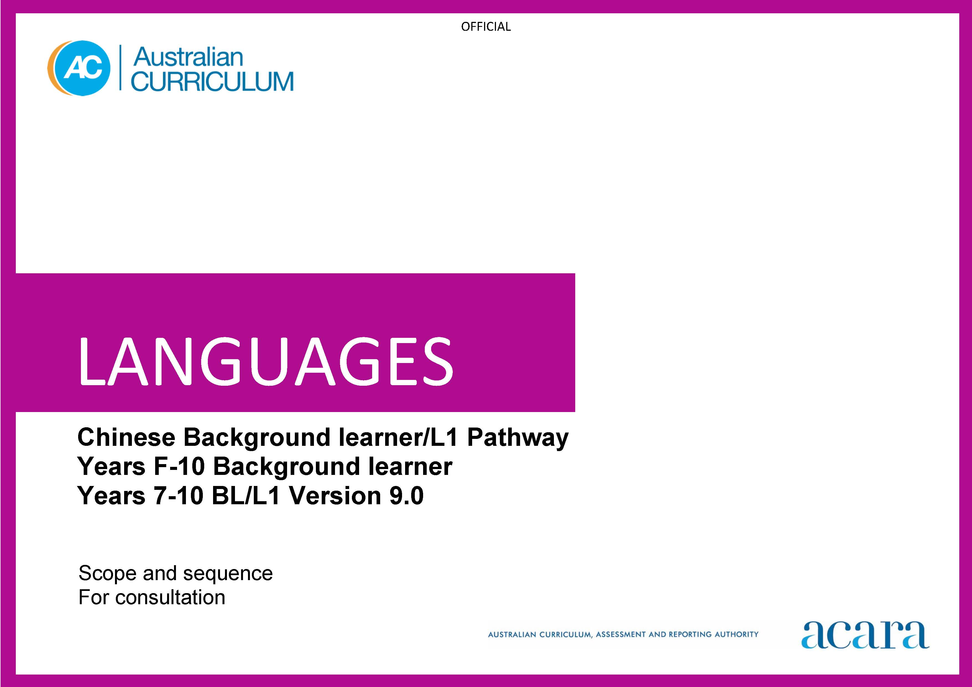

Copyright and Terms of Use Statement
© Australian Curriculum, Assessment and Reporting Authority 2023
The material published in this work is subject to copyright pursuant to the Copyright Act 1968 (Cth) and is owned by the Australian Curriculum, Assessment and Reporting Authority (ACARA) (except to the extent that copyright is held by another party, as indicated).
The viewing, downloading, displaying, printing, reproducing (such as by making photocopies) and distributing of these materials is permitted only to the extent permitted by, and is subject to the conditions imposed by, the terms and conditions of using the ACARA website (see, especially, clauses 2, 3 and 4 of those terms and conditions). The terms and conditions can be viewed at https://www.acara.edu.au/contact-us/copyright
CHINESE BACKGROUND LEARNERS SCOPE AND SEQUENCE
Foundation | Years 1–2
Achievement standard
By the end of the Foundation year, students use play and imagination to interact and create Chinese texts, with support. They identify that Chinese and English look and sound different. They recognise that there are languages and cultures as well as their own, and that aspects of language and culture contribute to their own and others’ cultural identity. | By the end of Year 2, students use Chinese language to interact and share information related to the classroom and themselves. They use cues to respond to questions and instructions, and use simple formulaic language. They locate and convey key items of information in texts using non-verbal, visual and contextual cues to help make meaning. They use familiar words and modelled language to create texts. They recognise and use familiar characters and Pinyin to make words and sentences.  Students recognise and use the sounds, tones and rhythms of spoken Chinese. They demonstrate understanding that Chinese has rules for non-verbal communication, pronunciation and writing. They give examples of similarities and differences between features of Chinese and English. They understand that language is connected with culture, and notice how this is reflected in their own language(s) and culture(s).

Content descriptions
 | Strand: Communicating meaning in [language}
 | Sub-strand: Interacting in Chinese
with support, recognise and communicate meaning in Chinese  AC9LCHF01 | interact in classroom-related routines; and personal introductions  AC9LCH2C01
explore, with support, language features of Chinese noticing similarities and differences between Chinese and English  AC9LCHF02 | collaborate with others in a range of play-based activities using modelled expressions, visual and spoken cues  AC9LCH2C02

explore connections between language and culture

AC9LCHF03
 | Sub-strand: Mediating meaning in and between languages

locate, with support, key information in spoken and written texts, and respond using gestures, images, words and modelled sentences

AC9LCH2C03

recognise that language carries cultural meaning in everyday social interactions

AC9LCH2C04
 | Sub-strand: Creating text in Chinese

with support, create spoken, written and multimodal texts, using familiar words, modelled phrases and sentences, copying known characters and Pinyin

AC9LCH2C05

Strand: Understanding language and culture
Sub-strand: Understanding systems of language

recognise and use sound patterns and the four tones of Chinese

AC9LCH2U01

recognise that Chinese components and/or characters and features of language are used to construct meaning

AC9LCH2U02

recognise that Chinese has features that may be similar to or different from English

AC9LCH2U03
Sub-strand: Understanding the interrelationship of language and culture

notice that people use language in ways that reflect cultural practices

AC9LCH2U04

Years 3–4 | Years 5–6
Achievement standard
By the end of Year 4, students use Chinese language to initiate interactions to share information and ideas related to the classroom and their personal world. They use modelled language to participate in spoken and written activities that involve planning. They locate and respond to key items of information in texts using strategies to help interpret and convey meaning in familiar contexts. They use familiar characters, Pinyin and modelled language to create texts.  Students recognise and use sounds, tones, syllables, and pronunciation and intonation patterns of spoken Chinese. They demonstrate understanding that Chinese has non-verbal, spoken and written language conventions and rules to create and make meaning. They recognise that some terms have cultural meanings. They identify patterns in Chinese and make comparisons between Chinese and English. They understand that the Chinese language is connected with culture, and identify how this is reflected in their own language(s) and culture(s). | By the end of Year 6, students initiate and use strategies to maintain interactions in Chinese language that are related to their immediate environment. They collaborate in spoken and written activities that involve the language of planning and problem-solving to share information, ideas and preferences. They use strategies to locate and interpret information and ideas in texts, and demonstrate understanding by responding in Chinese or English, adjusting their response to context, purpose and audience. They create texts, using characters with appropriate stroke order and radicals, vocabulary and sentence structures to suit context. They sequence information and ideas, and use conventions appropriate to text type.  Students apply rules for pronunciation and intonation in spoken Chinese. They apply conventions of script and punctuation, and use modelled structures, when creating and responding in Chinese. They compare language structures and features in Chinese and English, using some metalanguage. They show understanding of how some language reflects cultural practices and consider how this is reflected in their own language(s), culture(s) and identity.

Content descriptions
Strand: Communicating meaning in Chinese
Sub-strand: Interacting in Chinese
initiate exchanges and respond to questions about home and classroom environments, using familiar expressions  AC9LCH4C01 | initiate and sustain exchanges related to students’ experiences and perspectives  AC9LCH6C01
participate in activities that involve planning and transacting with others, using a range of phrases, structures and modelled sentences in familiar contexts  AC9LCH4C02 | participate in activities that involve planning, negotiating with others, using modelled and idiomatic language to agree, suggest and resolve  AC9LCH6C02
Sub-strand: Mediating meaning in and between languages
locate, organise and respond to key information related to familiar content in spoken, written and multimodal texts  AC9LCH4C03 | locate and process information and ideas in a range of spoken, written and multimodal texts, and respond in different ways to suit purpose and audience  AC9LCH6C03
develop strategies to interpret language that conveys cultural meaning  AC9LCH4C04 | apply strategies to interpret and translate language in non-verbal, spoken and written cultural contexts  AC9LCH6C04
Sub-strand: Creating text in Chinese
create and present informative and imaginative spoken, written and multimodal texts using a range of sentence structures and modelled textual conventions, characters appropriate to context, and/or Pinyin  AC9LCH4C05 | create and present informative and imaginative spoken, written and multimodal texts using a range of sentence structures to sequence information and ideas, and textual conventions, appropriate to purpose and audience  AC9LCH6C05

Strand: Understanding language and culture
Sub-strand: Understanding systems of language
recognise and use the tonal features of Chinese in different contexts and understand how syllables are represented in Pinyin  AC9LCH4U01 | use tone-syllables, intonation, stress and phrasing to express feelings and opinions  AC9LCH6U01
recognise and use features of the Chinese writing system, familiar components and/or characters, a range of sentence structures and basic syntax, in familiar texts and contexts  AC9LCH4U02 | identify and use components and/or characters, sentence structures, syntax and writing system features to compose and respond to familiar and some unfamiliar texts and contexts  AC9LCH6U02
recognise and compare features of familiar spoken and written text in Chinese and English  AC9LCH4U03 | compare some Chinese language structures and features with those of English, using some familiar metalanguage  AC9LCH6U03
Sub-strand: Understanding the interrelationship of language and culture
identify connections between Chinese language and cultural practices  AC9LCH4U04 | recognise that language reflects cultural practices, values and identity, and that this impacts on non-verbal and verbal communication  AC9LCH6U04

Years 7–8 (F–10) | Years 9–10 (F–10)
Achievement standard
By the end of Year 8, students initiate and maintain interactions in Chinese language in familiar and some unfamiliar contexts related to a range of interests and experiences. They use Chinese to collaborate and problem-solve, and adjust language in response to others. They interpret information, ideas and opinions in texts. They demonstrate understanding of similarities and differences between languages, in both familiar and some unfamiliar cultural contexts, by adjusting and reorganising responses. They select and use vocabulary sentence structures, and expressions to create texts and apply Chinese script conventions in written texts.  Students apply the conventions of spoken Chinese to develop fluency. They demonstrate understanding that spoken, written and multimodal texts use different language conventions, structures and features to convey meaning. They comment on structures and features of Chinese text, using metalanguage. They reflect on how the Chinese language, culture and identity are interconnected, and compare this with their own language(s), culture(s) and identity. | By the end of Year 10, students contribute to and extend interactions in Chinese language in increasingly unfamiliar contexts related to a wide range of interests and issues. They interpret texts by evaluating and synthesising information, ideas and perspectives. They show understanding of how features of language can be used to influence audience response. They create texts, selecting and manipulating language for a range of contexts, purposes and audiences. They enhance the overall meaning and cohesion of their spoken and written texts through the strategic use of language structures and features.  Students incorporate the features and conventions of spoken Chinese to extend fluency. They demonstrate understanding of the conventions of spoken and written texts and the connections between them. They apply knowledge of language structures and features to make and predict meaning. They support analysis of Chinese texts, using metalanguage. They reflect on their own cultural perspectives and identity, and draw on their experience of learning Chinese, to evaluate how this learning influences their ideas and ways of communicating.

Content descriptions
Strand: Communicating meaning in Chinese
Sub-strand: Interacting in Chinese
initiate and sustain exchanges in familiar and unfamiliar contexts related to students’ experiences, feelings and views, adjusting their language in response to others  AC9LCH8C01 | initiate, sustain and extend exchanges in a range of contexts, responding to ideas, opinions and perspectives  AC9LCH10C01
collaborate in activities that involve the language of transacting, negotiating and justifying to plan events  AC9LCH8C02 | contribute to discussions that involve diverse views to negotiate outcomes, address issues and compare cultural experiences  AC9LCHC10C02
Sub-strand: Mediating meaning in and between languages
interpret and analyse information, ideas and opinions in a range of spoken, written and multimodal texts, and respond appropriately to cultural context, purpose and audience  AC9LCH8C03 | analyse and evaluate information, ideas and perspectives in a broad range of spoken, written and multimodal texts and respond appropriately to cultural context, purpose and audience  AC9LCH10C03
interpret and translate non-verbal, spoken and written language to convey meaning in a range of familiar and unfamiliar cultural contexts  AC9LCH8C04 | interpret and translate a range of non-verbal, spoken and written texts, and justify how meaning is conveyed to reflect cultural context, purpose and audience  AC9LCH10C04
Sub-strand: Creating text in Chinese
create and present spoken, written and multimodal informative and imaginative texts, manipulating language to suit context, purpose and audience  AC9LCH8C05 | create and present informative and imaginative texts for diverse contexts and purposes, selecting vocabulary, expressions, sentence structures and textual features and conventions to engage different audiences  AC9LCH10C05

Strand: Understanding language and culture
Sub-strand: Understanding systems of language
apply tone-syllables, intonation, stress and phrasing to develop fluency in responding to and creating texts in a range of contexts  AC9LCH8U01 | apply features and conventions of spoken Chinese to extend fluency in responding to and creating texts appropriate to contexts, purposes and audiences  AC9LCH10U01
apply knowledge of character form and function, sentence structures, syntax, and writing system features to infer meaning and to compose a range of texts  AC9LCH8U02 | apply knowledge of character form and function and complex grammatical features and structures to predict meaning and to compose a wide range of texts  AC9LCH10U02
reflect on and explain similarities and differences between Chinese and English language structures and features, using metalanguage  AC9LCH8U03 | analyse a range of Chinese texts, using metalanguage to explain linguistic, textual and cultural elements  AC9LCH10U03
Sub-strand: Understanding the interrelationship of language and culture
reflect on and explain how their own and others’ identity is shaped by language(s), culture(s), attitudes, beliefs and values  AC9LCH8U04 | reflect on and evaluate how their own and others’ identity is shaped by language(s), culture(s), attitudes, beliefs and values, and how these affect ways of communicating  AC9LCH10U04

CHINESE BACKGROUND LEARNERS/FIRST-LANGUAGE LEARNERS SCOPE AND SEQUENCE

Years 7–8 (Year 7 entry) | Years 9–10 (Year 7 entry)
Achievement standard
By the end of Year 8, students use Chinese language to interact and collaborate with others, and to share information and plan activities in familiar contexts. They respond to others’ contributions, and use familiar gestures, questions and instructions in exchanges. They understand relationships between spoken and written forms. They interpret and analyse information in texts and translate non-verbal, visual and contextual cues to help make meaning. They respond in Chinese or English, and demonstrate understanding of context, purpose and audience in texts. They manipulate language and grammatical structures to create spoken and written texts by employing various techniques such as word choice and sentence structure appropriate to audience, context and purpose. Students apply their knowledge of script conventions in written texts.  Students apply tones, pronunciation and intonation in spoken Chinese. They use Chinese conventions and rules for non-verbal, spoken and written communication. They compare aspects of Chinese and English language structures and features, using metalanguage. They reflect on and explain that the Chinese language is connected with culture and identity, and that this connection is reflected in their own language(s), culture(s) and identity. | By the end of Year 10, students initiate and extend Chinese language to exchange and compare ideas, opinions, and experiences about their own and others’ personal world. They communicate using non-verbal, spoken and written language to collaborate, plan and reflect on activities and events. They evaluate and synthesise information and ideas in texts and demonstrate understanding of different perspectives. They analyse and interpret information and respond in Chinese or English, adjusting language to convey meaning and to suit context, purpose and audience. They create texts, selecting and manipulating language for a range of contexts, purposes and audiences. They enhance the overall meaning and cohesion of their written and spoken texts through the strategic use of language devices and structures.  Students apply features and conventions of spoken Chinese to extend fluency. They select and apply knowledge of language conventions, structures and features to interact, make meaning and create texts. They support discussion of structures and features of texts, using metalanguage. They reflect on their own language use and cultural identity, and draw on their experience of learning Chinese, to discuss how this learning influences their ideas and ways of communicating.

Content descriptions
Strand: Communicating meaning in Chinese
Sub-strand: Interacting in Chinese
initiate and sustain exchanges, related to students’ experiences and perspectives  AC9LCH8EC01 | initiate, sustain and extend exchanges in a range of contexts, responding to ideas, opinions and perspectives about their own and others’ personal worlds  AC9LCH10EC01
engage in activities that involve planning, transacting and negotiating with peers using a range of phrases, structures and sentences  AC9LCH8EC02 | contribute to discussions that involve diverse views to negotiate outcomes, address issues and compare cultural experiences  AC9LCH10EC02
Sub-strand: Mediating meaning in and between languages
locate and process information and ideas in a range of spoken, written and multimodal texts, responding in ways appropriate to cultural context, purpose and audience  AC9LCH8EC03 | analyse and evaluate information, ideas and perspectives in a range of spoken, written and multimodal texts and respond appropriately to cultural context, purpose and audience  AC9LCH10EC03
apply strategies to interpret, translate and convey meaning in familiar and some unfamiliar non-verbal, spoken and written cultural contexts  AC9LCH8EC04 | interpret and translate a range of non-verbal, spoken and written texts, and justify how meaning is conveyed to reflect cultural context, purpose and audience  AC9LCH10EC04

Sub-strand: Creating text in Chinese
create spoken, written and multimodal informative and imaginative texts, using appropriate characters and/or Pinyin, vocabulary, expressions, sentence structures and textual conventions to suit purpose and audience  AC9LCH8EC05 | create and present informative and imaginative texts for diverse contexts and purposes, selecting vocabulary, expressions, sentence structures and textual features and conventions to engage different audiences  AC9LCH10EC05

Strand: Understanding language and culture
Sub-strand: Understanding systems of language
use tone-syllables intonation, stress and phrasing to develop and enhance fluency in responding to and creating texts in a range of contexts  AC9LCH8EU01 | apply features and conventions of spoken Chinese to extend fluency in responding to and creating texts appropriate to contexts, purposes and audiences  AC9LCH10EU01
use components and/or characters, sentence structures, syntax and writing system features to infer meaning and to compose and respond to familiar and some unfamiliar texts and contexts  AC9LCH8EU02 | apply knowledge of character form and function, and complex grammatical features and structures to predict meaning and to compose a wide range of texts  AC9LCH10EU02
compare and explain similarities and differences between Chinese and/or English language structures and features, using familiar metalanguage  AC9LCH8EU03 | analyse a range of Chinese texts, using metalanguage to explain linguistic, textual and cultural elements  AC9LCH10EU03
Sub-strand: Understanding the interrelationship of language and culture
reflect on and explain how their own and others’ identity is shaped by language(s), culture(s), attitudes, beliefs and values  AC9LCH8EU04 | reflect on and evaluate how their own and others’ identify is shaped by language(s), culture(s), beliefs, attitudes and values, and how these affect ways of communicating  AC9LCH10EU04

